Performance Tasks:
Option 1: 4a

4a: I can develop a claim with supporting evidence to predict different environmental factors, which influence variation within populations.
Choose one of the genetic mutations on this website http://www2.csudh.edu/nsturm/CHEMXL153/DNAMutationRepair.htm
Research and answer the statements below.

What kinds of gene mutations are possible?
The DNA sequence of a gene can be altered in a number of ways. Gene mutations have varying effects on health, depending on where they occur and whether they alter the function of essential proteins. The types of mutations include:
Missense mutation
This type of mutation is a change in one DNA base pair that results in the substitution of one amino acid for another in the protein made by a gene.
Nonsense mutation
A nonsense mutation is also a change in one DNA base pair. Instead of substituting one amino acid for another, however, the altered DNA sequence prematurely signals the cell to stop building a protein. This type of mutation results in a shortened protein that may function improperly or not at all.
Insertion
An insertion changes the number of DNA bases in a gene by adding a piece of DNA. As a result, the protein made by the gene may not function properly.
Deletion
A deletion changes the number of DNA bases by removing a piece of DNA. Small deletions may remove one or a few base pairs within a gene, while larger deletions can remove an entire gene or several neighboring genes. The deleted DNA may alter the function of the resulting protein(s).
Duplication
A duplication consists of a piece of DNA that is abnormally copied one or more times. This type of mutation may alter the function of the resulting protein.
Frameshift mutation
This type of mutation occurs when the addition or loss of DNA bases changes a gene's reading frame. A reading frame consists of groups of 3 bases that each code for one amino acid. A frameshift mutation shifts the grouping of these bases and changes the code for amino acids. The resulting protein is usually nonfunctional. Insertions, deletions, and duplications can all be frameshift https://learn.genetics.utah.edu/content/basics/mutation/

Task Choose one of the genetic mutations  Multi toed cats.  Word document  Answer the question being asked!!! | Met | Not Met | Scoring Criteria
- Write a claim and defend with evidence that describes types of genetic variations and how they occur.  Grist stuff below:  https://learn.genetics.utah.edu/content/basics/outcomes/  -One sentence that describes how mutation causes genetic variation. (ok, two sentences)  - Claim  A type of genetic variation…  Mutations are mistakes or differences in the DNA of an individual. The mistakes/differences in the DNA cause a new phenotype to be expressed as a result of the differences.  - What type of mutation and how does it occur? 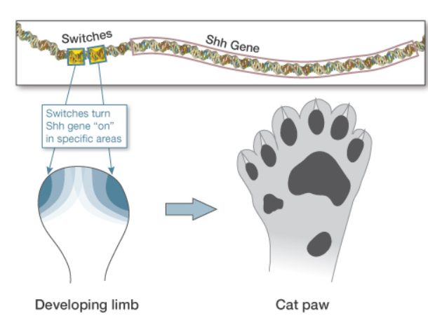  - What changed in the DNA?  “single-base change outside the protein-coding sequence of the Shh gene (cut and pasted)”  What is that?  Look back in the mutation info!!!  https://learn.genetics.utah.edu/content/basics/mutation/  Or google it!!  “Types of genetic mutation” |  |  | EMERGING
- Inheritable genetic variations may result from new genetic combinations through meiosis, DNA replication, and/or mutations caused by environmental factors.  - Defend your claim by including the type of protein and cells affected.  Grist  2 .  “The affected protein in extra-toed cats is sonic hedgehog (SHH) … SHH is a signaling protein normally made by cells on just the pinky side of the developing foot. As the toes form, their number and identity depend on their exposure to SHH protein.”  Defend claim  A mutation to the SHH will increase the number of toes. |  |  | DEVELOPING
- Use evidence to defend your claim that inheritable genetic variations may result from new genetic combinations through meiosis, DNA replication, and/or mutations caused by environmental factors.  - How does a difference in the DNA sequence (genotype) lead to a difference in an observable trait (phenotype)?  - Is this mutation helpful, harmful, or neutral for the organism?  Grist  # A mutation to the SHH gene (a gene that codes for the feet in cats) resulted in a new genetic combination that through meiosis and mitosis effects the number of toes a cat has. The difference in the DNA sequence lead to a difference in the observable traits of the foot on a cat.  Dot The mutation caused the SHH to code for 6 toes instead of the normal 5. This mutation is neutral ( for the organism. |  |  | PROFICIENT
- Predict a plausible environmental factor, which would lead to this mutation being beneficial.  - How would this mutation influence variation within the population?  - Would the mutation be an advantageous trait?  - Use words, beneficial, harmful, neutral, fitness, reproductive advantage, or any evolution vocab.  Grist  #  This mutation may become beneficial if a threat caused the kittens to need extra grip in order to survive. The extra toe may assist in the kitten’s ability to grip and therefore survive; This mutation influences variation within the population by introducing a new phenotype that does not interfere with the cat’s normal life.  The fact that most people do not want weird looking cats makes this makes the trait to be mostly non-advantageous. |  |  | EXEMPLARY
TEACHER FEEDBACK | STUDENT FEEDBACK

Option 2: 4a

4a: I can develop a claim with supporting evidence to predict different environmental factors which influence variation within populations.

Create a card game (matching, spoons, go fish…) that has 4 cards for 5 of the mutations (20 cards total will be the “deck of cards” for your game). Follow this format for the cards to match:
Each card: picture of the organism with the trait (printed or drawn) in the upper left hand corner
1st card: name of organism and trait affected
2nd card: affected protein with type of mutation
3rd card: physical (phenotypical) effects of mutation
4th card: predict an environmental factor that would make this trait beneficial.

Task | Met | Not Met | Scoring Criteria
Write a claim and defend with evidence that describes types of genetic variations and how they occur.  - What type of mutation and how does it occur? |  |  | EMERGING
Inheritable genetic variations may result from new genetic combinations through meiosis, DNA replication, and/or mutations caused by environmental factors.  - Defend your claim by including the type of protein and cells affected. |  |  | DEVELOPING
Use evidence to defend your claim that inheritable genetic variations may result from new genetic combinations through meiosis, DNA replication, and/or mutations caused by environmental factors.  - How does a difference in the DNA sequence (genotype) lead to a difference in an observable trait (phenotype)?  - Is this mutation helpful, harmful, or neutral for the organism? |  |  | PROFICIENT
Predict a plausible environmental factor which would lead to this mutation being beneficial.  - How would this mutation influence variation within the population?  - Would the mutation be an advantageous trait? |  |  | EXEMPLARY
TEACHER FEEDBACK | STUDENT FEEDBACK

Option 3: 4b

4b: I can model and predict changes in the frequency of traits in a population based on environmental or genetic pressures.

Create a dihybrid cross (big Punnett square) and a pedigree for a trait that exists in your family. Predict which genotype/phenotype would be more beneficial based on an environmental or genetic pressure.

Task | Met | Not Met | Scoring Criteria
Dihybrid cross and pedigree drawn correctly.  - Dihybrid cross requires two traits  - Pedigree can be one trait (Grandparents, Parents, kids)  - Must have a KEY |  |  | EMERGING
Use probability and statistics to find the variation and distribution of expressed traits in a population.  - What kind of inheritance pattern does the trait follow.  - Genotype frequencies  - Phenotype frequencies |  |  | DEVELOPING
Apply the probability and statistics to EXPLAIN the variation and distribution of expressed traits in a population.  - Write a paragraph that explains your genotype and phenotype frequencies and how they will affect the population in the future. |  |  | PROFICIENT
Make a prediction regarding the changes in the frequency of the traits in a population based on an environmental or genetic pressure.  - What is the environmental or genetic pressure?  - How will the frequency of the trait change? |  |  | EXEMPLARY

