**Waves and Sound**

The two biggest waves students will encounter are sound waves (compression or longitudinal waves) and waves on a string (transverse waves). For all waves, the formula, wavelength = velocity / frequency, applies. It is important to see the equation written this way because:

1) the velocity is a property of the medium and can only change if the medium is changed in some way (ex: tightening a string will increase the wave velocity)

2) frequency is a property of the wave source and can only be changed if the source changes.

Neither of these things depends on the other. The wavelength, however, is dependent on both the frequency and velocity. The only notable exception is a setup in which the string length is fixed, like a stringed instrument. In that case, the wavelength will not change, so the velocity and frequency will--but both changes will still be from the medium and source respectively.

When two waves meet in the same medium, their amplitudes add. When the crests are in phase, the amplitude increases (constructive interference). When the crests are out of phase, the amplitude decreases (destructive interference). Wave interference affects the medium, but not the wave. Interfering waves will pass through each other without changing.

Beat frequency occurs when two waves with near, but not identical frequencies, meet in a medium. The interference pattern between the two results in a repeated high amplitude and low amplitude wave.

The doppler shift is a change in the perceived frequency of a wave based on movement of either the wave source or the observer. As the source moves, waves in the direction of the motion are pressed together in the medium, resulting in a lower wavelength and a higher frequency. Waves behind the source are stretched out and the frequency is lower. The shift in frequency depends only on the velocity of the source. If the source is moving with a constant velocity, the frequency is shifted by a constant amount.

A standing wave forms on an object when the right size and shape of a wave fits into the object and it resonates. A free or open end on an object will resonate with an antinode. A fixed or closed end will resonate with node. The fundamental frequency of an object is the lowest frequency/ largest wavelength that will fit onto an object. As the number of harmonic increases, so do the number of waves that fit onto an object. When looking at standing wave forms, one lobe or segment is half of a wave. A "V" shape is a quarter of a wave (half of a segment). Strings fixed at both ends and tubes open at both ends will resonate with multiples of half of a wave. Tuning forks, fixed at one end and free at the other, and tubes open at one end and closed at the other resonate with multiples of quarter waves.

**Multiple Choice:**

1. The wavelength of a wave is 0.25 m, and its frequency is 960 Hz. The speed of the wave is
2. 40 m/s
3. 60 m/s
4. 120 m/s
5. 240 m/s
6. 360 m/s
7. Assume that waves are propagating in a uniform medium. If the frequency of the wave source doubles, then
8. The wavelength of the waves halves
9. The wavelength of the waves doubles
10. The speed of the waves halves
11. The speed of the wave doubles
12. 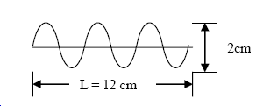The diagram below represents a wave propagating along a string at a speed of 360 cm/s. The frequency of the wave is
13. 50 Hz
14. 90 Hz
15. 360 Hz
16. 720 Hz
17. 1080 Hz
18. Consider the following properties of waves.

I. Frequency

II. Wavelength

III. Speed

Which of the above properties change as a wave changes medium?

1. I only
2. II only
3. I and II only
4. II and III only
5. I, II, and III
6. A violinist is tuning the A string on her violin by listening for beats when this note is played simultaneously with a tuning fork of frequency 440 Hz. She hears a beat frequency of 4 Hz. She notices that, when she increases the tension in the string slightly, the beat frequency decreases. What was the frequency of the mistuned A string?
7. 448 Hz
8. 444 Hz
9. 436 Hz
10. 432 Hz
11. 438 Hz

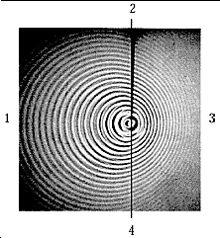

1. The object shown in the figure is
2. traveling from 2 toward 4.
3. traveling from 3 toward 1.
4. traveling from 1 toward 3.
5. traveling from 4 toward 2.
6. not in motion.
7. A student is making a wave in a spring by moving her hand back and forth two times each second. She then increases the rate to three times back and forth each second. At the increased rate, which of the following statements is true?
8. The velocity of the wave also increases.
9. The wavelength of the wave also increases.
10. The frequency of the wave stays the same.
11. The velocity of the wave stays the same
12. A 4-m long string, clamped at both ends, vibrates at 200 Hz. If the string resonates in four segments, what is the speed of the waves on the string?
13. 100 m/s
14. 133 m/s
15. 267 m/s
16. 328 m/s
17. 400 m/s

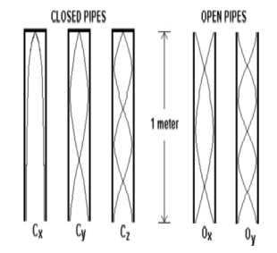

1. The diagrams provided represent five different standing sound waves set up inside of a set of organ pipes 1 m long. Which of the following statements correctly relates the frequencies of the organ pipes shown? Select two answers.
2. Cy is twice the frequency of Cx
3. Oy is twice the frequency of Ox
4. CZ is five times the frequeny of Cx
5. Ox is four times the frequency of Cx
6. A standing wave pattern is created on a guitar string as a person tunes the guitar by changing the tension in the string. Which of the following properties of the waves on the string will change as a result of adjusting only the tension in the string? Select two answers.
7. The speed of the traveling wave that creates the pattern
8. The wavelength of the standing wave
9. The frequency of the standing wave
10. The amplitude of the standing wave

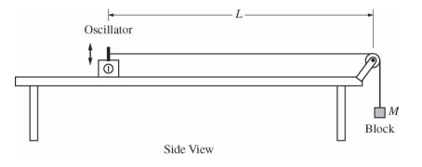**Free Response**

1. 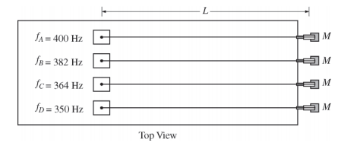The figure above shows a string with one end attached to an oscillator and the other end attached to a block. The string passes over a massless pulley that turns with negligible friction. Four such strings, A, B, C, and D, are set up side by side, as shown in the diagram below. Each oscillator is adjusted to vibrate the string at its fundamental frequency f. The distance between each oscillator and pulley L is the same, and the mass M of each block is the same. However, the fundamental frequency of each string is different.

The equation for the velocity v of a wave on a string is $v= \sqrt{\frac{F_{T}}{m/L}}$, where FT is the tension of the string and m/L is the mass per unit length (linear mass density) of the string.

1. What is different about the four strings shown above that would result in their having different fundamental frequencies? Explain how you arrived at your answer.
2. A student graphs frequency as a function of the inverse of the linear mass density. Will the graph be linear? Explain how you arrived at your answer.
3. 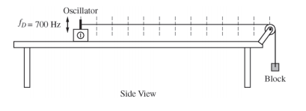The frequency of the oscillator connected to string D is changed so that the string vibrates in its second harmonic. On the side view of string D below, mark and label the points on the string that have the greatest average vertical speed.

Answers: <https://governscience.weebly.com/uploads/5/7/0/9/57096571/waves_and_sound_fr_key.pdf>



1. To demonstrate standing waves, one end of a string is attached to a tuning fork with frequency 120 Hz. The other end of the string passes over a pulley and is connected to a suspended mass M as shown in the figure above. The value of M is such that the standing wave pattern has four "loops." The length of the string from the tuning fork to the point where the string touches the top of the pulley is 1.20 m. The linear density of the string is 1.0 x 10–4 kg/m, and remains constant throughout the experiment.
2. Determine the wavelength of the standing wave.
3. Determine the speed of transverse waves along the string.
4. The speed of waves along the string increases with increasing tension in the string. Indicate whether the value of M should be increased or decreased in order to double the number of loops in the standing wave pattern. Justify your answer.
5. If a point on the string at an antinode moves a total vertical distance of 4 cm during one complete cycle, what is the amplitude of the standing wave?