Murder By Meal Lab
Question: Which restaurant is responsible for killing your favorite Biology teacher?
Hypothesis: If _______________________________________, then ____________________
____________________________ because ________________________________________
____________________________________________________________________________
Materials:
- Lipid Test Station:

- Carbohydrate Test Station:

- Protein Test Station:

Procedure:
Lipid Test

Protein Test

Carbohydrate—Glucose Test

Carbohydrate—Starch Test

Results:
Table 1 LIPID TEST
Food Samples | Lipid Present | Lipid Not Present
Oil
Candy
Potato
Egg White

CARBOHYDRATE TEST
Food Samples | Glucose Present | Starch Present
Celery
Potato
Candy
Egg White

PROTEIN TEST
Food Samples | Protein Present | Protein Not Present
Celery
Egg White
Potato
Oil

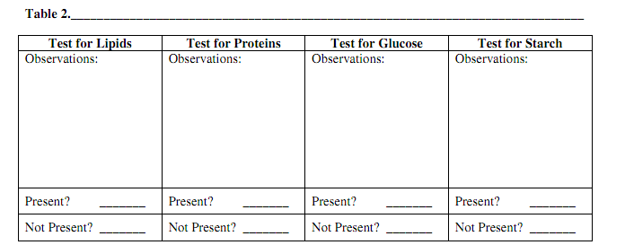
Analysis:
When I performed this experiment I observed that the vomit contained the following organic macromolecules: ______________________________________________________________
________________________________________________________________________________________________________________________________________________________
Conclusion:
I conclude the science teacher ate at this restaurant last night: __________________________
I know this because ____________________________________________________________
____________________________________________________________________________
This is beneficial to the real world because:
- What does your body need lipids for?________________________________________
- What does your body need protein for?_______________________________________
- What does your body need carbohydrates for?_________________________________
Bonus: How can you extend this lab to test a related question in the future? _______________
________________________________________________________________________________________________________________________________________________________

