8/30 and 8/31 classwork
Grist Physics 2021
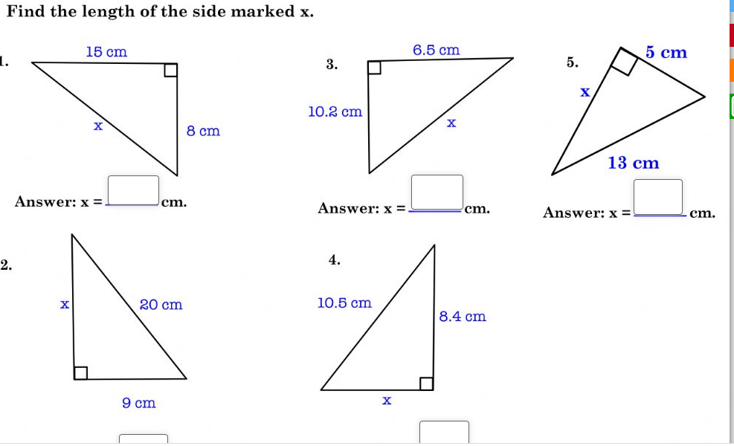

Basic trigonometry (watch before doing second page)
https://www.khanacademy.org/math/geometry/hs-geo-trig/hs-geo-trig-ratios-intro/v/basic-trigonometry

