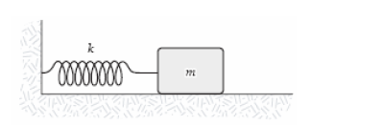
- A mass m = 2.0 kg is attached to a spring having a force constant k = 290 N/m as in the figure. The mass is displaced from its equilibrium position and released. Its frequency of oscillation (in Hz) is approximately…

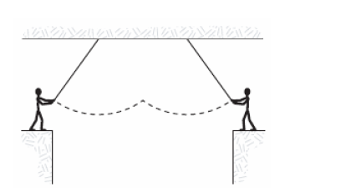

____ 2**. Two circus clowns (each having a mass of 50 kg) swing on two flying trapezes (negligible mass, length 25 m) shown in the figure. At the peak of the swing, one grabs the other, and the two swing back to one platform.
The time for the forward and return motion is…

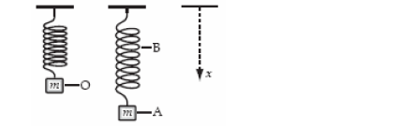
____ 3. A weight of mass m is at rest at O when suspended from a spring, as shown. When it is pulled down and released, it oscillates between positions A and B. Describe why each statement is correct or incorrect. NOT a multiple choice question!!
a. The gravitational potential energy of the system is greatest at A.
b. The elastic potential energy of the system is greatest at O.
c. The rate of change of momentum has its greatest magnitude at A and B.
d. The rate of change of gravitational potential energy is smallest at O.
e. The rate of change of gravitational potential energy has its greatest magnitude at A and B.

*** 4. A graph of position versus time for an object oscillating at the free end of a horizontal spring is shown below. 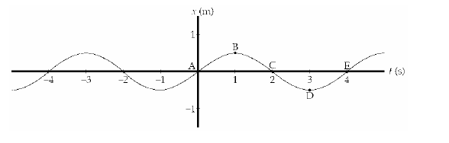
Describe acceleration, velocity, and energies at each point.
ABCDE

