Rotation partner Quiz 2/3/2020

1) When a rigid object rotates about a fixed axis, what is true about all the points in the object? (There could be more than one correct choice.)
A) They all have the same tangential acceleration.
B) They all have the same angular speed.
C) They all have the same angular acceleration.
D) They all have the same tangential speed.
E) They all have the same radial acceleration.

2) Two children, Ahmed and Jacques, ride on a merry-go-round. Ahmed is at a greater distance from the axis of rotation than Jacques. Which of the following are true statements? (There could be more than one correct choice.)
A) Jacques and Ahmed have the same angular speed.
B) Ahmed has a greater tangential speed than Jacques.
C) Jacques has a greater angular speed than Ahmed.
D) Jacques has a smaller angular speed than Ahmed.
E) Jacques and Ahmed have the same tangential speed.

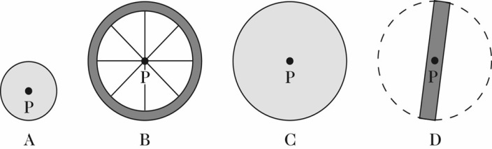
3) The figure shows scale drawings of four objects, each of the same mass and uniform thickness, with the mass distributed uniformly. Which one has the greatest moment of inertia when rotated about an axis perpendicular to the plane of the drawing at point P?
A) A
B) B
C) C
D) D
E) The moment of inertia is the same for all of these objects.

4) A chicken is running in a circular path with an angular speed of 1.52 rad/s. How long does it take the chicken to complete one revolution?
A) 4.77 s
B) 2.07 s
C) 8.26 s
D) 4.13 s
E) 118 s

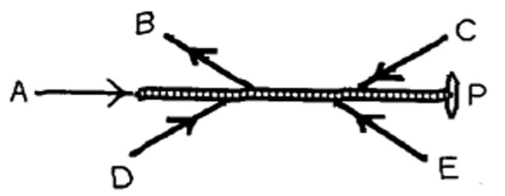
5) Five forces act on a rod that is free to pivot at point P, as shown in the figure. Which of these forces is producing a counter-clockwise torque about point P?
A) force A
B) force B
C) force C
D) force D
E) force E
6) A string is wound tightly around a fixed pulley having a radius of 5.0 cm. As the string is pulled, the pulley rotates without any slipping of the string. What is the angular speed of the pulley when the string is moving at 5.0 m/s?
A) 100 rad/s
B) 10 rad/s
C) 25 rad/s
D) 20 rad/s
E) 50 rad/s

7) A cinder block of mass m = 4.0 kg is hung from a nylon string that is wrapped around a frictionless pulley having the shape of a cylindrical shell, as shown in the figure. If the cinder block accelerates downward at 4.90 m/s2 when it is released, what is the mass M of the pulley?
A) 6.0 kg
B) 8.0 kg
C) 4.0 kg
D) 10 kg
E) 2.0 kg

8) A wheel accelerates from rest to 59 rad/sec at a uniform rate of 58 rad/s². Through what angle (in radians) did the wheel turn while accelerating?
A) 24 rad
B) 30 rad
C) 60 rad
D) 38 rad

9) A man in a gym is holding an 8.0-kg weight at arm's length, a distance of 0.55 m from his shoulder joint. What is the torque about his shoulder joint due to the weight if his arm is horizontal?
A) 0.24 N ∙ m
B) 43 N ∙ m
C) 15 N ∙ m
D) 4.4 N ∙ m
E) 0 N ∙ m

10) If you're on a Ferris wheel at a carnival, seated 10 m from the Ferris wheel's axis that makes a complete rotation each minute, your linear speed is
A) 10 m/min.
B) 100 m/min.
C) 31.4 m/min.
D) 62.8 m/min.
E) Need more information

