Pig Practical Review
Class: Mammalia
Latin Name: Sus scrofa
https://www.biologycorner.com/pig/review.html

Locations
- Anterior
- Posterior
- Dorsal
- Ventral
- Medial
- Lateral
- Proximal
- Distal
- Sagittal plane
- Frontal plane
- Transverse plane
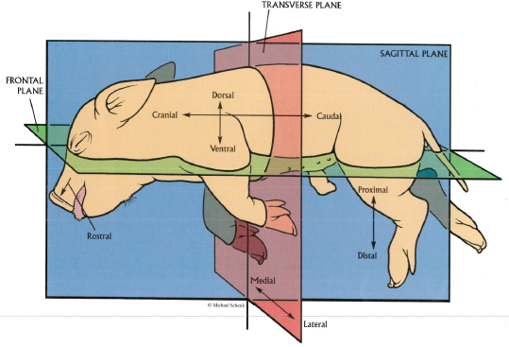

You must be able to identify the function, and location of the following:

External
- Urogenital papilla
- External nares
- Pinna
- Umbilical cord
- Vibrissae
- Nictitating membrane
- Anus

Mouth
- Hard palate
- Soft palate
- Oral papillae
- Epiglottis
- Pharynx
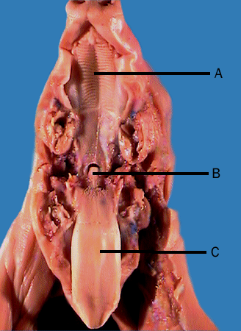

Neck
- Esophagus
- Trachea
- Larynx
- Jugular vein
- Carotid artery
- Thyroid gland

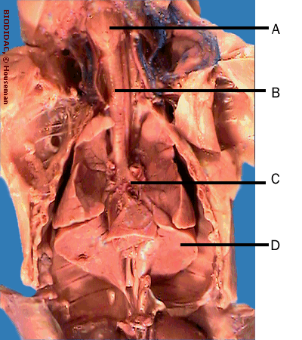

Abdominal Cavity
Digestive
- Esophagus (Neck)
- Stomach
- Small intestine (duodenum/jejunum/ ileum)
- Large intestine (Cecum/colon/rectum)
- Liver
Spleen
- Gallbladder
- Pancreas

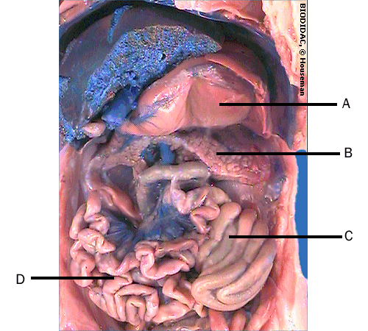
Urinary
- Ureter
- Kidney
- Bladder
- Urethra

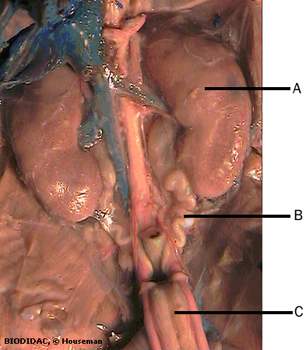

Reproductive
- Ovaries
- Oviduct (fallopian tubes)
- Uterus
- Vagina
- Testes

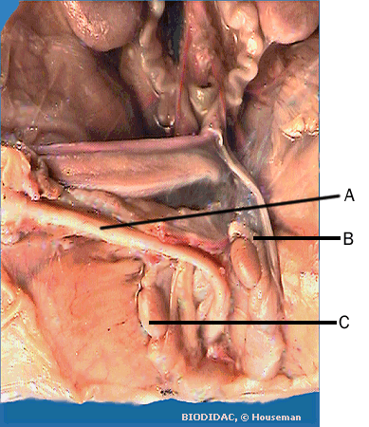

Thoracic Cavity
- Heart
- Pericardium
- Right atrium
- Left atrium
- Right ventricle
- Left ventricle
- Coronary artery
- Vena cava
- Aorta
- Lungs
- Pulmonary trunk
- Diaphragm
- Thymus gland

