Liquids Review Sheet: Ch. 19 2017
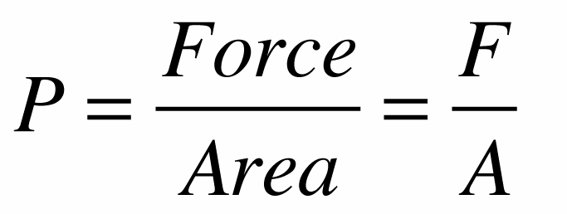
Equation for pressure:
If a weighted, air-filled balloon begins to sink in a lake, it will…
F_{g}>F_{b} by a little when the balloon isn’t very deep. F_{g}>F_{b} even more because balloon increases in depth and the balloon becomes smaller and smaller in size due to the increase. Pressure squishes balloon.
There is a net force on the balloon because the F_{g}>F_{b}. The net force increases because the buoyant force decreases as the balloon increases its depth. There’s less buoyant force because the volume of the balloon gets smaller.
The balloon will sink faster and faster because the net force is increasing. Thus, it is accelerating down.
Why does a life jacket help you float?
Because it decreases the object’s overall density; it increases the volume without increasing the volume significantly.
Problems like Clay Boat Lab (all)
- Weight in water ______N
The object’s actual weight (not mass) minus the F_{b}
F_{b} is the object’s apparent weight loss (weight out of water minus weight in water)
- Weight out of the water_____N
Object’s normal weight (not mass)
Rank the weight of the buckets if they were full to the top with water and…
- Just full of water…
- Full of water and a floating block of wood
- Full to the top with a sunken rock
1=2 because block is floating and displaced amount of water equal to its weight.
3 weighs the most because it displaces an amount of water equal to its volume (because it sank) which is a lot less than the amount of water displaced that’s equal to its weight.
Floating block and sunken block (identical volumes). Which has the greater…
- Buoyant force
The sunken block because it displaces an amount of water equal to ts volume.
The weight of this displaced water is equal to the buoyant force.
- Volume of water displaced
The sunken block because displaced an amount of water equal to its volume.
- Weight of water displaced
The sunken block because displaced it displaces a volume of water equal to its volume which is more than the floating object because not all of the floating object is under water. This greater volume of water weighs more.
- Density
The sunken block because displaced an amount of water equal to its volume
An elephant or someone wearing high heels stomps on your foot. Explain in terms of pressure, force, and area which is worse.
The high heel is worse because it is applying less force, but over a significantly smaller area making the pressure much greater (refer back to equation for pressure). F/A (elephant) = P = F/A (highheel). The high heel would hurt more because it is more concentrated in a smaller area.
Bullets
bounce off you when you wear a bulletproof vest. This causes twice the force during impact. Using the terms pressure, force, and area, explain why the vest is a good idea.
You absorb the force over a greater amount of area, so it is less pressure. Wearing the vest might be more force, but that force is applied to you over a much greater area, so the pressure becomes less. Bullet proof vests decrease the pressure.
Neutral buoyancy: when the object’s density equals the fluid’s density, so wherever you place it in the liquid it will neither sink nor float.
Two things achieve neutral buoyancy:
Fish (naturally) by use of a swim bladder. They change their density by changing their volume.
Submarines (unnaturally) change their density by changing their mass.
Canoe/cargo scenarios thrown overboard, first graders with floaties… What happens to the level of the pool when...?
- Thrown into water
Stays the same because they’re floating so they’re displacing an amount of water equal to their weight.
- Thrown onto shore
Lowers because the kids are no longer in the water.
- Let go of balloons
rises

- Styrofoam cat
same

- Lead cats
lowers

- Shark jumps in
same
- Students pee over the side
same
- Barrel of water
same

Ice in a glass of ice water, when ice melts what happens to the level of the water?
same
Changing the density of the liquid, what happens to the buoyant force when floating?
same
How can an iron boat float?
Displace more water
Hydraulic press

Which piston moves more? Why?
The smaller piston because it has to displace an equal amount of water that the big piston does in a smaller amount of area. It depends on how much force is applied on either side.
Equation: F/A = F/A
The water distributes the pressure equally throughout. The little piston has to displace an equal amount of water that the big piston does, but the amount of water moved is the same.
The deeper you go in water…
- Everyone knows the pressure increases. Why?
Because there’s more water on top of you the deeper you go.

- What happens to your buoyant force? Why? same
The difference in pressure doesn’t change so it stays the same.
The difference in pressure between the top of an object and the bottom remains the same

A kg of something dense and something not dense. Which has the greater buoyant force?
The less dense thing is experiencing more buoyant force because it is ea greater volume and is displacing more water.

