Directions: Read Chapter 14, pages 392-407 and carefully answer each question.

During presentation: typer,
- Page 392
Earth’s Early Environment | Earth’s Current Environment
Atmosphere 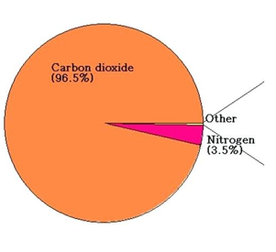  Mostly CO2… no O₂ | atmosphere:  80% nitrogen, 20% O₂  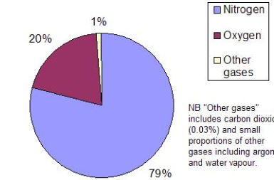
Lots of volcanoes | Less active volcanoes
Cooling interior radiated a lot of heat | Warm surface that enables life to thrive
Lots of meteorites crashed onto the surface | Less meteorites
3.8 billion years ago, water filled the basins that are now our oceans. | 71% of surface covered in ocean
Life just getting started? | Large diversity of life exists

- How are fossils formed?
Fossils are formed in sedimentary rock when an organism dies and is buried in sediments.
- The age of fossils is determined by what techniques?
Relative dating: compares rocks with different layers.
Radiometric dating: uses decay of isotopes.
- How is the Geologic Time Scale organized?
Eon, Era, Period, Epoch, MYA, Biological
- When were the 5 mass extinctions?
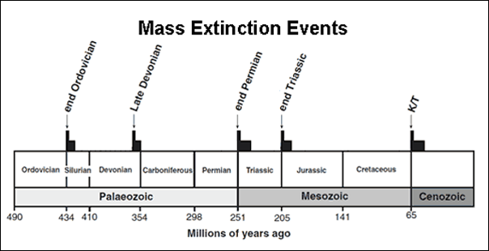

- Which major group of organisms arose after each mass extinction?
1: land plants, Insects, Tetrapods, sharks, and boney fish.
2:Amphibians, Gymnosperms appear. 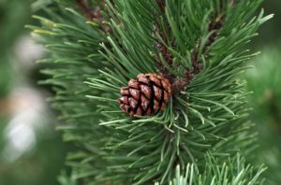
3:Mamals appear, Dinosaurs appear,
4: Birds appear, Flowers appear
5:The KT boundary: Monkeys appear, Humans appear, Hominins Appear, apes appear.

- When was the Precambrian? What major events happened during this time?
Page number 398
First animal life started to originate during this eon
Not visible on the time scale

- When was the Paleozoic Era? What was Earth like during this time?

The Paleozoic Era occurred about 541 million years ago, and ended about 299 million years ago. The Paleozoic era started very cold, mostly frozen. Then got warmer and it ended with very high temperatures.
- Aquatic life
- Amphibian life
- Reptiles
- Cambrian explosion
- Guys your on your own for the rest

- When was the Mesozoic Era? What major events happened during this time?

- When was the Cenozoic Era? What was Earth life during this time?

