Directions: Read Chapter 14, pages 392-407 and carefully answer each question. gristcatranch.weebly.com
Biology-> ecology-> p7 history of the earth answers
- ON THE BACK MAKE A T-CHART that describes the similarities and differences between Earth’s early
environment and Earth’s current environment?

Earth’s Early Environment | Earth’s Current Environment
Atmosphere 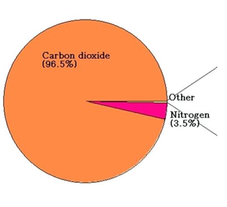  Mostly CO2… no O₂ | atmosphere:  80% nitrogen, 20% O₂  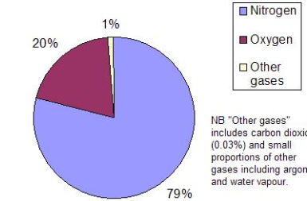
Lots of volcanoes | Less active volcanoes
Cooling interior radiated a lot of heat | Warm surface that enables life to thrive
Lots of meteorites crashed onto the surface | Less meteorites
3.8 billion years ago, water filled the basins that are now our oceans. | 71% of surface covered in ocean
Life just getting started? | Large diversity of life exists

- How are fossils formed?
P.394
Fossils are formed when sediment covers an organism and it is preserved. In some cases, minerals will replace organic matter. In other cases, an impression of a body is left behind.

- The age of fossils is determined by what techniques?
Relative dating it is by layers of rock it’s like a newspaper at the bottom are all old at the top are new pg 394
- How is the Geologic Time Scale organized?
Pg.396 records of earth’s history and major geological and biological events. Eon big one, era seconds biggest, period are split up in the eras epochs last several million years
- When were the 5 mass extinctions?

Pg.397 see book
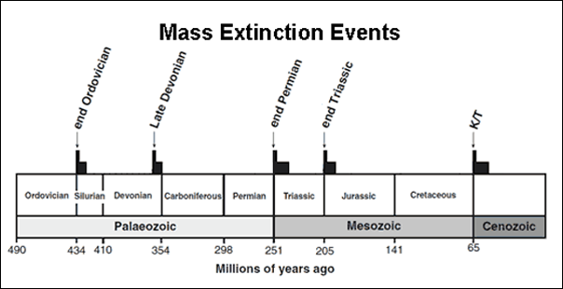
- Which major group of organisms arose after each mass extinction?
Pg. 397
Extinctions oldest to most recent:
1- land plants and insects and fish
2- Reptiles
3-dinosaurs, mammals, flowers
4- Birds
5- (KT extinction) Monkeys, apes, and humans

- When was the Precambrian eon? What major events happened during this time?

Pg 398
4.6 billion years ago - Earth was Made
4.5 Billion years ago – Moon formed
4.2 Billion years ago – Life was born
3.2 Billion years ago – Tectonic Plates formed

- When was the Paleozoic Era? What was Earth like during this time?
Pg 398 mass extinction – 90% of marine life
Meteorite impact evolving birds
Life on land and huge insects evolved

- When was the Mesozoic Era? What major events happened during this time?
Pg 399 Triassic Jurassic cretaceous kt mass extinction majority of animals

- When was the Cenozoic Era? What was Earth life during this time?
Pg 397 55.8 mya to .01 mya. Tropical climate. Monkeys, apes, plants started to appear. Ice ages occur. Humans form civilizations.

1.Rocks
2. fossils
3. living things (plants and animals)

- minerals
- organic matter
- minerals replacing organic matter

