Linear Motion Review
- Definition of speed vs. Velocity
Velocity is speed with direction, speed is the magnitude of velocity
- Units and equations for speed and velocity (non-accelerated)
Speed = distance/time and the units are m/s
- Instantaneous speed versus average speed
Instantaneous = speed at 1 moment
Average = speed over a period of time
- Definition and examples of Acceleration
Speeding up, slowing down, changing direction, the ball starts slow and goes faster and faster
- A turtle going at a constant speed of 4 meters per second, that’s a damn fast turtle, what’s its speed at one sec? Five seconds? An hour?
4 m/s
4 m/s
4 m/s it’s the same speed duh that’s what constant means
- b How far would that same turtle go after one second? Two seconds? Three seconds?
1-4m
2-8m
3-12m
- The turtle falls into a hole towards turtle hell, how fast would it be falling at one second? Two seconds? Three seconds?
- 10m/sec
- 20 m/sec
- 30m/sec
6. b How far does the falling turtle fall from the top of the hole at one second. Two seconds? Three seconds? d=1/2gt^2
1 sec – 5 m
2 sec- 20m
3sec- 45 m
7. Describe the acceleration and velocity as an object falls (constant, increasing, decreasing, blah blah blah) acceleration is constant and velocity is increasing
8. Hammer and feather video demonstrates what
Without air resistance objects will fall independent of their weight
- What would happen in the video if there was air on the moon?
The hammer would fall much faster than the feather
- Reproduce the chicken and cheetah diagram from memory, include distance and velocity.
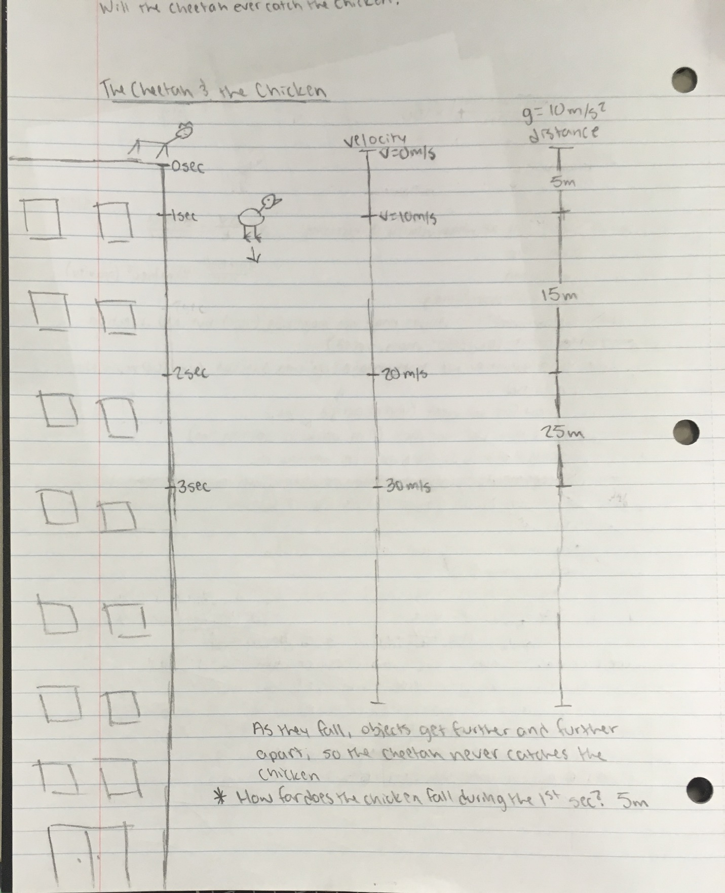
- How high would you need to jump to get a four second hang time?
d=1/2gt^2 d=20m
12. Draw a picture of a projectile and indicate the speed at the top where the speed is maximum, minimum.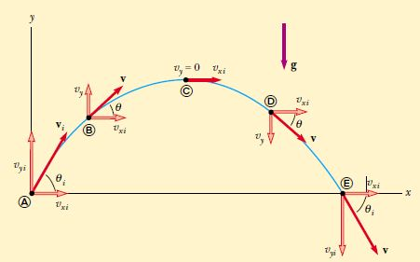
13. At the top of a projectile’s path, the velocity is ___0m/s___and the acceleration is__10m/s/s___ in the y-direction. What are they in the X-direction?

1) Consider a car that travels between points A and B. The car's average speed can be greater than the magnitude of its average velocity, but the magnitude of its average velocity can never be greater than its average speed. 1) ___true___

A) True B) False

2) Which of the following quantities has units of a velocity?

A) 186,000 mi
B) 120 m/s it doesn’t have direction
C) 9.8 m/s² downward
D) 40 km southwest
E) 9.8 m/s downward- cuz speed with direction

3) When is the average velocity of an object equal to the instantaneous velocity? 3) ___e____
A) only when the velocity is decreasing at a constant rate
B) never
C) always
D) only when the velocity is increasing at a constant rate
E) when the velocity is constant

4) You drive 6.0 km at 50 km/h and then another 6.0 km at 90 km/h. Your average speed over the 12 km drive will be 4) ___d____

A) greater than 70 km/h.
B) equal to 70 km/h.
C) exactly 38 km/h.
D) less than 70 km/h.

5) If the velocity of an object is zero at some point, then its acceleration must also be zero at that point. 5) ___b____

A) True B) False

6) Which of the following situations is impossible? - trick question theyre all possible
A) An object has constant non-zero acceleration and changing velocity.- speeding up
B) An object has constant non-zero velocity and changing acceleration.- could be turning
C) An object has velocity directed east and acceleration directed west.- throwing a ball in the wind
D) An object has zero velocity but non-zero acceleration.- gravity affecting an object
E) An object has velocity directed east and acceleration directed east.- a car speeding up

7) If the acceleration of an object is zero, then that object cannot be moving. 7) ___b____ex. Anything going at a constant speed
A) True B) False

8) Suppose that an object is moving with a constant velocity. Which statement concerning its acceleration must be correct? 8) ___b____

A) The acceleration is a constant non-zero value.
B) The acceleration is equal to zero.
C) The acceleration is constantly increasing.
D) The acceleration is constantly decreasing.

*The people who made this poster should have shown the OG equation and manipulated equation with their Answer(calculation).*
9) Did you make this poster
a) yes
b) no
