Linear motion FRQ fall 2018
Now I’m running… Please illustrate
There, I have escaped…
The first meters of a 100-meter escape run by a cat are covered in 2 seconds by a cat who starts from rest and accelerates with a constant acceleration away from the cat catcher. The remaining 90 meters are run with the same velocity the cat had after 2 seconds. a. 4 pts Determine the cat's constant acceleration during the first 2 seconds. b. 4 pts Determine the cat’s velocity after 2 seconds have elapsed. c. 4 pts Determine the total time needed to run the full 100 meters. d. 3 pts Draw the displacement vs time curve for the escaped cat. e. Could you catch this cat?

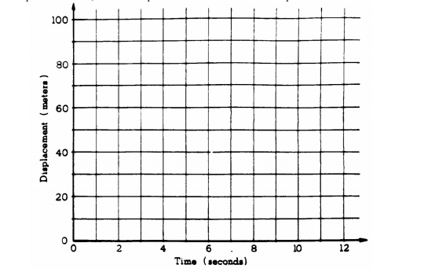

Could you catch this cat?

