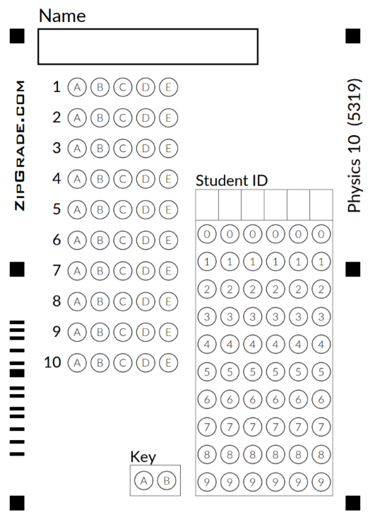
Test: Kinematics 2

Free Response:
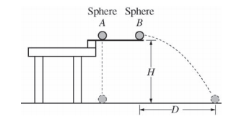
1.Two identical spheres are released from a device at time t = 0 from the same height H, as shown above. Sphere A has no initial velocity and falls straight down. Sphere B is given an initial horizontal velocity of magnitude v_{o} and travels a horizontal distance D before it reaches the ground. The spheres reach the ground at the same time t_{f}, even though sphere B has more distance to cover before landing. Air resistance is negligible.

(a) On the axes below, sketch and label a graph of the vertical component of the velocity of sphere A and of sphere B as a function of time.
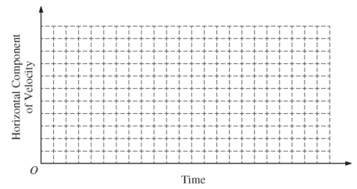
Vertical Component of Velocity

(b) On the axes below, sketch and label a graph of the horizontal component of the velocity of sphere A and of sphere B as a function of time.
(c) Explain why the spheres reach the ground at the same time even though they travel different distances.

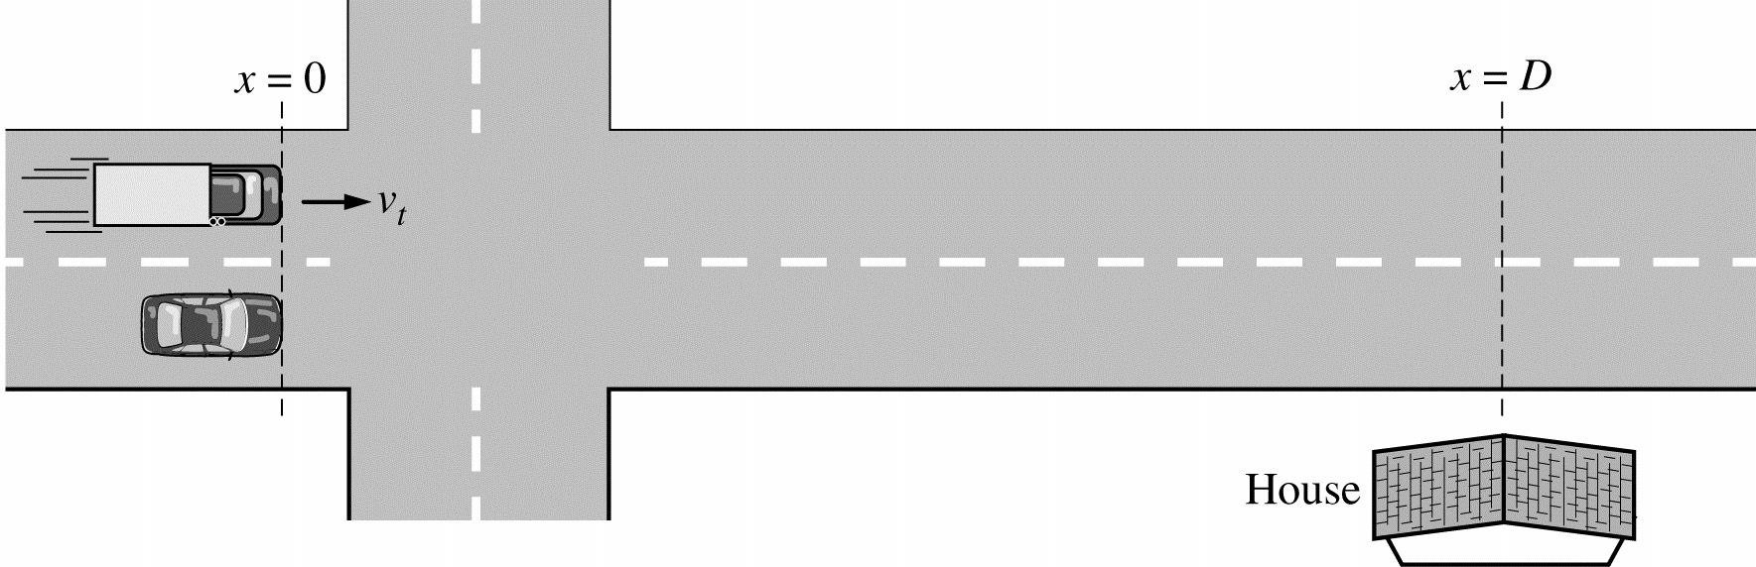

2. A car is stopped at a traffic light. The light turns green, and at time t = 0 the car starts moving and travels with a constant acceleration. At that instant a truck traveling at constant speed v_{t} alongside the car, with the front of each vehicle at position x = 0, as shown above. The truck passes the car, but the car later catches up to the truck in front of a house, such that at time t_{D} the front of each vehicle is at position x = D.

  - On the axes below, sketch and label graphs of the velocity of the car and the velocity of the truck as a function of time. Indicate any important velocities or times.

  - Two students are discussing how the speed of the car compares to the speed of the truck when both vehicles are in front of the house.
Student 1 says, “The distance traveled by the car and the truck is the same, and the time is the same, so they must have the same speed.”
Student 2 says, “I don’t see how that can be. The car catches up to the truck, so the car has to be going faster.”

    - Which aspects of Student 1’s reasoning, if any, are correct? Support your answer in terms of relevant features of your graphs in part (a).

    - Which aspects of Student 2’s reasoning, if any, are correct? Support your answer in terms of relevant features of your graphs in part (a).

  - Derive an expression for the acceleration of the car. Express your answer in terms of D and vt .

  - Determine the time at which the speed of the car is equal to the speed vt of the truck. Express your answer in terms of tD . Justify your answer.
Multiple Choice B
1. A small cart is rolling freely on an inclined ramp with a constant acceleration of 0.50 m/s² in the negative x-direction. At time t=0 , the cart has a velocity of 2.0 m/s in the +x-direction. If the cart never leaves the ramp, which of the following statements correctly describes the motion of the cart at t > 5 s?
a. The cart is travelling in the +x-direction and is speeding up.
b. The cart is travelling in the +x-direction and is slowing down.
c. The cart is travelling in the -x-direction and is speeding up.
d. The cart is travelling in the -x-direction and is slowing down.

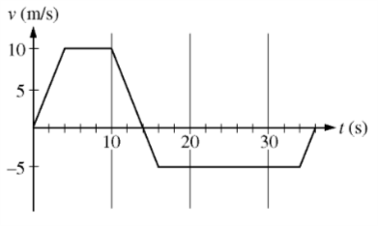
2. An object’s velocity v as a function of time t is given in the graph above. Which of the following statements is true about the motion of the object?
a. The object’s initial and final positions are the same.
b. The object is not moving from t =4 s to t = 10 s.
c. The object is slowing down from t = 14 s to t = 16 s.
d. The average acceleration of the object from t = 0 s to t = 4 s is different from the acceleration from t = 34 s to t = 36 s.

3. A kitten sits in a lightweight basket near the edge of a table. A person accidentally knocks the basket off the table. As the kitten and the basket fall, the kitten rolls, turns, kicks, and catches the basket in its claws. The basket lands on the floor with the kitten safely inside. If air resistance is negligible, what is the acceleration of the kitten-basket system while the kitten and basket are in midair?
a. the acceleration is directed downward with magnitude less than g because the basket is light.
b. the acceleration is fluctuates because of the rolling, turning, and kicking motion of the kitten.
c. the acceleration is directed downward with magnitude equal to g because the system is a projectile.
d. the acceleration cannot be determined without knowing how hard the basket is pushed.

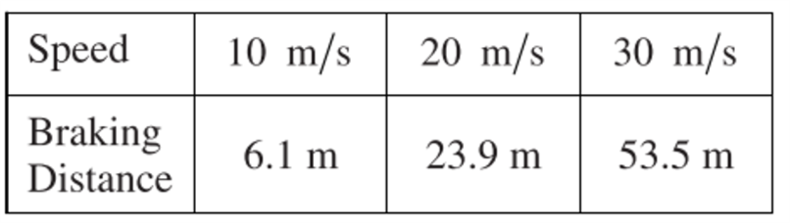
4. To analyze the characteristics and performance of the brakes on a car, researchers collected the date shown in the table above. It shows the car’s speed when the brakes are first applied and the corresponding braking distance required to stop the car. The magnitude of the average acceleration of the car is most nearly
a. 1.1 m/s²
b. 8 m/s²
c. 20 m/s²
d. 50 m/s²

5. An object’s starts from rest and slides down an inclined track. A student records values of the object’s position along the track at various times. The acceleration can best be determined from which of the following?
a. the y-intercept of a graph of position as a function of time
b. the y-intercept of a graph of position as a function of the square of time
c. the slope of a graph of position as a function of time
d. the slope of a graph of position as a function of the square of time

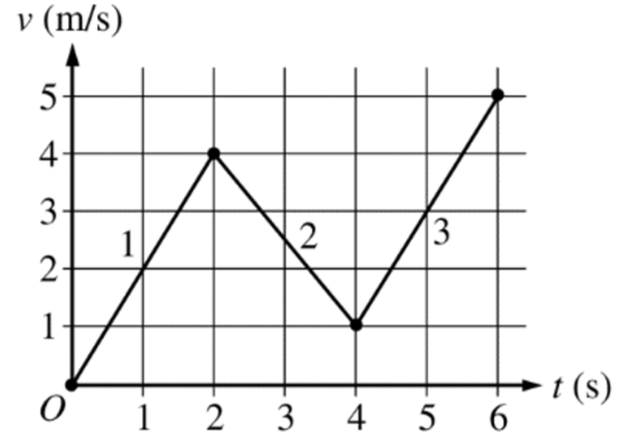
6. The graph above shows velocity as a function of time for an object moving in a straight line. The graph has three segments labeled 1, 2, and 3. Which of the following correctly ranks the displacement Δx for the three segments of the object’s motion?
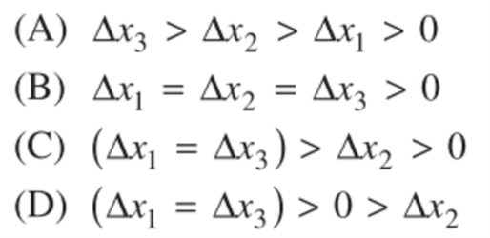

7. A Triumph sports car accelerates uniformly from rest to a speed of 30 m/s in 6 s. Calculate the distance the car travels in this time interval,
A. 360 m
B. 90 m
C. 180 m
D. 15 m
E. 5 m

8. A ball is dropped from the top of a building. In the absence of air resistance, the ball will hit the ground in 4.5s. The height of the building is
A. 10 m
B. 25 m
C. 44 m
D. 101 m
E. 240 m

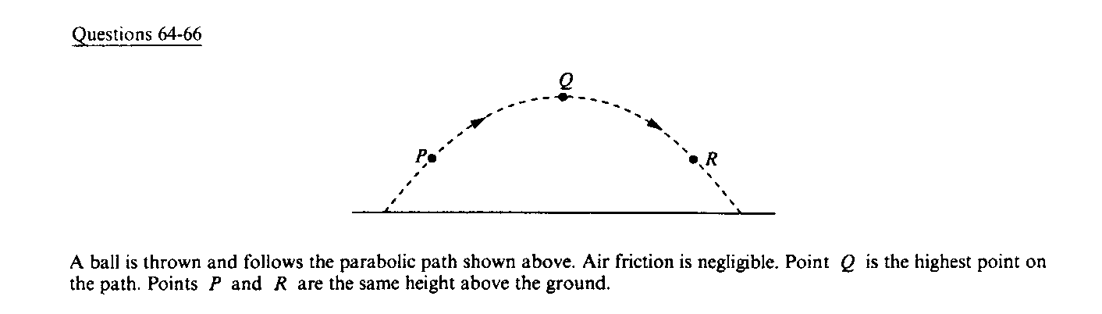
Questions 9-10

9. Which of the following diagrams best shows the direction of the acceleration of the ball at point P?
10. Which statement is true concerning the ball when it is at Q, the highest point in its trajectory?
A. The ball's velocity and acceleration are both zero.
B. The ball's velocity is zero, but its acceleration is not zero.
C. The ball's velocity is not zero, but its acceleration is zero.
D. The ball's velocity is perpendicular to its acceleration.
E. The horizontal and vertical components of the ball's velocity are equal.

