AP physics 1 Style Problem (Jim and Sara on the moon) used 2018
Jim and Sara stand at the edge of a 50 m high cliff on the moon. Jim extends his arm over the cliff edge and throws a ball straight up with an initial speed of 20 m/s. Sara throws an identical ball with the same initial speed, but she throws the ball at a 30 degree angle above the horizontal.
- Consider each ball at the highest point in its flight. At this point:
  - Which person’s ball has the greater vertical velocity? Choose your answer and explain briefly.
Jim or Sara?

  - Whose ball has the greater horizontal velocity? Choose your answer and explain briefly.
Jim or Sara?

  - Who’s ball's velocity vector has greater magnitude? Choose your answer and explain briefly.
Jim or Sara?

- Now consider each ball just before it hits the ground, 50 m below where the balls were initially released. At this point:
  - Which ball has the greater vertical velocity? Choose your answer and explain briefly.

  - Which ball's velocity vector has greater magnitude? Choose your answer and explain briefly.

- Which ball reaches the peak of its flight more quickly after being thrown? Choose your answer and explain briefly.

- Below is a velocity-time graph representing the vertical velocity of Sara's ball. On the same axes, sketch a velocity-time graph representing the vertical velocity of Jim's ball with a dashed line.
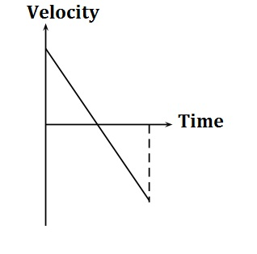

Homework Assignment
On an airless planet the same size and mass of the Earth, Jim and Sara stand at the edge of a 50 m high cliff. Jim extends his arm over the cliff edge and throws a ball straight up with an initial speed of 20 m/s. Sara throws an identical ball with the same initial speed, but she throws the ball at a 30 degree angle above the horizontal.
- Determine the horizontal and vertical components of each ball's velocity when it is at the highest point in its flight. Then, determine the magnitude of each ball's velocity vector at the highest point.
- Determine the horizontal and vertical components of each ball's velocity when it reaches the ground, 50 m below where it was initially thrown. Then, determine the magnitude of each ball's velocity vector at ground level.

Follow-Up Quiz with Solutions
You may use your original projectile problem, including any notes you made on it, as a reference.
- How is the behavior of the projectiles on the moon different than on earth? At least 2 things.
- Answer in no more than three words: how do you find acceleration from a velocity-time graph?
- If these balls were thrown from the 50 m high cliff on an airless planet of the same size and mass as the Earth, what would be the slope of a graph of the vertical velocity of Jim's ball vs. time? Answer in units of m/s².
https://apcentral.collegeboard.org/courses/resources/ap-physics-featured-question-projectile-concepts

