Immune Cells
What Are Immune Cells?
An army is a force of people fighting together. The immune system is just like that, except it's a collection of cells fighting together. The immune cells are the soldiers that defend our bodies from invaders. Just like different soldiers have different jobs, so do different immune cells.
The immune system has two parts: _________________ and __________________. Different immune cells play roles in each of them.
The ___________________________ is very general and includes the skin, mucus, and saliva. It also contains cells that travel around the body looking for things that are suspicious. Immune cells have receptors that allow them to detect certain things (like bacterial cell proteins and dsRNA) that are unique to bacteria, viruses, or fungi. In other words, _________________________________.
Some immune cells find these things and then get rid of them by eating them! They ingest the sketchy invader in a process called ______________________ and then break it down. One type of phagocytic cell is called a ________________________. Neutrophils hang out in the _______________ and can get called to particular sites of infection. Another type of phagocytic cell is a _____________________. Macrophages can move here and there around the body, but they really like to hang out in the ________________________________ where they see a lot of action.
- _________________________________ are just what they sound like: tough, assassin-type cells. These guys look for problems within our own cells. If it looks like a cell has been hijacked by a virus or cancer, the natural killers move into action. However, they don't eat their prey. Instead, they release _________________to get the job done.
- _________________________ are similar to Natural Killer Cells because they don't engulf their prey. These cells hang out near _______________________ and look for things like parasites. They release ___________________ to destroy any invaders.
- __________________________ are a link between the innate and the adaptive immune system. They are sentinels that look for fishy things near _______________. If they find something, they eat it, but then bring it to a ________________ and deliver it to the adaptive immune system.
Unlike the innate immune system, the _________________________ relies on fewer types of cells to carry out its tasks: B cells and T cells.

The cells of the adaptive immune system are ______________________. B cells, which are derived from the bone marrow, become the cells that produce _________________________. T cells, which mature in the thymus, differentiate into cells that either participate in lymphocyte maturation, or kill _________________________.
After ________________ develop in the thymus, they either travel around in the blood or lymphatic system or migrate to different organs in the body. As soon as a specific invader stimulates them, helper T cells produce ___________________.
Some chemicals trigger ________________ to develop into plasma cells, while others stimulate killer T cells to target and kill cells that may have either become infected by the invader or are cancerous. __________________________ help to control the immune reaction to prevent it getting out of hand.
Natural killer T cells also produce chemicals to help regulate the immune response and protect against invaders and tumors. ____________________________ stay around for a long time after the immune response has finished. In this way, they can react quickly if the same invader appears again and multiply to produce a large number of T cells to eliminate it.
Unlike T cells, ___________________ cannot directly attack infected cells. Instead, B cells primarily produce proteins called __________________ that can hijack invaders as they travel in the blood.
When they come across invaders, B cells are stimulated into action and produce plasma cells and memory B cells. Each plasma cell is specialized to make a particular antibody -- a specialized protein to attack a specific invader.
The function of antibodies is to _____________________________________________ so T cells recognize which cells to destroy. When invaders become coated with antibody, they are more easily targeted by other proteins in the immune system, as well as by the specialized cells known as phagocytes that are responsible for eating foreign substances and infected cells.
While plasma cells disappear after an immune response is finished, ______________________ stay around for a long time. If the same invader appears again, antibodies are already available to help fight it off.
How Diseases Spread
Direct contact: An easy way to catch most infectious diseases is by coming in contact with a person or animal who has the infection. Three ways infectious diseases can be spread through direct contact are:
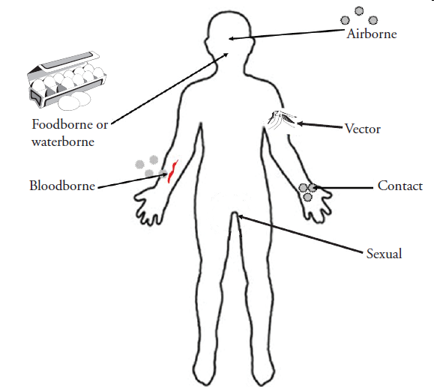
- ___________________________________. A common way for infectious diseases to spread is through the direct transfer of bacteria, viruses or other germs from one person to another. This can occur when an individual with the bacterium or virus touches, kisses, or coughs or sneezes on someone who isn't infected.
- These germs can also spread through the exchange of body fluids from sexual contact. The person who passes the germ may have no symptoms of the disease, but may simply be a carrier.
- __________________________. Being bitten or scratched by an infected animal — even a pet — can make you sick and, in extreme circumstances, can be fatal. Handling animal waste can be hazardous, too. For example, you can acquire a toxoplasmosis infection by scooping your cat's litter box.
- _____________________________. A pregnant woman may pass germs that cause infectious diseases to her unborn baby. Some germs can pass through the placenta. Germs in the vagina can be transmitted to the baby during birth.
Indirect contact: Disease-causing organisms also can be passed by indirect contact. Many germs can linger on an inanimate object, such as a tabletop, doorknob or faucet handle. When you touch a doorknob handled by someone ill with the flu or a cold, for example, you can pick up the germs he or she left behind. If you then touch your eyes, mouth or nose before washing your hands, you may become infected.
- _____________________________ Some germs rely on insect carriers — such as mosquitoes, fleas, lice or ticks — to move from host to host. These carriers are known as vectors. Mosquitoes can carry the malaria parasite or West Nile virus, and deer ticks may carry the bacterium that causes Lyme disease.
- ______________________________ Another way disease-causing germs can infect you is through contaminated food and water. This mechanism of transmission allows germs to be spread to many people through a single source. E. coli, for example, is a bacterium present in or on certain foods — such as undercooked hamburger or unpasteurized fruit juice.

