Horse and cart reading
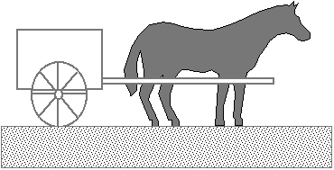
Farmer Bob hitches Steve the horse to his wagon one day, then says, "OK, Steve, let's go!"
Steve turns to Farmer Bob and says, "Do you remember back in high school, when we took Physics together?"
"Yes, I do. We were lab partners in that class, and we had a lot of fun." says Farmer Bob.
"Ah, yes! Those were the good old days, all right!", says Steve, "You do remember Newton's Three Laws, of course, which tell how all objects move?"
"Yes, I do! I remember that Newton's Laws of Motion are the cornerstone of mechanics. Now, let's get this wagon moving!"
"Do you remember how Newton's Third Law says that every action force has an equal and opposite reaction force?", says, Steve ignoring Farmer Bob's impatience.
"Yes, I do." says Farmer Bob, sensing trouble.
"Newton's Third Law says that if I pull on the wagon, the wagon exerts an equal and opposite force on me. Don't you agree?", asks Steve .
"Yes... but..."
"If these two forces are equal and opposite, they will cancel, so that the net force is zero, right?", argues Steve.
"Well, I suppose so," stammers Farmer Bob.
"The net force is always the important thing. If the net force is zero, then Newton's Second Law (and Newton's First Law, too) says that the acceleration of the wagon must be zero."
"Yes, I remember Newton's Second Law very well, Steve.” says Farmer Bob, hopefully. "This physics discussion is certainly interesting, but let’s gets going!"
"But that's the point!", objects Steve, "If the wagon's pull is always equal and opposite of my pull, then the net force will always be zero, so the wagon can never move! Since it is at rest, it must always remain at rest! Get over here and unhitch me, since I have just proven that Newton's Laws say that it is impossible for a horse to pull a wagon!"
At this point, Farmer Bob throws up his hands in dismay and turns to you. "Please help me!" he says, "I really should have paid more attention in physics class! I know that Newton's Laws are correct, and I know that horses really can pull wagons. There has to be an error in Steve’s argument, but what is it? How can I convince Steve that if he pulls on the wagon, it will move?"
So, what is your reply?

