Physics Review Sheet | Heat, Temperature Expansion, and Phase Change
April 2017

☆ :)
- Why does Green Bay, WI have a colder winter than Anchorage, AL?
  - Green Bay is colder because it is in the center of the landmass. The air moving toward Green Bay goes over a landmass that has a low specific heat, allowing the air to get cold. The air moving toward Anchorage travels over the ocean which has a high specific heat, making the air warm.
- Why doesn’t a paper cup burn if it is filled with water over a flame?
  - The flashpoint of paper is 400℉, but the water will only get to 212℉ (boiling); the water will not “allow the paper to reach its flash point.
- When a sample of 0℃ water is heated, it first…
  - CONTRACTS
- When a sample of 4℃ water is cooled, it…
  - EXPANDS
  - Water is kind of “attracted” to itself, so it forms hexagonal patterns when in the form of ice
- Why do pigs roll in the mud?
  - They don’t sweat; mud evaporates off their skin and cools them off
- What would happen if all water molecules had the same jiggling speed (internal energy) at… 100℃? 0℃?
  - 100℃ → flash boil
  - 0℃ → flash freeze
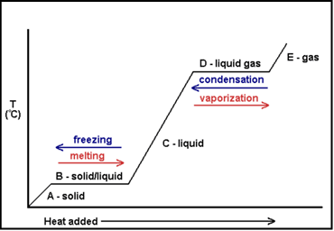
- Which would make a more painful burn? 100℃ water or 100℃ steam?
  - Steam because it condensates on your skin
- When water vapor condenses on the inside of the window, the window becomes…
  - Warmer because condensating warms you up
- What does melting snow do to the surrounding air?
  - Cools it because it takes energy from the air to melt the snow
- If you’re walking on hot coals, do you want wet or dry feet?
  - Wet because the water has a high specific heat
- What are the bubbles in boiling water made of?
  - Steam/vapor because boiling is a rapid form of evaporation
- If you put warm food in a cooler, the energy goes…
  - Into the ice, changing the ice from solid to liquid water; temperature doesn’t change until all ice is melted
- Grandfather’s root cellar
  - Prevent freezing by placing giant tub of water in cellar because as the water froze, it would release energy into the cellar and warm the cellar, preventing the jars from freezing and breaking
- What is the temperature of the water at the bottom of a very cold lake?
  - Temperature is 4℃ because water is its densest at 4℃ with its greatest volume (regardless of outside temperature)
- How does styrofoam keep things cold?
  - By preventing energy from getting in; it prevents heat transfer
- How to blankets keep you warm?
  - Keep your body heat in; prevent heat transfer
- Why is the East coast not as temperate as the West?
  - Because the air travels over land before it reaches the East Coast (see Green Bay/Anchorage problem)
- If you mix 1L of 80℉ water with 5L of 20℉ water, the resulting temperature of the total 6L of water would be…
  - (⅙ x 80℉) + (⅚ x 20℉) = 30℉
- If you have 1L of water in a bucket, 3L of water in another bucket, and they both receive the same amount of heat…
  - The 1L of water will get to a higher average kinetic energy per particle because there are less particles, and both buckets will receive the same amount of heat
- Evaporation is a cooling process and condensation is a…
  - Warming process
- The higher the altitude, the _________ the boiling point of water.
  - Lower
- Ball and hole lab
  - The hole gets bigger as it warms up because all particles expand equally and the outside expands more because it has a larger circumference.
- Power lines should be hung _________ in the ________ because…
  - Loosely in the summer because they will become taught in the winter
- The reason pressure cookers cook food faster is because they…
  - Trap vapor causing the pressure inside the pressure cooker to increase. The boiling point of water in this high pressure environment is higher. The water boils at a higher temperature thus cooking the food faster.
NOTES:
- Heat: Transferred thermal energy. Always goes from HOT→Cold
  - Because there is no such thing as cold, only a lack of heat
- Temperature: Kinetic Energy per Particle “Jiggling” kinetic energy not motion
- Total Internal Energy: Total Kinetic Energy per particle: Every particle all added up.
  - No upper limit of total energy
  - There IS a lower limit: Absolute zero. Because you can’t make something stoppeder.
    - The Arctic Ocean has more IE than a match
  - Not all particles are created equal
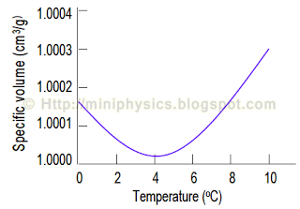
- Specific Heat: Amount of energy per gram needed to raise the Temp. by 1ºC
  - Water has a very high specific heat=4.18 J/gºC
    - Means it is hard to heat up; Hard to cool down
- Celsius is based on Freezing (0ºC) and Boiling (100ºC)
- Degrees C + 273 = Kelvin
- K - 273= Degrees C
- 273 K Freezing 373 K Boiling
- 32ºF Freezing 212ºF Boiling
- 4.18J=1 calorie (small c)
- 1000 calories (small c)= 1 Calorie (Big C)
- Q=mc∆t
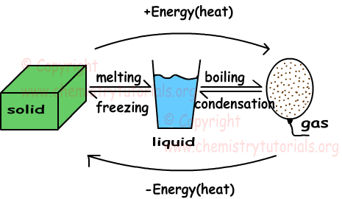
  - Q= Thermal energy (Joules)
  - m= Mass (grams)
  - c= Specific Heat (J/gºC) or (Calories)
  - ∆t= Change in temperature (Final-initial)
- Islands are not too hot AND not too cold
- Thermal Expansion: Particles jiggle faster so they move farther apart
- Low energy can’t move
- When Ice melts: Object GAINS energy→Surroundings LOSE energy
- When Ice Freezes: Object LOSES energy→Surroundings GAIN energy
- Sweat Evaporates off of you→Sweat GAINS energy from you, making you loose energy cooling you down
- Evaporation=Boiling REALLY fast
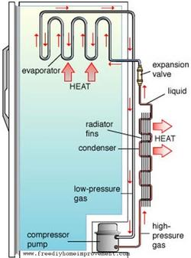
- Frozen= Being solid, not necessarily cold
- Ice can get WAY colder than 0ºC
- Latent Heat of Fusion: Energy required to change one gram from Solid to Liquid or Liquid to Solid
  - H_{f}= 334 J/g
- Latent Heat of Vaporization: Energy required to change one gram from Liquid to Gas or Gas to Liquid
  - WAY WAY harder to boil water off than to freeze it
  - H_{v}= 2,230 J/g
- LHF and LHV change STATE not TEMPERATURE
- SHA
- How Refrigerators Work
- Compressor compresses high energy gas into liquid
- High energy liquid goes into condenser coils and cools, becoming low energy liquid
  - All the heat from inside the fridge is going to the back of the fridge
- Low energy liquid goes through the expansion valve and vaporizes (vaporizes inside fridge)
  - Vaporization sucks energy from inside of fridge
- High energy gas goes back to the compressor
- Repeat
- Burning Gas can make a fridge cold.
- Sublimation: phase change from solid to gas

