Number#
Grist Chemistry Final Review Part 1 Name_________
Draw a Bohr model and a Lewis dot for magnesium… Then get your remote
- How many___ does Mg have?
a. protons
b. neutrons
c. electrons
d. Valence electrons
e. ionic charge
f. metal or nonmetal (circle one)

- What is the difference between a group and a period?
_________ go across and _________ go up and down

- What is the name of each of the following groups: 1, 2, 7, and 8? Match the number with the family
  - Halogens ____
  - Alkali metals____
  - Noble gasses____
  - Alkaline earth metals_____

- Draw the electron dot structure (Lewis dot diagram) of every element in period 2. What do the dots represent? Label what the ionic charge would be for each.
Lithium | Beryllium | Boron | Carbon | Nitrogen | Oxygen | Fluorine | Neon

- What is the formula of the bonding of Li with P? What is the name of that formula?

- On the periodic table color the metals and leave the nonmetals uncolored
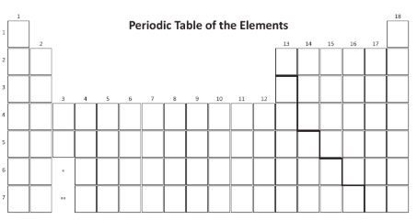

- What type of nuclear reaction makes the sun hot?

- How is the Doppler Effect related to the big bang? (Watch video) Use the term “red shift” correctly in your answer.
https://www.youtube.com/watch?v=h4OnBYrbCjY
Number#
Grist Chemistry Final Review Part 1 Name_________
Draw a Bohr model and a Lewis dot for magnesium… Then get your remote
1)How many___ does Mg have?
a. protons
b. neutrons
c. electrons
d. Valence electrons
e. ionic charge
f. metal or nonmetal (circle one)

- What is the difference between a group and a period?
_________ go across and _________ go up and down

- What is the name of each of the following groups: 1, 2, 7, and 8? Match the number with the family
  - Halogens ____
  - Alkali metals____
  - Noble gasses____
  - Alkaline earth metals_____

- Draw the electron dot structure (Lewis dot diagram) of every element in period 2. What do the dots represent? Label what the ionic charge would be for each.
Lithium | Beryllium | Boron | Carbon | Nitrogen | Oxygen | Fluorine | Neon

- What is the formula of the bonding of Li with P? What is the name of that formula?

- On the periodic table color the metals and leave the nonmetals uncolored

- What type of nuclear reaction makes the sun hot?

- How is the Doppler Effect related to the big bang? (Watch video) Use the term “red shift” correctly in your answer. https://www.youtube.com/watch?v=h4OnBYrbCjY

