Genetics Study Guide
Genetics Objectives
- Be familiar with DNA and RNA. Know the bases, the base pairing rules, molecules, the components of nucleotides, similarities and differences between DNA and RNA in (shapes and bases), chromosomes, mutations, and crossing over.
A to T or U on RNA and C to G
Mutations covered later

- Be able to describe DNA replication at a basic level. This is not protein synthesis
DNA gets copied
Mistakes in this process cause mutations!
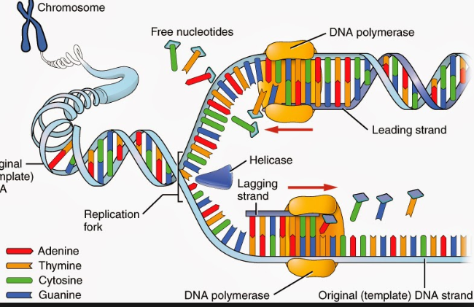

- Be able to describe the process of protein synthesis including mRNA, tRNA, and amino acids.
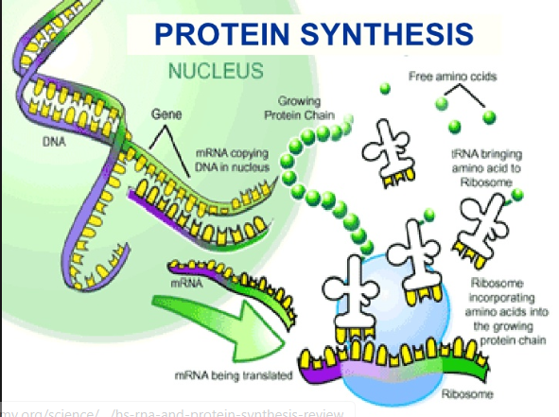

- Be able to discuss inheritance patterns. This includes dominance, recessiveness, Punnett squares, blood type, phenotypes, genotypes, heterozygous, homozygous, and X-linked traits.
phenotypes
genotypes
homogenous
hetero generous

Study Questions
DNA/RNA and Protein Synthesis:
- Know the base-pairing rules as well as which bases you would expect to find in DNA and RNA.
Test yourself

- Describe DNA replication.

Test yourself

- What is a mutation? Describe types of mutations.
-Insertion
-deletion
-Frame shift
-Base change

Example:
Original DNA Sequence: T A C A C C T T G

DELETION (a base is lost)

A C A C C T T G…
Frame shift

INSERTION (an extra base is inserted)
T A G C A C C T T G
FRAMESHIFT

Deletion and insertion may cause what is called a FRAMESHIFT, meaning the reading “frame”.
POINT MUTATION (one base is substituted for another) or base change is what I called it

T A C A T C T T G

- Compare and contrast meiosis and mitosis. What is crossing over?

Mitosis: the cell makes an identical copy of itself

Meiosis: production of sex cells (not identical copies)
Crossing over occurs and genetic variation is increased,
The reason why you are not the same as your siblings.

- Be able to describe the process of protein synthesis. Describe transcription and translation. Be able to code from DNA to amino acid sequence or from amino acid sequence to DNA.
- Test yourself

DNA
mRNA
Ribosome
tRNA
amino acid
protien

Inheritance:
- What is the ratio of phenotypes from a cross between two heterozygotes with the alleles Aa?
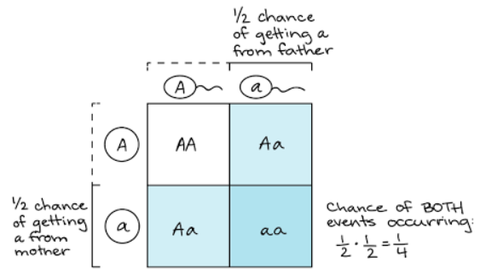

- What are gametes and where are they made?
Come on? Really?

- Know the difference between genotype and phenotype.
Ss Aa and SSAA same _____________ but different ______________

- Know what Punnett squares are and how and why they are used. Be able to set up, fill in, and interpret a dihybrid cross.

- 16 box Punnett square
- foil

- What is fertilization?
Really?

- Explain the concepts of haploid and diploid chromosomes.

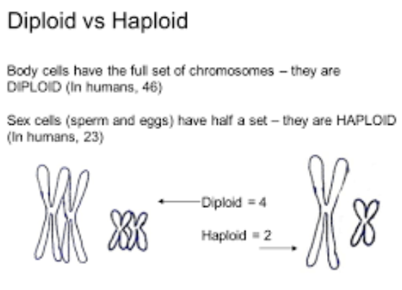

- Explain the typical characteristics of X-linked traits.

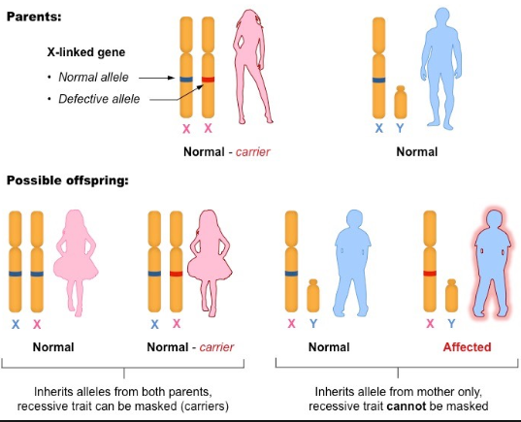

X-linked traits are the traits that you receive from your mother. Typical disorders that come from x-linked traits include red-green color blindness, a disorder only received through the x chromosome. It is important to note that fathers cannot pass x-linked traits to their sons.

