#0 Fill in all balnks

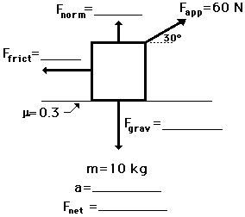

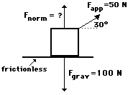
- A 50-N applied force (30 degrees to the horizontal) accelerates a box across a horizontal sheet of ice (see diagram). Glen Brook, Olive N. Glenveau, and Warren Peace are discussing the problem. Glen suggests that the normal force is 50 N; Olive suggests that the normal force in the diagram is 75 N; and Warren suggests that the normal force is 100 N. While all three answers may seem reasonable, only one is correct. Indicate which two answers are wrong and explain why they are wrong.

2. A box is pulled at a constant speed of 0.40 m/s across a frictional surface. Perform an extensive analysis of the diagram below to determine the values for the blanks.
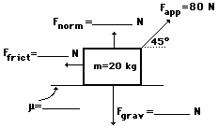
3. Use your understanding of force relationships and vector components to fill in the blanks in the following diagram and to determine the net force and acceleration of the object. (F_{net} = m•a; F_{frict} = μ•F_{norm}; F_{grav} = m•g)
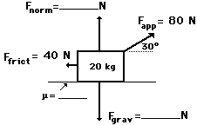
4. The 5-kg mass below is moving with a constant speed of 4 m/s to the right. Use your understanding of force relationships and vector components to fill in the blanks in the following diagram and to determine the net force and acceleration of the object. (F_{net} = m•a; F_{frict} = μ•F_{norm}; F_{grav} = m•g)
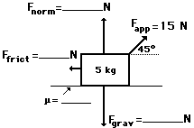
5. The following object is being pulled at a constant speed of 2.5 m/s. Use your understanding of force relationships and vector components to fill in the blanks in the following diagram and to determine the net force and acceleration of the object. (F_{net} = m•a; F_{frict} = μ•F_{norm}; F_{grav} = m•g)
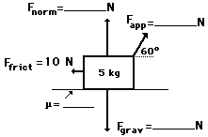
6. Use your understanding of force relationships and vector components to fill in the blanks in the following diagram and to determine the net force and acceleration of the object. (F_{net} = m•a; F_{frict} = μ•F_{norm}; F_{grav} = m•g)

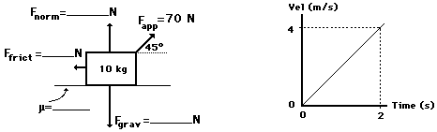
7. Study the diagram below and determine the acceleration of the box and its velocity after being pulled by the applied force for 2.0 seconds.
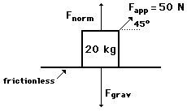
8. A student pulls a 2-kg backpack across the ice (assume friction-free) by pulling at a 30-degree angle to the horizontal. The velocity-time graph for the motion is shown. Perform a careful analysis of the situation and determine the applied force.
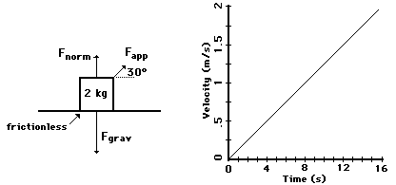
9. The following object is moving to the right and encountering the following forces. Use your understanding of force relationships and vector components to fill in the blanks in the following diagram and to determine the net force and acceleration of the object. (F_{net} = m•a; F_{frict} = μ•F_{norm}; F_{grav} = m•g)
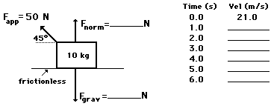
10. The 10-kg object is being pulled to the left at a constant speed of 2.5 m/s. Use your understanding of force relationships and vector components to fill in the blanks in the following diagram. (F_{net} = m•a; F_{frict} = μ•F_{norm}; F_{grav} = m•g)
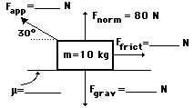
11. Use your understanding of force relationships and vector components to fill in the blanks in the following diagram and to determine the net force and acceleration of the object. (F_{net} = m•a; F_{frict} = μ•F_{norm}; F_{grav} = m•g)
