1 st period

Circular Motion & Rotational Mechanics
Afton, Sadie, Emmett and Natalie
Notes
- A radian is how many times the radius goes around the circumference of a circle or 2 pi
- Rotation is a spin inside an object, a Revolution is a turn around an external object
- Rotational speed and tangential speed are proportionate : all parts have the same rate of rotation- RS is the # of rotations/ revolutions made per unit of time
- When an object moves in a circle, there is no force acting outward!!!! (PS ALWAYS ANSWER INWARD)
- CENTRIPETAL FORCE: any force that causes an object to follow a circular path (center seeking)
- Linear speed, tangential speed, tangential velocity→ WIND IN YOUR HAIR
- Rotational speed, angular speed→ green & red dots (same speed) (circles per second)
- Torque changes rotational motion (either stop or go… like gas or brake) when torque is balanced, no change
- ROTATIONAL INERTIA: how hard it is to change something’s rotation
- Mass far from axis→ more inertia → harder to roll
- Mass close to axis → less inertia → resistance
- Greater inertia= harder to change
- ANY DISK WILL BEAT ANY HOOP MASS DOESN’T MATTER!!!!
- ANGULAR MOMENTUM: “the inertia of rotation” which is the product of rotational inertia & Rot. velocity
- Angular momentum is conserved what does this mean
- Torque can change rotational velocity and angular velocity which can change angular momentum
- Cats Always land on their feet
  - Once dropped, the cat tucks its front legs in, making the top half of the cat rotate. Meanwhile, the cat sticks its back legs out (greater rotational inertia), making the bottom half of the cat spin the opposite way (only a little)
  - Next, the cat extends its front legs and pulls its back legs in, this makes the back half rotate and stops the front half’s momentum (kinda... fix this)
  - Next, the cat extends all 4 legs, stopping its momentum WRONG!
  - Finally the cat arches its back so that it hits the ground with less force over longer time compared to what?
  - The change in angular motion=0
Equations
- Arc length= (radians) x radius
- Radians= arc length/radius
- Velocity Centripetal Force= d/t OR 2(pi)(r)/T OR circumference/Period
- Centripetal Acceleration= (circumference/T)^2 /radius
- Centripetal Force= ma OR mV^2/r

:) *
- What is the direction of the force that acts on clothes in the spin cycle of a washing machine?
  - Inwards
- If you whirl a can on the end of a string and it flies off it will
  - Fly off, tangent to its circular path
- A car travels in a circle with a constant speed. The force is directed
  - Towards the center of the curve
    - The net force is not pushing the car in the circle, it is changing direction not speed
- The Centripetal Force exerted on a motorcycle in the cage of death is
  - Normal force because the cage is the only thing touching it
- If a cat and a bird are rollerblading at a constant speed, in a circle, are they accelerating?
  - Yes because A is a change in V and they are changing direction
- If the force keeping an object spinning in a circle is taken away, what happens to the object?
  - It goes off in a tangent line
QUESTIONS:
In a pendulums course of motion, the velocity of the mass is greatest at…
- Right as you drop it
- Bottom of the swing
- Top of the swing
- None of the above
A cowboy lassoes his lasso in a circle over his head and then sees a bull! He releases the lasso. What way does the rope fly?
- In a circle
- Misses the bull
- Tangent to its rotation
What does torque cause
- Rotation and spinning constantly
- The earth spinning
- Change in rotation
A hula hoop and a frisbee race down a hill. Who wins?
- They tie
- Hula hoop
- Frisbee

Gravitation and Gravitational Interaction
Ryan, Rex Gwinn, Caleb, Carlie Brown, Sophie Brown, Ethan Casselberry

- Newton's law of universal gravitation states that a particle attracts every other particle in the universe using a force that is directly proportional to the product of their masses and inversely proportional to the square of the distance between their centers (everything pulls on everything else).
- $F=G\frac{m_{1}m_{2}}{d^{ 2}}$ ???
  - F = Force of attraction
  - G = universal gravitational constant = $6.67×{10}^{-11} N∙m^{2}/{kg}^{2}$
  - m₁ = mass of first object
  - m₂ = mass of second object
  - d = distance
  - Gravitational field = g = $\frac{F}{m}$
- Gravitational constant (G) is very small, making gravitational forces weak compared to electrical and nuclear interactions.
- All objects in the universe attract one another.
Examples:
Two objects. Mass of one is doubled. Result: Gravitational force is doubled.
Two objects. Distance is doubled. Result: Gravitational force is $\frac{1}{4}$ as much.
- Why do we have seasons?
  - The proximity of the sun from the Earth has nothing to do with the seasons. It has to do with if the sun rays are direct or indirect. If there are direct rays on an area of the Earth, it is Summer, and if there are indirect rays on an area of the Earth it is not summer. Indirect rays also means less rays per square mile.
- Eclipses:
  - Solar Eclipse: sun is getting blocked out by the moon (moon is between the earth and the sun)
  - Lunar Eclipse: earth is in the way of the moon (earth is between the sun and the moon)
- Tides:
  - What causes the tides?
    - The moon; the distance between the front of the earth to the sun and the back of the earth to the sun is not substantial, but the distance from the front of the earth to the moon compared to the distance from the back of the earth to the moon is. The direct pull of the moon on the front of the earth creates a bulge and on the backside, a bulge is caused by inertia. The moon only pulls on one side at a time
  - Bigger moon, bigger tides; smaller moon, smaller tides
  - No moon = high tides during the day, low tides at night
- Twin Paradox:
  - If you experience a different amounts of gravity and one twin goes to space while the other stays on earth, they will age differently

- Black holes:
  - When a star collapses; black hole is as big as the star
  - Distance from center of mass to the outer edge goes down, gravity goes up
  - When distance is almost 0, gravity would be almost infinite
  - When close enough your escape speed become greater than the speed of light
  - Only sucks you in if you get close to its center of mass
  - If the sun became a black hole…
    - Nothing would change

- Light:
  - Speed of light...
  - = 3 x 10^8 m/s
  - = 186,000 miles/sec
  - = 670,000,000 miles/hr
  - Light doesn’t follow our space time rules
  - Light always goes the same speed (doesn’t matter if anyone is moving)
- Elevator
  - Going up, accelerating up = weigh more
  - Going up, accelerating down = weigh less
  - Going down, accelerating up = weigh more
  - Going down, accelerating down = weigh less
- Man jumping through Earth:
  - Jumps in the hole
  - Oscillates between America and China
  - When you jump in you accelerate at 1g
  - Continue falling, acceleration decreases and speed increases
  - Speed up until the center
  - Once past the center, begin to decelerate
  - Deceleration increases as you get closer to the surface
  - Stop and then oscillate to the other side
- Vomit Comet
  - Accelerating down in free fall

Questions:
- If you were in a plane and the engines failed so you started plummeting downwards, and you were accelerating downward, the scale would read…
  - Less (this is the correct answer)
  - More
  - The same
  - Nothing
- Sally thinks the seasons are caused by the distance between the Earth and the sun. David thinks the seasons are caused by direct and indirect sunrays because of the tilt of the Earth’s tilt. Who is right?
  - Sally
  - David
  - Neither
  - John Cena, he controls everything
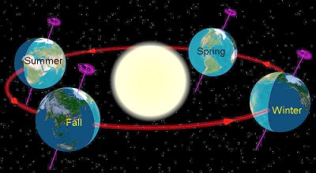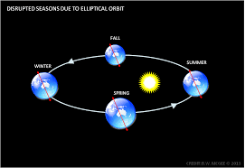

- If Steve Powell is running at the speed of light to tackle a standing John Cena, and a flash of light moves across the sky in the same direction Steve Powell is running, who will the flash of light appear faster to?
  - Steve Powell
  - John Cena
  - It will appear to be going to be the same speed to both

Buoyancy (ch 19) Liquids
Nicholas C Piccaro ,Kegan J. D’Aleo, Teagan A. Seiler, Joseph M Pope
-When an object is sinking or sunk F_{g}>F_{b}, Vol of Object=Vol of H20 Displaced
-When an object is floating Fg=Fb, Vol Object>Vol of H20 Displaced
ρ=m/v ρ(density)
WTF ……….Think about a pirate hording all his booty, then decides to throw it all over board to save the rum… Why is the rum always gone? Because they throw all their booty overboard and can't buy more rum.
Archimedes’ Principle An object is buoyed up by a force equal to the weight of the fluid it displaces.

An object surrounded by air is buoyed up by a force equal to the weight of the air displaced.

F_{B} is the buoyant force, is the density of the fluid, g is the acceleration of gravity, and V is the volume of fluid that is displaced.
- Buoyancy (also known as the buoyant force) is the force exerted on an object that is wholly or partly immersed in a fluid.
  - The symbol for the magnitude of buoyancy is B or F_{B}
  - As a vector it must be stated with both magnitude and direction.
    - Buoyancy acts upward for the kind of situations encountered in everyday experience.
  - As with other forces, the SI unit of buoyancy is the newton [N].
- Buoyancy is caused by differences in pressure acting on opposite sides of an object immersed in a static fluid.
  - A typical situation:
    - The pressure on the bottom of an object is greater than the top
    - (since pressure increases with depth).
    - The force on the bottom pushes up and the force on the top pushes down
    - (since force is normal to the surface).
    - The direction of the net force due to the fluid is upward.
  - Pressure variations in a fluid are typically caused by gravity (since P = P0 + ρgh), but in general buoyant forces act opposite the direction of the frame of reference acceleration.
    - Under conditions of apparent weightlessness there can be no buoyant forces.
    - Practice Problem. A cube of steel that measures 5.0 cm on each side is immersed in water. The density of steel is 9.0 x 103 kg/m3 . The density of water is 1.0 x 103 kg/m3 . What is the (a) buoyant force acting on the cube and what is (b) its apparent weight?

Two cats that are the same size are held underwater. Cat one is just beneath the surface of the water while cat two is held at a greater depth. The force needed to hold cat two in place is
Larger
The same as
Smaller
Than the force required to hold cat one in place.

A fish is swimming away from a scuba diver trying to capture him, if the fish gets caught the dad fish will have to search the entire ocean, the fish sinks by ______(ing) its _____ bladder in order to decrease its ________.

A iron cable holds a 100kg fish tank 4 meters below the surface of water. The water displaced by the tank is 1 cubic meter. What is the tension of the cable?

What does the density of water have to be to have a sumo wrestler float?
-greater than his density
-less than his density
-equal to his density

Bab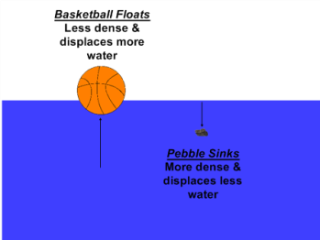

Heat Temp and Expansion and Phase Change
Alden and Curtis
Heat: Transferred thermal energy. Always goes from HOT→Cold
  - Because there is no such thing as cold, only a lack of heat
- Temperature: Kinetic Energy per Particle “Jiggling” kinetic energy not motion
- Total Internal Energy: Total Kinetic Energy per particle: Every particle all added up.
  - No upper limit of total energy
  - There IS a lower limit: Absolute zero. Because you can’t make something stoppeder.
    - The Arctic Ocean has more IE than a match
  - Not all particles are created equal
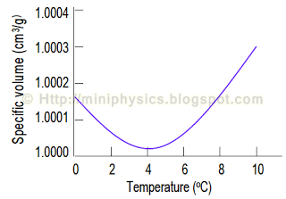
- Specific Heat: Amount of energy per gram needed to raise the Temp. by 1ºC
  - Water has a very high specific heat=4.18 J/gºC
    - Means it is hard to heat up; Hard to cool down
- Celsius is based on Freezing (0ºC) and Boiling (100ºC)
- Degrees C + 273 = Kelvin
- K - 273= Degrees C
- 273 K Freezing 373 K Boiling
- 32ºF Freezing 212ºF Boiling
- 4.18J=1 calorie (small c)
- 1000 calories (small c)= 1 Calorie (Big C)
- Q=mc∆t
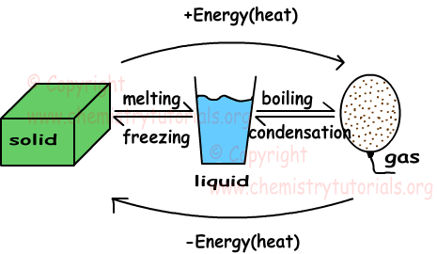
  - Q= Thermal energy (Joules)
  - m= Mass (grams)
  - c= Specific Heat (J/gºC) or (Calories)
  - ∆t= Change in temperature (Final-initial)
- Islands are not too hot AND not too cold
- Thermal Expansion: Particles jiggle faster so they move farther apart
- Low energy can’t move
- When Ice melts: Object GAINS energy→Surroundings LOSE energy
- When Ice Freezes: Object LOSES energy→Surroundings GAIN energy
- Sweat Evaporates off of you→Sweat GAINS energy from you, making you loose energy cooling you down
- Evaporation=Boiling REALLY fast
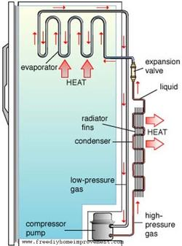
- Frozen= Being solid, not necessarily cold
- Ice can get WAY colder than 0ºC
- Latent Heat of Fusion: Energy required to change one gram from Solid to Liquid or Liquid to Solid
  - H_{f}= 334 J/g
- Latent Heat of Vaporization: Energy required to change one gram from Liquid to Gas or Gas to Liquid
  - WAY WAY harder to boil water off than to freeze it
  - H_{v}= 2,230 J/g
- LHF and LHV change STATE not TEMPERATURE
- SHA
- How Refrigerators Work
- Compressor compresses high energy gas into liquid
- High energy liquid goes into condenser coils and cools, becoming low energy liquid
  - All the heat from inside the fridge is going to the back of the fridge
- Low energy liquid goes through the expansion valve and vaporizes (vaporizes inside fridge)
  - Vaporization sucks energy from inside of fridge
- High energy gas goes back to the compressor
- Repeat
- Burning Gas can make a fridge cold.
- Sublimation: phase change from solid to gas

☆ :)
- Why does Green Bay, WI have a colder winter than Anchorage, AL?
  - Green Bay is colder because it is in the center of the landmass. The air moving toward Green Bay goes over a landmass that has a low specific heat, allowing the air to get cold. The air moving toward Anchorage travels over the ocean which has a high specific heat, making the air warm.
- Why doesn’t a paper cup burn if it is filled with water over a flame?
  - The flashpoint of paper is 400℉, but the water will only get to 212℉ (boiling); the water will not “allow the paper to reach its flash point.
- When a sample of 0℃ water is heated, it first…
  - CONTRACTS
- When a sample of 4℃ water is cooled, it…
  - EXPANDS
  - Water is kind of “attracted” to itself, so it forms hexagonal patterns when in the form of ice
- Why do pigs roll in the mud?
  - They don’t sweat; mud evaporates off their skin and cools them off
- What would happen if all water molecules had the same jiggling speed (internal energy) at… 100℃? 0℃?
  - 100℃ → flash boil
  - 0℃ → flash freeze
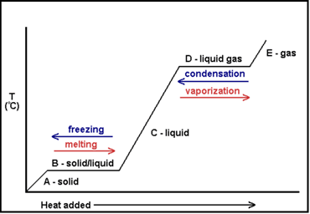
- Which would make a more painful burn? 100℃ water or 100℃ steam?
  - Steam because it condensates on your skin
- When water vapor condenses on the inside of the window, the window becomes…
  - Warmer because condensating warms you up
- What does melting snow do to the surrounding air?
  - Cools it because it takes energy from the air to melt the snow
- If you’re walking on hot coals, do you want wet or dry feet?
  - Wet because the water has a high specific heat
- What are the bubbles in boiling water made of?
  - Steam/vapor because boiling is a rapid form of evaporation
- If you put warm food in a cooler, the energy goes…
  - Into the ice, changing the ice from solid to liquid water; temperature doesn’t change until all ice is melted
- Grandfather’s root cellar
  - Prevent freezing by placing giant tub of water in cellar because as the water froze, it would release energy into the cellar and warm the cellar, preventing the jars from freezing and breaking
- What is the temperature of the water at the bottom of a very cold lake?
  - Temperature is 4℃ because water is its densest at 4℃ with its greatest volume (regardless of outside temperature)
- How does styrofoam keep things cold?
  - By preventing energy from getting in; it prevents heat transfer
- How to blankets keep you warm?
  - Keep your body heat in; prevent heat transfer
- Why is the East coast not as temperate as the West?
  - Because the air travels over land before it reaches the East Coast (see Green Bay/Anchorage problem)
- If you mix 1L of 80℉ water with 5L of 20℉ water, the resulting temperature of the total 6L of water would be…
  - (⅙ x 80℉) + (⅚ x 20℉) = 30℉
- If you have 1L of water in a bucket, 3L of water in another bucket, and they both receive the same amount of heat…
  - The 1L of water will get to a higher average kinetic energy per particle because there are less particles, and both buckets will receive the same amount of heat
- Evaporation is a cooling process and condensation is a…
  - Warming process
- The higher the altitude, the _________ the boiling point of water.
  - Lower
- Ball and hole lab
  - The hole gets bigger as it warms up because all particles expand equally and the outside expands more because it has a larger circumference.
- Power lines should be hung _________ in the ________ because…
  - Loosely in the summer because they will become taught in the winter
- The reason pressure cookers cook food faster is because they…
  - Trap vapor causing the pressure inside the pressure cooker to increase. The boiling point of water in this high pressure environment is higher. The water boils at a higher temperature thus cooking the food faster.

Electricity
Autumn and Eli and Luke and Jenna and saylor:)
Series Circuits | Parallel Circuits
- Voltage is divided  - Current is the same everywhere because only one path  - One with more resistance is brighter  - Add resistors = dimmer ; take away resistors = brighter | - Voltage is the same everywhere  - Current is always divided  - Total current = sum of the currents in ea. parallel branch  - As # of parallel branches increase, resistance decreases  - The brighter light parallels the higher resistor  - When bulbs are added or removed, the brightness of the remaining bulbs remains the same  - Brighter than series circuit

Electric conductors (free-range parents): materials that allow easy flow of charged particles
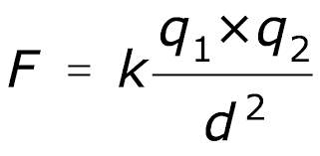
- Outermost electrons of atoms attached loosely (metals)
Electric insulators (overprotective parents): materials having tightly bound electrons
Direct current: all electrons go same way
- One end of current to other (circle)
Alternating current: electrons wiggle back and forth (domino effect)
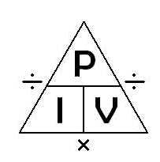
Units:
Attraction (static)
F= Force (Newtons)
K= Proportionality Constant= 9.0$×{10}^{-19}$(m²/c²)
q= Charges (coulombs)
d= distance of separation (meters)
Power
P= power (watts)
I = current (amps)
V = voltage (volts)
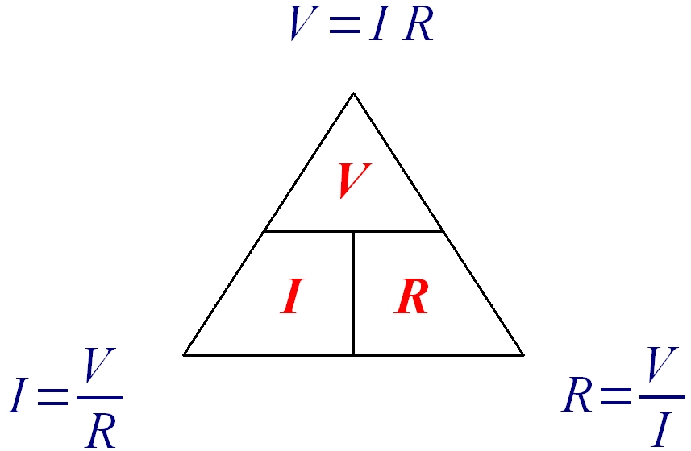
Ohm’s Law
V= Voltage (Volts)
I= Current (amps)
R= Resistance (ohms/Ω)

Electricity Questions:
- If there is a 3 ohm resistor lamp with a 9V battery, how many watts does it have?
  - 27
  - 9
  - 3
  - 18
- If you add lightbulbs to a series circuit string of christmas lights, the rest…
  - Stay the same
  - Become brighter
  - Become dimmer
- In a series circuit the _______ is divided and the ________ stays the same.
  - Voltage, current
  - Current, voltage
  - Voltage, resistance
  - Resistance, current
- If you add resistors to a parallel circuit, the rest…
  - Stay the same
  - Become brighter
  - Become dimmer
- A toaster with 15 ohms resistance, a blender with 10 ohms resistance, and a lamp with 20 ohms resistance are all connected in parallel to an outlet. Which has the lowest voltage?
  - The toaster
  - The blender
  - The lamp
  - All of them

