Earth Science and Chemistry Final Review
Chemistry
- How many protons, neutrons, and electrons does Mg have?

- What is the difference between a group and a period?

- What is the name of each of the following groups: 1, 2, 7, and 8?

- Draw the electron dot structure (Lewis dot diagram) of every element in period 2. What do the dots represent? Label what the ionic charge would be for each.

- What is the formula of the bonding of Li with P? What is the name of that formula?

- What are the five properties of metals? What line divides metals from nonmetals on the periodic table?

THE ELECTROMAGNETIC SPECTRUM
- Does the left side or the right side have the shortest wavelength? Name at least 1 thing each section of the electromagnetic spectrum is used for.

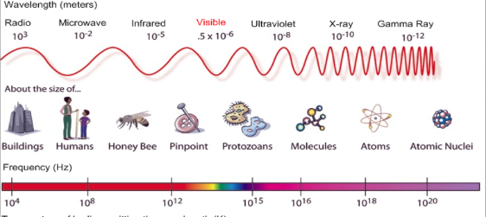

- Make a triple Venn diagram comparing and contrasting alpha, beta, and gamma radiation.

- Explain what ‘238’ in Uranium-238 means. Take u-238 through a beta decay and alpha decay.

- Define solid, liquid, and gas in terms of shape and volume.

- What are the only 2 things that cause a chemical change?

- What is the density of an ostrich egg with a volume of 315 cm³ and a mass of 700 g? Will the egg float in water?

Earth Science
- What do greenhouse gases do to the atmosphere?

- In what quadrant of the HR diagram do you find a cool, bright star? What is on the x and y axis of the HR diagram?
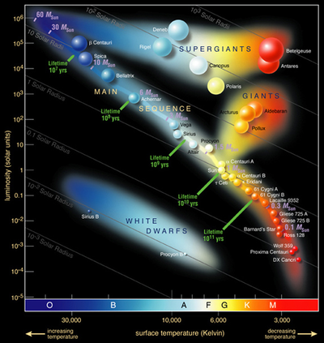

- Explain red shift and what it proves.

- What does the Big Bang theory explain?

- What is the Doppler Effect?

- What is the evidence that Earth’s continents used to be one supercontinent?

- Draw diagrams of plate boundaries using arrows to represent convergent, divergent, sea-floor spreading, and subduction zones.

- List each of the 8 natural hazards we talked about in class. Review how to read their scales.

- Draw the life cycle of the stars. Label each section and give a brief description of what is going on in each.

