“Murder by Meal” Lab

The Case
A murder has occurred right here in our peaceful little town of Durango, CO. As top-notch biology students at DHS, you have been asked to assist in the investigation of this most unfortunate incident. It is believed that the victim, a science teacher at DHS was poisoned by one of her past students, who was probably envious of this teacher ’s extreme smartness, charm, and sense of humor. Her body was found this morning lying in a pool of vomit on her classroom floor. This teacher will be greatly missed for she was, without a doubt, the best teacher of all time.
An autopsy, which was performed on the victim, has revealed that the victim ate just prior to the time of death and rat poison was found in her stomach.
Central to identifying the individual who committed this crime is establishing at which restaurant the victim ate on the night of the crime so that detectives can question the individuals who work there. Several students work at this teacher’s favorite restaurants, so they would have had easy access to poisoning her food. Upon questioning the victim’s friends and family, detectives working the case have learned that the victim enjoyed eating at the following places:

Candy Queen
The victim loved a bag of candy after a long day spent with teenagers. She typically bought gummy bears, gummy worms, sour cherry chewies, and extra jelly beans. What macromolecules would you expect to find in the stomach contents of the victim if the victim's final meal was eaten here? ANSWER:
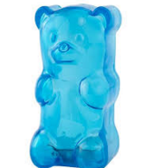
Brooklyn’s Salad Heaven
The victim would never eat salad from anywhere else! She would typically order a salad, with olive oil dressing and a side of french fries. What macromolecules would you expect to find in the stomach contents of the victim if the victim’s final meal was eaten here? ANSWER:
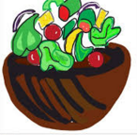
Eggs Over My Hammy
The victim would hang out here and eat breakfast for dinner. She would have scrambled egg whites, with hash browns, and a soda. What macromolecules would you expect to find in the stomach contents of the victim if the victim’s final meal was eaten here? ANSWER:
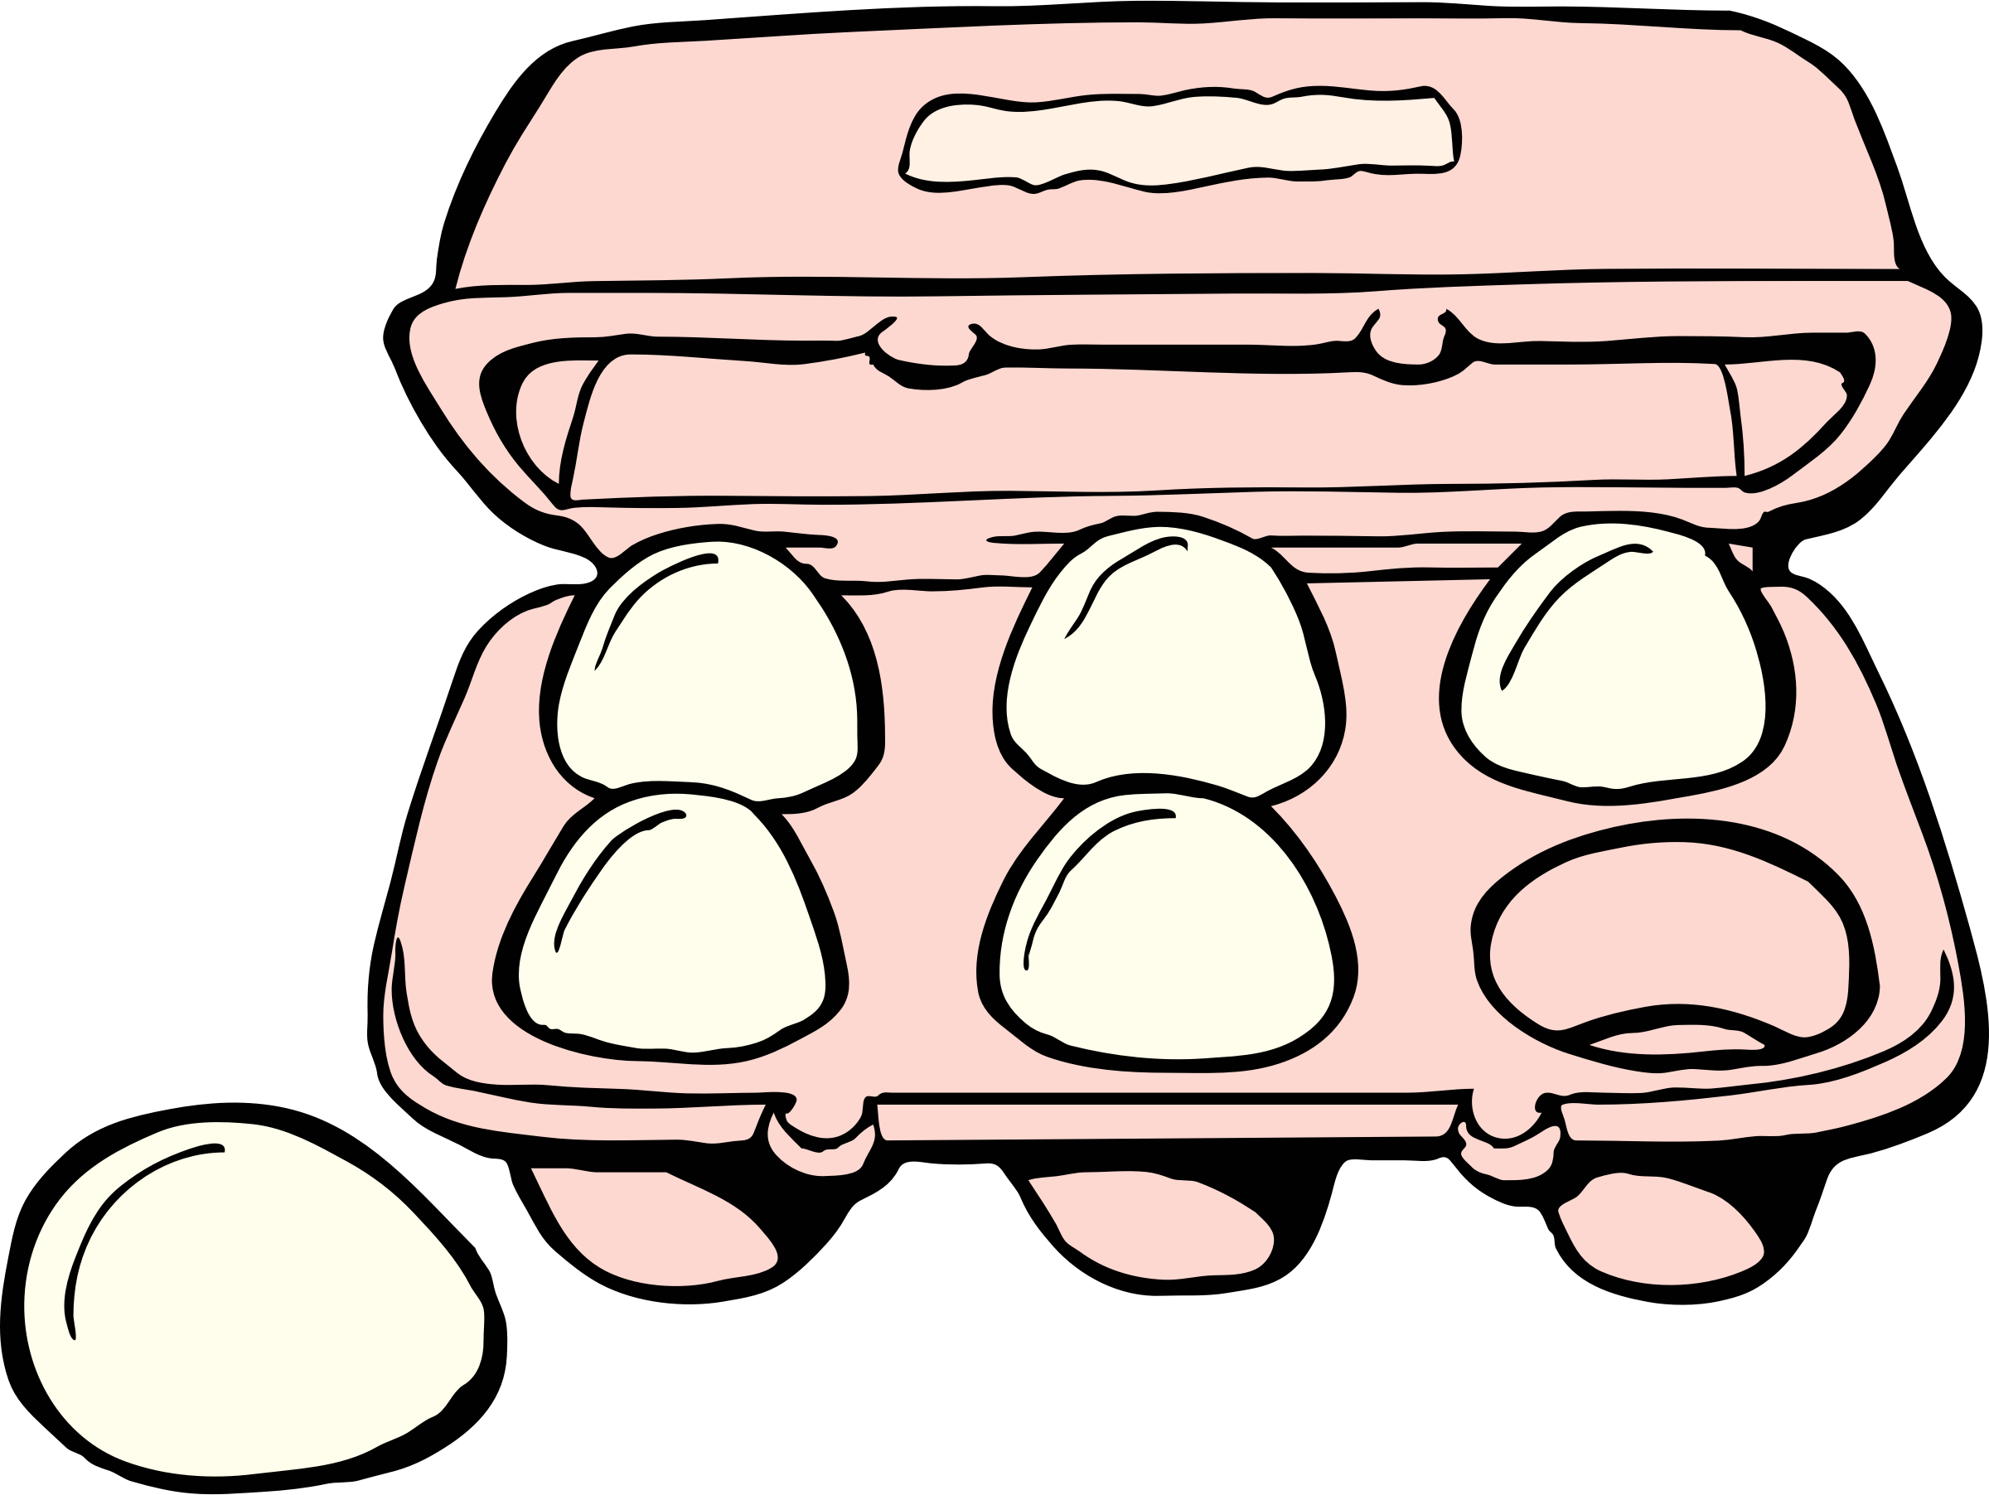
The Spaghetti Palace
The victim loved to go here for a heaping bowl of chicken and broccoli fettuccine alfredo. What macromolecules would you expect to find in the stomach contents of the victim if the victim’s final meal was eaten here? ANSWER:
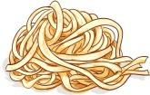

Procedure

First, you must practice testing for Organic Compounds. Around the room (watch out for the vomit on the floor) you will find 3 stations. Go to each station and follow the procedure CAREFULLY for the tests. Safety goggles must be worn at all times and hair must be back. If you get any chemicals on your hands wash them immediately. NO FOOLING AROUND!! REMEMBER YOU ARE IN A CRIME SCENE!!

- LIPID TEST
- What are lipids?
- What kind of foods could you find lipids in?
- Fill out chart with your results:
Food Samples | Lipid Present | Lipid Not Present
Oil
Candy
Potato
Egg White

- CARBOHYDRATE TEST
There are two kinds of carbohydrates commonly found in food, starches, and glucose (or sugars). Starches form when sugars join together in a long chain called a polymer. They are healthy to eat and are found in plants as fiber. Some common foods with starches would be items made from grains, potatoes, and other vegetables. Glucose or sugars are monomers and found in foods such as fruits and vegetables, and the refined sugar that is found in most candies and sweets.

Fill out chart with your results:
Food Samples | Glucose Present | Starch Present
Celery
Potato
Candy
Egg White

- PROTEIN TEST
Your physical traits -- from the shape of your ears to the color of your eyes -- are determined by the proteins that are made in the cells of your body. Proteins are also present in the food you eat.

Fill out the chart with your results:
Food Samples | Protein Present | Protein Present
Celery
Egg White
Potato
Oil

TESTING THE VOMIT

1. Before analyzing the stomach contents of the deceased, you must determine the procedures to be used
to test for each organic compound. You are now experienced testers. Prior to testing the vomit, for each macromolecule, you must:
--Describe the procedure (in enough detail so that others can repeat your work) that you will follow to perform each test.
--Describe what the result will look like if the macromolecule is present (positive) or if it is not present (negative).

Lipid Test

Protein Test

Carbohydrate—Glucose Test

Carbohydrate—Starch Test

2. As a group, use the four test tubes of vomit to test for the presence of each macromolecule. Do each test and record result below.

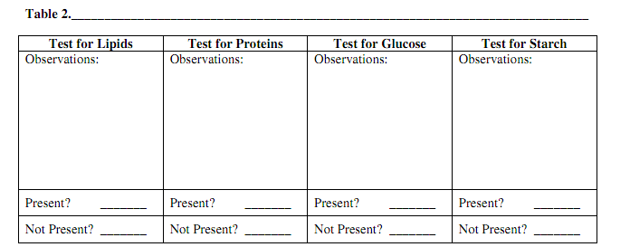

CRIME LAB RESULTS: What restaurant did your teacher eat at last night?

The procedure I followed to test her vomit is as follows:__________________________________________________________________________________________________________________________________________________________________________________________________________________________________________________________________________________________________________________________________________________________________________________________________________________________________________________________________________________________________________________________________________________
When I performed this experiment I observed that the vomit contained the following organic macromolecules: _________________________________________________________________________________________________________________________________________________________________________________________________________
I conclude the science teacher ate at this restaurant last night: ______________________________________________________________________________________________________________________________________
What does your body need lipids for?
______________________________________________________________________________________________________________________________________
What does your body need protein for?
______________________________________________________________________________________________________________________________________
What does your body need carbohydrates for?
______________________________________________________________________________________________________________________________________

LIPIDS TEST
- Your group will need to collect 4 samples: gather 2-3 drops of oil, candy, potato, egg white into their labeled test tube. Carefully drop 3 drops of Sudan red into each test tube. Put the stopper back on top of each and shake for 15 seconds. Let contents settle out for 1 minute. If lipids are present you will see red staining the fat molecules. Wash your hands.
- After filling out your data chart, carefully carry test tubes to the trash can, dump out contents. Take to sink and rinse out well with water. Put test tubes back into their bins with their lids off. Wash hands.

CARBOHYDRATES TEST
- Your group will need to collect 4 samples: gather 2-3 drops for each labeled test tube of 1 celery, 1 candy, 1 potato, and 1 egg whites. Separate your samples so that you have one set of each food sample.
- For the Glucose test: Take 4 test strips out of the container. Dip the square end into the sample, soaking it completely. Remove the strip from the sample, scraping off any extra on the test tube. After 2 minutes, compare the test strip to the colored squares on the container. If it had changed to match any color but the original, there is glucose present.
- For the Starch test: Drop 2 drops of iodine into a food sample test tube. Put the stopper back on top of it and shake it for 20 seconds. Watch to see if iodine turns bluish in color. If there is a bluish color, there is starch present. Repeat with the rest of the samples.
- After filling out your data chart, carefully carry test tubes to trash can, dump out contents, and rinse out at sink with water. Put test tubes back into their bins with their lids off. Wash hands.

PROTEINS TEST
- Your group will need to collect 4 samples: gather 2-3 drops of celery, egg white, potato, and oil into their labeled test tube.
- You will be using a chemical called biuret reagent. It is a base and can harm your skin and eyes. You must wash your hands immediately after performing this test.
- Add 3 drops of biuret reagent to each of the food samples.
- Cover the test tubes with their stoppers and gently shake each tube.
- A pink or purple color indicates the presence of a protein.
- After filling out your data chart, carefully carry test tubes to trash can, dump out contents, and rinse out at the sink with water. Put test tubes back into their bins with their lids off. Wash hands.

VOMIT TEST
- Protein test: biuret reagent
- Glucose test: strips
- Starch test: iodine solution
- Lipid test: sudan red

Answer Key
Candy Queen (glucose--candy)
Brooklyn’s Salad Heaven (glucose--celery, starch--potato, lipid--oil)
Eggs Over My Hammy (protein--egg whites, starch--potato, glucose--candy)
The Spaghetti Palace (protein--egg white, glucose--celery, starch--potato, lipid--oil)

Vomit should be made with: lettuce or celery, corn starch or potato, oil (glucose, starch, lipid)

Hypothesis: If my teacher ate at ___________ restaurant, then the macromolecules of ______________ will be
present in her vomit because _____________________ foods tested positive for their indicator.
Results
LIPID TEST
Food Samples | Lipid Present | Lipid Not Present
Oil | X
Candy |  | X
Potato |  | X
Egg White |  | X

CARBOHYDRATE TEST
Food Samples | Glucose Present | Starch Present
Celery | X
Potato | X | X
Candy | X
Egg White | n/a | n/a

PROTEIN TEST
Food Samples | Protein Present | Protein Not Present
Celery |  | X
Egg White | X
Potato |  | X
Oil |  | X

