Physics

Chapter 3 Outline

Projectile Motion
- Nonlinear motion: motion along a curved path
- A curve is a combo of constant velocity horizontal motion and accelerated vertical motion
- What happens horizontally is not affected by what happens vertically
- Vectors are used to represent quantities that have both magnitude (how much) and direction (which way)
- Velocity and acceleration are vector quantities
- Scalar quantity: a quantity that is completely described by magnitude only
- Arrows represent vector quantities
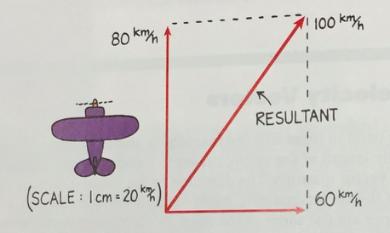
- To find length of vector, make triangle then use pythagorean theorem
- Any vector can be resolved into two component vectors at right angles to each other
- Resolution: the process of determining the components of a vector
- Surfing is another example of vectors
- Projectiles near the surface of Earth follow a curved path
  - When no horizontal force acts on the projectile, the horizontal velocity remains constant
- The horizontal component of motion for a projectile is completely independent of the vertical component of motion
- Upwardly launched projectiles
  - Object continually falls falls beneath this imaginary line until it hits the ground
  - The verticle distance it falls beneath any point on the dashed line is the same vertical distance it would fall if it were dropped from rest and had been falling for the same amount of time
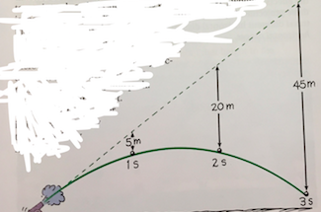
- The vertical distance a object falls below the imaginary straight-line path increases continually with time and is equal to 5t^2
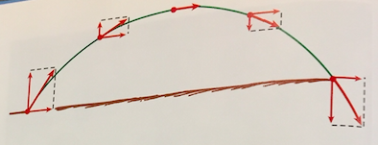
- Picture above: only the vertical distance changes, horizontal stays the same
- Angle affects distance and height of projectile
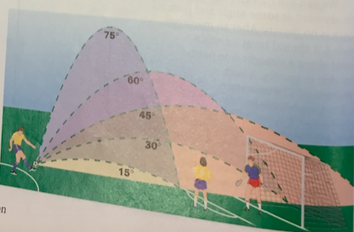
- 2 angles that add up to 90 have the same horizontal distance
- A projectile will rise to its max height in the same time it takes to fall from its max height
- Fast- moving projectiles---Satellites
  - Satellite: a projectile traveling fast enough to fall around Earth rather than into it
  - Satellites are launched above 150 kilometers- puts satellite beyond earth's atmosphere, where air resistance is almost totally absent

