Catapult Lab part I
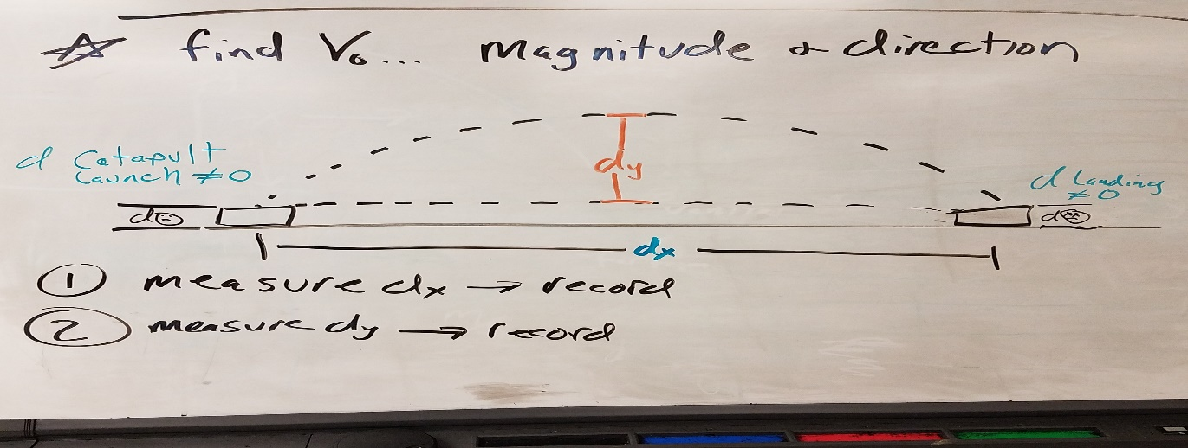

- Shoot until consistent.
- Measure d_{x} and d_{y} and record, in a data table.

- Solve for t1 and hang time (total time)

- Solve for v_{ox}.

- Use equation 3 to solve for v_{oy}.

- Use trigonometry or pathagmorian theorem to solve for v_{o}.

- Solve for Θ, (Theta) (The angle) (you have to use trig now!!!)_

- If photogate is available, compare your v_{oy} with photogate. (not gonna happen)

- If there is time, try to knock down as many guys as you can in 10 launches & find your catapult’s max d_{x} and d_{y}.

