Mammalia-anything with mammary glands and logical thinking, fur/hair

Sus Scrofa- classification for domesticated pig (Genus and Species)

Superior- top (towards the head)

Inferior- bottom (towards the bottom)

Distal- further from the center

Proximal- Close to the center

Posterior-bottom half of the body (butt area)

Ventral- towards the front (belly)

Dorsal- towards the back (like a dorsal fin on a shark)

Sagittal Plane- splits the pigs between the eyes

Transversal Plane- splits the pig in half (face and butt)

Frontal Plane- splits the pig horizontal between the belly and back
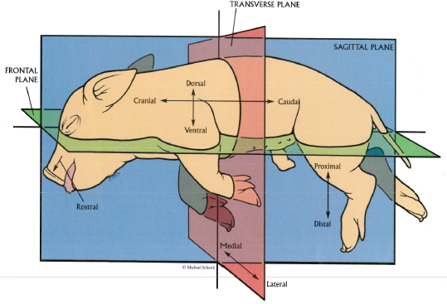

Word | Form | Function | Location | how to remember
Vibrissae | hairs | Find food in the dark | under chin | as in vibrissae looks like two curly hairs
External Nares | nostrils | Smelling and breathing | snout | nares and nostrils both start with n’s
Nictitating membrane | Translucent 3rd eyelid | Protects and moistens eye while maintaining visibility | eyeballs | 3 t’s in nictitating and it's the 3rd eyelid
Penis | Genital Appendage | Reproduction and Urination | groin | you should know this
Anus | Opening at the end of the alimentary canal and the end of the digestive system | To excrete solid waste material from the body | Under the tail on the posterior of the body | you should know this
Genital Papillae | Tissue flap | Excretion | Female genitalia | You should know this
Pinnae | cartilage | To hear | outer part of the ears | think of the saying “so quiet you could hear a pin drop” pin sounds like pinn(ae)
Oral Papillae | tastebuds | Grind food | tounge | when you eat the food will “lay” on your tongue: lay sounds like “papiLLAE”  and oral is mouth
Stomach | pouch large internal organ | Breaks down and churns food | Posterior to the diaphragm. - under the liver on the left side of the pig | you should know this
Small Intestine | Tube or duct | final site of food digestion and primary site of nutrient absorption | Between the stomach and large intestine  Made up of Duodenum & Ileum/jejunum | small intestine is curly
Large Intestine | Tube or duct | absorb fluids and electrolytes and provide temporary storage | cecum, colon, rectum, and anal canal | large room stores more nn. nutrients
Duodenum | Tube | receives partially digested food from the stomach and begins the absorption of nutrients. | first part of the small intestine  Duo = 2; bile duct + pancreatic duct come together here | duodenum says: this nutrients is nummy!
Jejunum/ileum | Small intestine | Most nutrients present in food are absorbed by the jejunum | between the duodenum and the ileum  Jejunum/ileum both make up the majority of the small intestine | food is absorbed like Jello absorbs the guy in cloudy with a chance of meatballs
Liver | Wedge shaped organ | production of bile, storage of carbohydrates as glycogen, and the control of glucose content in the blood | posterior to the diaphragm
Spleen | Flat long organ | filter for purifying the blood, removing microbes | Near backbone | your blood is clean after it goes through the spleen
Kidney | Bean shaped | Removes bad substances from blood and produces urine | thoracic
Bladder | a membranous sac in humans and other animals | Collects urine for excretion. | Urinary Tract | you should know this
Gall Bladder | Small sac-shaped organ | bile is stored after secretion | Beneath the liver
Cecum | A pouch | absorb fluids and salts that remain after completion of intestinal digestion and absorption and to mix its contents with a lubricating substance, mucus | Connects both the small and the large intestine 1st part of large intestine | two c’s in cecum sounds like a seed that needs to absorb nutrients from the ground but it absorbs nutrients after digestion
Pancreas | Large gland | secretes digestive enzymes into the duodenum. | Behind the stomach | enzymes speed up processes like oil speeds up the process when you cook pancakes  (Pancreas sounds like pancakes)
Ureter | A duct | Urine passes through | Connects the kidneys to the bladder
Rectum | Tube | Is the final stage of the digestive tract along with the anus. | Final portion of the large intestine. Terminates at the end of the anus.
Esophagus | a muscular tube lined with a mucus membrane | carries food, liquids, and saliva from the mouth to the stomach | part of the alimentary canal that connects the throat to the stomach | imagine a guy named Gus that’s really muscular
Pericardium | Membrane around the heart | Protects the heart and helps the heart and lungs not rub against each other | Thoracic | perry the platypus protects phineas and Ferb like the PERIcardium protects the heart
Right Atrium | chamber | Pumps blood to the right ventricle | Part of the heart where blood comes back from the body to the right atrium | goes to the right Atrium because A comes before V (ventricle)
Left Atrium | chamber | Holding place for the blood which is also a pump | Part of the heart | goes to the left atrium after the lungs cause A comes before V (ventricle)
Right Ventricle | chamber | Pumps Oxygen depleted blood into the lungs | Part of the heart | v goes after a
Left Ventricle | chamber | Pumps oxygenated blood to all the tissues in the body | Part of the heart | v goes after a
Carotid Artery | Arteries | two key arteries located in the front of the neck, through which blood from the heart goes to the brain. | neck | carotid artery is in the neck and you wear a 13 CARat diamond necklace on your neck
coronary Artery | arteries | Supplies oxygenated blood to the frontal lobes and superior medial parietal lobes. | heart; artery on the heart that supplies blood to the heart | Pretend you love a guy named cory and he is always in your heart
Vena Cava | Superior and Inferior  Blood vessels | connects body to the heart  that transfers unox–ygenated blood from the body to the heart | thoracic | Two v’s in Vena cava and there are 2 blood Vessels that come together
Aorta | Large artery | distributes the blood to the body | Near the heart | A leads the alphabet and the Aorta leads the blood to the whole body
Mitral Valve | Valve | Allows the access of oxygenated blood from the Left Atrium to the Left Ventricle | In the heart | mitral has an l and its between the left ventricle and atrium
Tricuspid valve | Valve | Allows access of unoxygenated blood between the Right Atrium to the Right Ventricle | In the heart | tricuspid has a  Ri like right atrium and ventricle
Lungs | Organ | transporting oxygen from the air into the blood and removing carbon dioxide from the blood | Chest/thoracic Cavity | you should know this
Pulmonary Artery | Artery | Allows passage of blood to and from the lungs and from the heart | Thoracic | pulmon is lungs in Spanish and the pulmonary artery and vein leads to the lungs
Larynx | Muscular organ | muscular organ forming an air passage to the lungs and holding the vocal cords (The voice box) | Neck | Air sounds like lARYnx
Jugular vein | Several large veins | carrying blood from the head and face | In the neck | Jug rhymes with Mug like a mug shot of your face
Pulmonary vein | tube/vein | Carries oxygenated blood to the Left Atrium from the lungs | thoracic | Pulmon is lung in spanish
Trachea | large membranous tube reinforced by rings of cartilage | conveys air to and from the lungs; the windpipe. | extending from the larynx to the bronchial tubes | You hold a tray if you are a waiter to carry food to and fro
Diaphragm | membrane - muscle that contracts to fill the lungs | the membrane separating the thoracic cavity from the abdominal cavity | Center of the body
Thymus Gland | butterfly-shaped gland | produces several hormones which stimulate development of cells important in immunity | Base of the neck
Thyroid Gland | gland | it produces hormones which control metabolism | Below the larynx -- above the heart
Umbilical Cord | Tube connecting the mother and fetus | Carries nutrients from the mother to the fetus and also carries away | External abdominal
Umbilical vein | Vein | delivers oxygenated blood from the placenta to the fetus | In the umbilical cord
Umbilical Artery | artery | arteries on both sides of the urinary bladder that carry deoxygenated blood from the fetus to the placenta | By the bladder
Ovaries | two glands | that produce female sex cells | on each side of the pelvic cavity
Oviduct (fallopian tubes) | Tube or duct | carry the mature female reproductive cell from the ovary to the uterus | pelvic cavity
Uterus | womb | where a fertilized egg is embedded and where the fetus will develop | pelvic cavity
Testes |  | produce and store sperm, source of male hormones, male sex gland | pelvic cavity
Scrotal Sack | membrane | Contains and protects the testes | pelvic cavity
Vas Deferen | tube/duct | Tube where sperm travel from testis to prostate during ejaculation and urination | pelvic cavity
Urethra | tube | tube that transports urine from bladder to outside of body | penis

The Digestive System

- Salivating - enzymes break down food

- Chewing- masticating with the masseter muscle

- Tongue- Oral papillae break down food

- Esophagus- tube that connects the mouth to the stomach

- Cardiac Sphincter- connects esophagus with the Stomach- it opens and closes

- Stomach- food mixes with acid...forms a paste

- Duodenum- Brings together two things
  - Brings in *bile* through the bile duct connecting
  - the liver and duodenum.
    - breaks down fats
  - Brings in Pancreatic duct which provides bicarbonate
and digestive enzymes
    - Neutralizes acid

- Goes to the Jejunum/ileum
  - Ileum is the first part of s.i.
  - Jejunum is the second part of the s. I.
    - Absorption of most of food nutrients

- Cecum- Appendix
  - First part of the L. I.

- Colon
  - Lined with E. Coli
  - Reabsorbs H2O
  - Poop (feces)

- Rectum- muscular tube (pushes the poop)
- Anus- 2 sphincters (butthole)

The Digestive System Diagram

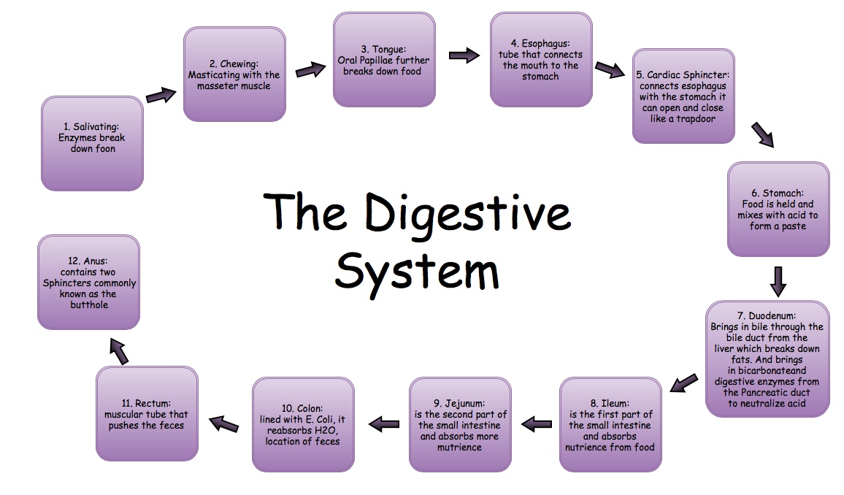

The Cardiovascular System

- Superior and Inferior Vena Cava blood vessel that connects body to the heart
that transfers unoxygenated blood
  - Superior- top of the body blood
  - Inferior- bottom of the body blood

- Blood goes to the Right ventricle first

- Pumps blood through the tricuspid valve into

- The Right Ventricle

- Pulmonary valve allows the passage of the blood

- Blood goes into the Pulmonary artery
  - Transfers blood to the lungs

- Lungs produce CO2

- Oxygenated blood goes from the Left Atrium and through the...

- Mitral Valve that allows the blood to pass to..

- The Left Ventricle transfer blood to the…

- Aorta ( big artery) which distributes the blood to the body
  - Arteries carry blood away from the heart and distributes oxygenated blood

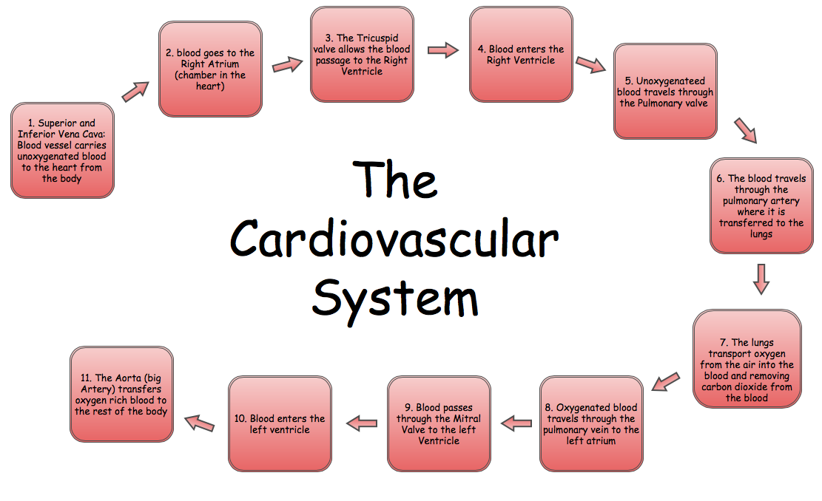
The Cardiovascular System Diagram

