(b) Indicate which arrow, if either, has the greater vertical velocity at its maximum height? Justify your answer
(c) A velocity-time graph is shown, representing the vertical velocity of the arrow shot straight upward. On the same axes, sketch a velocity-time graph representing the vertical velocity of the arrow shot at an angle of 45⁰.
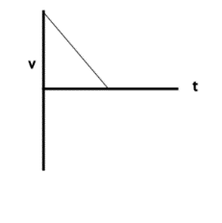
(d) Indicate which arrow, if either, has the greater vertical acceleration at its maximum height? Justify your answer.

