Partner quiz Veterans’ Day Force 1
For all questions, consider to the right,and up positive

1. For each of the following pairs of objects, which one has more inertia?

A. A freight train or a car?
B. A ping pong ball or a baseball?
C. A fast bowling ball or a slow bowling ball?
D. A 20 kg mass or a 10 kg mass?
E. A rock on the earth or a rock in space?
F. A fast baseball or a bowling ball at rest?

2. Identify the following forces as F (applied), T, F_{g} (weight), F_{f} (friction), or F_{N}.

A. _____ From a rope or a string.
B. _____ Opposes weight for objects on surfaces.
C. _____ You push down on an object on a table, this increase.
D. _____ Caused by gravity.
E. _____ Would decrease on the moon.
F. _____ Decreases if a surface is smooth.
G. _____You place a heavy object onto a board. The board will break if this is too small.
H. ____ Always vertical.
I. _____ If a surface is tilted, this changes direction, too.
J. _____ Has the units of Newtons.
K. ____ Doesn’t exist for hanging objects.

3. While a force is acting on an object, list three things that can happen

4. Calculate the net force on M₁. 5. Calculate the net force on M₂. 6. Calculate the net force on M₃.
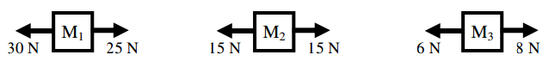

7. Which of the above masses: M1, M2, or M3?

A. ____ Which could be at rest?
B. ____ Acceleration is negative.
C. ____ Acceleration is positive.
D. ____ Has a net force of 0 N.
E. ____ Has a net force (F_{net} ≠0)
F. _____ Has balanced forces.
G. _____ Could be changing direction.
H. _____ Has unbalanced forces.
I. _____ Could be a constant speed.
J. _____ Could be slowing down to the left.

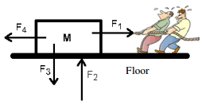

8. Two very small people are pulling a box. Identify the four shown forces as F_{f} (friction); F_{T}; F_{g}; F_{N}. The “Σ” symbol is sigma and means to add up all of the forces.
A. _____ F₁— the two men pulling WITH A ROPE.
B. _____ F₂— the force pushing up by the floor.
C. _____ F₃— the force pulling down on the mass.
D. _____ F₄— the force trying to stop the mass from moving.
E. _____ Which force is in the negative x-direction?
F. _____ Which force is in the positive y-direction?
G. _____ Which force is in the positive x-direction?
H. _____ Which force is in the negative y-direction?
I. Which forces would be used in this equation:
ΣF_{y} = ma_{y}=

J. Which forces would be used in this equation:
ΣF_{x} = ma_{x}=

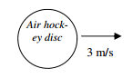
9. Imagine a giant air hockey table, several miles across. Because there is a layer of air everywhere, there is NO friction. We will also assume that the disc has no air resistance. The disc is pushed and moves with an initial velocity of 3 m/s to the right. How far will the disc go?

10. Because there is no friction, what will its speed be after 40 seconds?

11. Two masses are attached by a rope that is threaded around a pulley, as shown. Identify the four shown forces as F_{f} (friction); F_{T}; F_{g}; F_{N}. Calculate the acceleration show work with summation equations. Finding the tension later

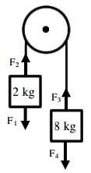
A. ____ F₁ (the force pulling down on the 2 kg mass).
B. ____ F₂ (the force of the rope pulling up on the 2 kg mass).
C. ____ F₃ (the force pulling up on the 8 kg mass).
D. ____ F₄ (the force pulling down on the 8 kg mass).
E. Which two forces are equal?

F. Why?

G. Calculate F₁.

H. Calculate F₄.

12. i) A man pushes on a 10 kg mass with 50 N. Draw FBD’s, Calculate the acceleration of the mass. (mu=0.1) not frictionless.

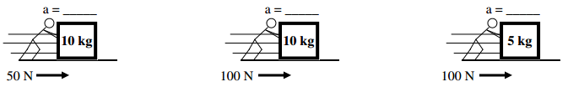
ii. The man then doubles his force. Draw a FBD, Calculate the new acceleration of the mass.

iii. The mass of the object is then halved. Draw a FBD, Calculate the new acceleration.

13. So, from what you just learned above:
A. If you double the applied force the acceleration:

B. If you half the mass, the acceleration of the object:

C. If you applied four times the force, the acceleration would be:

D. If you doubled the mass of the object, the acceleration would:

