AP final 2019 sem 1 Test Review

Energy

1. Write each equation as a sentence.
   1. **Ex:** PE = mgh Potenital energy is defined as mass times gravity times height.
   2. KE = ½ mv2
   3. Work=Fxd
   4. P=W/t
2. If you double ____, what happens to ____?
   1. **Ex:** distance, W answer: since W = Fd then **2**W = F (**2**d) so work doubles
   2. **Ex:** mass and height, PE answer: since PE = mgh then **4**PE = **2**m*g\***2**h so PE quadruples
   3. Mass, KE
   4. Velocity, KE
   5. Speed, stopping distance
3. You push a big car and a small car the same distance across a parking lot. Which car has the greater v at the end? Which car did you do more work on?
4. On the roller coaster pictured below,
   1. What type(s) of energy does the cart have at the starting point, A, assuming it is not moving yet?
   2. What type(s) of energy does the cart have at point B?
   3. What type(s) of energy does the cart have at point C?
   4. Calculate the KE and the PE of the cart at point D if the cart has a mass of 500 kg.
   5. At what points does the car the same TME? PE? KE? Where does KE = PE?
   6. Why will the cart never reach point Z?
5. Who does more work: Baz who can get up 2 flights of stairs (10 m total) in 20 s or his **identical** twin Simon who can get up 1 flight of stairs (5 m) in 10s? Who is more powerful?
6. A worker uses more power running up the stairs than climbing the same stairs slowly. Tor F
7. If he were to run the 2 flights of stairs would he produce more power than running just one? Y/N
8. If you drove your car twice as far as usual, would your car’s engine become more powerful? Y/N
9. An engine with twice the power can do twice the work of one engine in the same amount of time. T/F
10. Chuck Norris throws our principal downward off a cliff into a pillow factory. Our fabulous principal survives, climbs the cliff to yell at Chuck, but Chuck gets mad again and this time throws the principal upward off the cliff with the same velocity he threw him down. Ignoring air resistance, describe the KE of both impacts.
11. You have 2 choices: jump off a cliff or ride a slide down from the cliff. In which situation would you land with more v? More KE?

**Kinematics**

1. 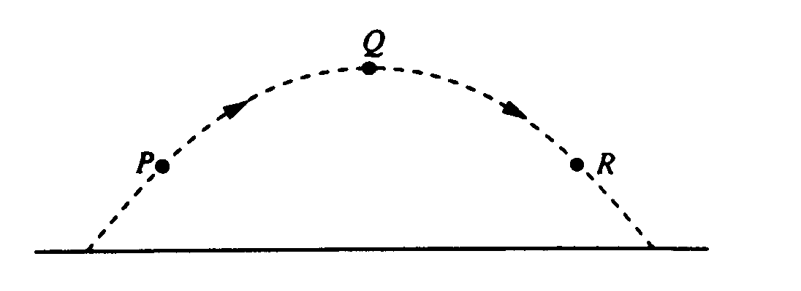1. A truck traveled 800 meters north in 80 seconds, and then it traveled 600 meters east in 70 seconds. The magnitude of the average velocity of the truck was most nearly

(A) 1.3 m/s (B) 5.3 m/s (C) 6.7 m/s (D) 9.3 m/s (E) 13.2 m/s

1. *Next Two Questions:* A ball is thrown and follows the parabolic path shown to the left. Air friction is negligible. Point Q is the highest point on the path. Points P and R are the same height above the ground.
2. 2. How do the speeds of the ball at the three points compare?  
   (A) vP < vQ < vR (B) vR < vQ < vP (C) vQ < vR < vP (D) vQ< vP = vR (E) vP = vR < vQ
3. 3. Which of the following diagrams best shows the direction of the acceleration of the ball at point P?  
   (A)  (B)  (C)  (D)  (E) 
4. 4. Two people are in a boat that is capable of a maximum speed of 5 kilometers per hour in still water, and wish to cross a river 1 kilometer wide to a point directly across from their starting point. If the speed of the water in the river is 5 kilometers per hour, how much time is required for the crossing?

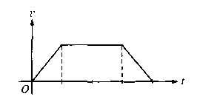(A) 0.05 hr (B) 0.1 hr (C) 1 hr (D) 10 hr (E) The point directly across from the starting point cannot be reached under these conditions.

5.The graph above shows the velocity *v* as a function of time *t* for an object moving in a straight line. Which of the following graphs shows the corresponding displacement *x* as a function of time *t* for the same time interva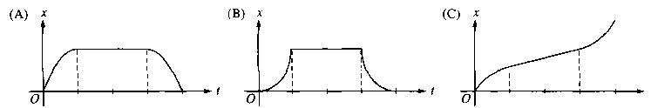 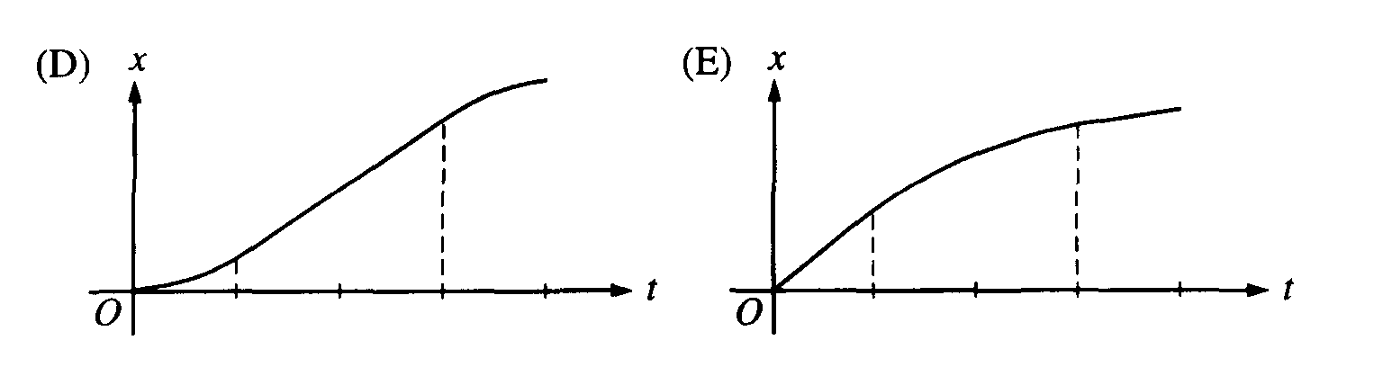

1. 6.A child left her home and started walking at a constant velocity. After a time she stopped for a while and then continued on with a velocity greater than she originally had. All of a sudden she turned around and walked very quickly back home. Which of the following graphs best represents the distance versus time graph for her walk?

(A)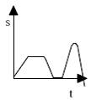(B)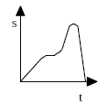(C)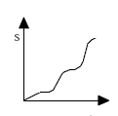(D)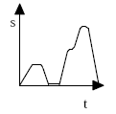(E)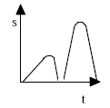

1. 7.A bird is flying in a straight line initially at 10 m/s. It uniformly increases its speed to 15 m/s while covering a distance of 25 m. What is the magnitude of the acceleration of the bird?

(A) 5.0 m/s2 (B) 2.5 m/s2 (C) 2.0 m/s2 (D) 0.5 m/s2 (E) 0.2 m/s2

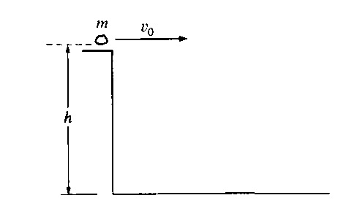

1. 8.A rock of mass *m* is thrown horizontally off a building from a height *h*, as shown above. The speed of the rock as it leaves the thrower’s hand at the edge of the building is *v0*.How much time does it take the rock to travel from the edge of the building to the ground?

(A)  (B)  (C)  (D)  (E) 

1. 9.A ball is thrown straight up in the air. When the ball reaches its highest point, which of the following is true?

(A) It is in equilibrium. (B) It has zero acceleration. (C)It has maximum momentum   
(D) It has maximum kinetic energy. (E) None of the above

1. 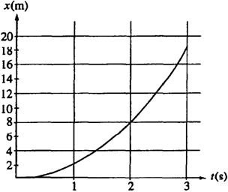10.The graph to the right represents position x versus time t for an object being acted on by a constant force. The average speed during the interval between 1 s and 2 s is most nearly

(A) 2 m/s (B) 4 m/s (C) 5 m/s (D) 6 m/s (E) 8 m/s

1c) Average velocity = total displacement/total time; magnitude of total displacement = 1000 m (3-4-5 triangle) and total time = 150 seconds

2d) At the top of its path, the vertical component of the velocity is zero, which makes the speed at the top a minimum. With symmetry, the projectile has the same speed when at the same height, whether moving up or down.

3e) g points down in projectile motion. Always.

4e) To travel straight across the river, the upstream component of the boat’s velocity must cancel the current. Since the speed of the current is the same as the speed of the boat, the boat must head directly upstream to cancel the current, which leaves no component across the river

5d) A velocity-time graph represents the *slope* of the displacement-time graph. Analyzing the v-t graph shows an increasing slope, then a constant slope, then a decreasing slope (to zero)

6b) The slope of the line represents her velocity. Beginning positive and constant, going to zero, then positive and larger than the initial, then negative while the line returns to the time axis.

7b) vf2 = vi2 + 2ad

8e) For a horizontal projectile; h = ½ gt2 (initial vertical component of velocity is zero)

9e) At *every* point of a projectiles free-fall, the acceleration is the acceleration due to gravity

10d) Average speed = total distance/total time = (8 m – 2 m)/(1 second)

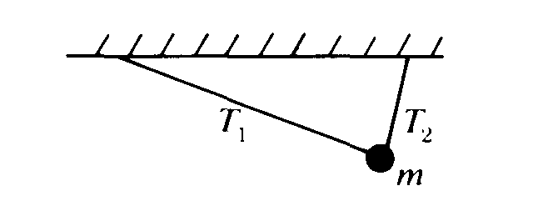**Dynamics**

1. 1. A ball of mass m is suspended from two strings of unequal length as shown. The magnitudes of the tensions T1 and T2 in the strings must satisfy which of the following relations? Ask for help!!

(A) Tl = T2 (B) T1 > T2 (C) T1 < T2 (D) Tl + T2 = mg (E) T1 – T2 = mg

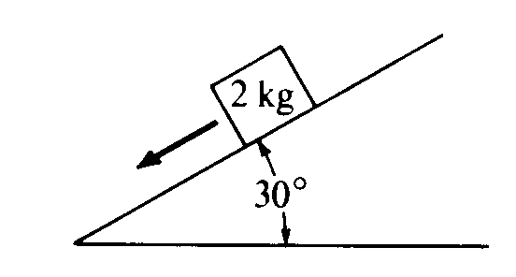*Next Two*: A 2‑kilogram block slides down a 30° incline as shown with an acceleration of 2 m/s2.

1. 2. Which of the following diagrams best represents the gravitational force W (weight). the frictional force f, and the normal force N that act on the block?  
   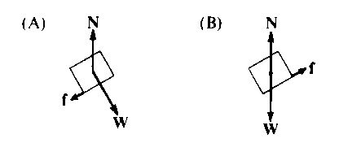 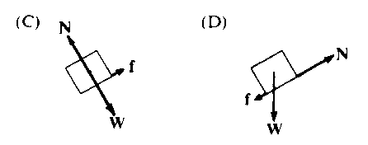 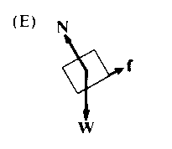
2. 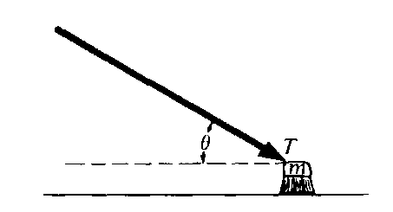3. The magnitude of the frictional force along the plane is most nearly

(A) 2.5 N (B) 5 N (C) 6 N (D) 10 N (E) 16 N

1. 4. A push broom of mass m is pushed across a rough horizontal floor by a force of magnitude T directed at angle θ as shown . The coefficient of friction between the broom and the floor is μ. The frictional force on the broom has magnitude  
   (A) μ(mg + Tsinθ) (B) μ(mg – Tsinθ) (C) μ(mg + Tcosθ) (D) μ(mg – Tcosθ) (E) μmg
2. 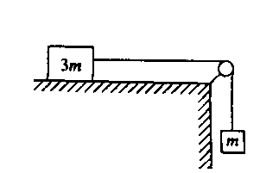5. A block of mass 3m can move without friction on a horizontal table. This block is attached to another block of mass m by a cord that passes over a frictionless pulley, as shown. If the masses of the cord and the pulley are negligible, what is the magnitude of the acceleration of the descending block?  
   (A) Zero (B) g/4 (C) g/3 (D) 2g/3 (E) g
3. 6. Three forces act on an object. If the object is in equilibrium, which of the following must be true?

I. The vector sum of the three forces must equal zero.

II. The magnitudes of the three forces must be equal.

III. All three forces must be parallel.

(A) I only (B) II only (C) I and III only (D) II and III only (E) I, II, and III

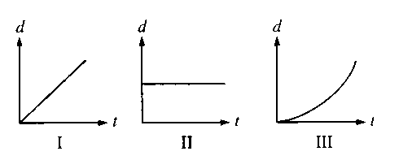

1. 7. Three objects can only move along a straight, level path. The graphs above show the position *d* of each of the objects plotted as a function of time *t*. The sum of the forces on the object is zero in which of the cases?

(A) II only (B) III only (C) I and II only (D) I and III only (E) I, II, and III

1. 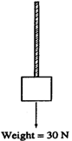8. A rope of negligible mass supports a block that weighs 30 N, as shown to the right. The breaking strength of the rope is 50 N. The largest acceleration that can be given to the block by pulling up on it with the rope without breaking the rope is most nearly

(A) 6 m/s2 (B) 6.7 m/s2 (C) 10 m/s2 (D) 15 m/s2 (E) 16.7 m/s2

1. 9. If the net force on an object were doubled while at the same time the mass of the object was halved, then the acceleration of the object is

(A) 1/4 as great. (B) 1/2 as great. (C) 2 times greater. (D) 4 times greater. (E) unchanged.

1. 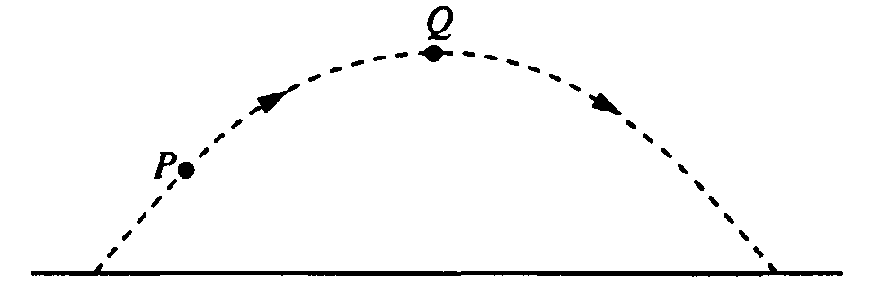

10. A ball is thrown and follows a parabolic path, as shown above. Air friction is negligible. Point Q is the highest point on the path. Which of the following best indicates the direction of the net force on the ball at point P ?

    

**Dynamics**

Answers

1c)

2e)

3c)

4a)

5b)

6a)

7c)

8b)

9d)

10d)