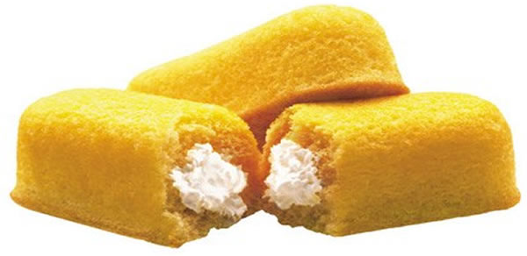

AMERICANS URGED TO STOP SENDING JUNK FOOD TO STARVING PEOPLE

October 11 2009
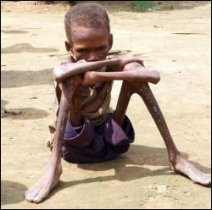
Geneva, Switzerland – The World Health Organization has joined Doctors Without Borders in urging people from the United States to cease sending junk food to starving people around the world. The call comes just as deadly earthquakes and
Tsunamis devastate sections of Indonesia and The Philippines, incidents which has prompted a global outpouring of donations. Though the organization acknowledged that junk food comes from every country, the greatest offenders appear to be the United States which also happens to provide the majority of foodstuffs to countries in need.
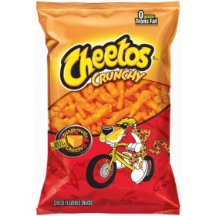
With millions of people starving and millions more on the verge of malnutrition the need for food distribution has become greater in recent years. Devastating droughts across Africa have put hundreds of millions of people at risk but the foodstuffs being received are deemed insufficient to meet dietary requirements, especially in respect to children. WHO has urged people to continue to donate food but has set a list of the most needed foods on their website. The list also details the types of foods that are rejected before reaching those in need as well as foods the majority of people simply don’t like.
“We have been finding more and more that shipments from certain countries, most significantly the United States, have been insufficient to meet the dietary requirements of the majority of people that we are trying to help. While we understand that chocolate bars and Cheetos are very much a part of the American diet they have very limited nutritional value and are therefore simply not usable for the majority of people suffering from malnutrition,” said WHO in a statement. “We encourage people to continue contributing because without you we would be unable to continue to help those most in need but people need to understand the importance of proper diet and nutritional standards. Because certain foods taste good and are filling they are deemed to be of value but that is not always the case.”
WHO reported that shipments of Twinkies, corn chips, and Ho Hos are not distributed to starving people and are largely thrown away. The organization also made it clear that half-eaten foods would also be rejected.
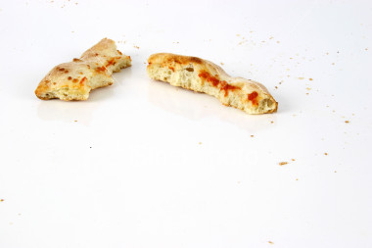
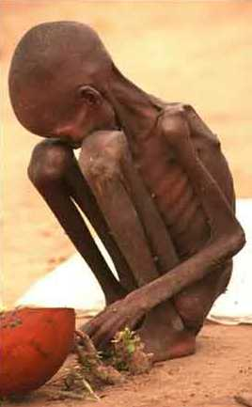
“There is a significant discrepancy between cultures and that is what is likely causing this issue. The concern though is that many Americans will see this as a slap in the face or somehow a rejection of their culture which could prompt them to stop donating altogether. The American people are under no obligation per se to give away food and this type of demand could anger a lot of people,” said Scrape TV Health analyst Rebecca Phelps. “One has to keep in mind that the majority of Americans subsist on this food and cannot understand why it would be rejected. There is a simple explanation for that and it has to do with basic levels of nutrition but that is a hard thing to get across to the American people as a general rule.”
WHO did acknowledge that a recent shipment of M&M’s was intercepted by one of the aid organizations and eaten. That organization has been suspended and the organization stated that it was an isolated incident.
“Pizza crusts and half-eaten sandwiches just don’t cut it for the majority of people who are suffering from serious dietary-related issues that impinge on their health. With proper nutrition people in these will eventually get to the level where their bodies are able to sustain themselves on snack foods but it takes decades of effort and multiple generations to get to that level,” continued Phelps. “Hopefully this request, which is really what it is, won’t prohibit Americans from donating. Their contribution and power is enormous but they need to understand that half-eaten bags of Doritos just aren’t the right thing to donate.”
WHO also stated that they are looking to tailor food shipments to specific countries and the varying preferences of those people.

Emil Uliya, International Correspondent
