Rotation 2: Angular Momentum and Rotational Kinetic Energy

Angular momentum conservation works exactly like linear momentum, with a few caveats. Linear momentum is conserved when both objects are free to slide (the net force acting on the system is zero). Angular momentum is conserved when both objects are free to rotate (the net torque acting on the system is zero). As long as this condition is met, the total angular momentum will remain constant.

When this happens for a single spinning object (ice skater), or a child on a merry go round (who stays on the merry go round), an increase in the rotational inertia will cause a proportional decrease in the angular velocity.

For an object moving in a straight line with constant with respect to a pivot (like a child running and jumping on a merry go round), the angular momentum of that object must be constant (no torque on the object). It is found by L=mva where a is the distance between the line of action of the object (a line drawn through the object parallel to its velocity) and the pivot point for the system.

When two objects stick together and angular momentum is conserved, their rotational inertias add together.

Rotational kinetic energy is just another type of energy that an object can have. When an object rolls without slipping, angular velocity which equals linear velocity / radius, and the linear kinetic energy which refers to the speed of the center of mass of the object, can be combined.

When an object rolls down an incline without slipping, the potential energy becomes linear kinetic energy (because gravity does work to change the energy) and rotational kinetic energy (because friction does work to change the energy. Without friction, none of the potential energy would become rotational kinetic energy.

As the rotational inertia of the object increases, a greater portion of the potential energy becomes rotational kinetic energy than linear. When the rotational inertia increases, the object is harder to turn and more work is required to make it spin--this is why more energy goes into rotational kinetic. It means that the object will be moving with a slower linear velocity.

When the angular momentum of an object is conserved, and its angular velocity increases, the rotational kinetic energy must increase. Likewise, when the angular velocity decreases, the rotational kinetic energy will decrease.

Multiple Choice

- A uniform disk, a uniform hoop, and a uniform solid sphere are released at the same time at the top of an inclined ramp. They all roll without slipping. In what order do they reach the bottom of the ramp?
- sphere, disk, hoop
- disk, hoop, sphere
- hoop, disk, sphere
- sphere, hoop, disk
- hoop, sphere, disk

- A uniform solid 5.25-kg cylinder is released from rest and rolls without slipping down an inclined plane with a height of 0.7 m. How fast is it moving at the bottom of the plane?
- 2.6 m/s
- 3.7 m/s
- 3.0 m/s
- 5.2 m/s
- 4.3 m/s

- Consider a uniform solid sphere of radius R and mass M rolling without slipping. Which form of its kinetic energy is larger, translational or rotational?
- Its translational kinetic energy is larger than its rotational kinetic energy.
- Both forms of energy are equal.
- Its rotational kinetic energy is larger than its translational kinetic energy.
- You need to know the speed of the sphere to tell.

- As you crawl toward the edge of a large freely-rotating horizontal turntable in a carnival funhouse, the angular momentum of you and the turntable
- increases.
- decreases.
- remains the same, but the revolutions per minute decrease.
- remains the same, but the revolutions per minute increase
- none of these

- A 40.0-kg child running at 3.00 m/s suddenly jumps onto a stationary playground merry-go-round at a distance 1.50 m from the axis of rotation of the merry-go-round. The child is traveling tangential to the edge of the merry-go-round just before jumping on. The moment of inertia about its axis of rotation is 600 kg ∙ m2 and very little friction at its rotation axis. What is the angular speed of the merry-go-round just after the child has jumped onto it?
- 2.00 rad/s
- 6.28 rev/s
- 0.261 rad/s
- 3.14 rev/s
- 0.788 rad/s

- A spinning ice skater on extremely smooth ice is able to control the rate at which she rotates by pulling in her arms. Which of the following statements are true about the skater during this process?
- Her angular momentum remains constant.
- She is subject to a constant non-zero torque.
- Her kinetic energy remains constant.
- Her moment of inertia remains constant.
- A particle of mass m moves with a constant speed v along the dashed line y = a. When the x-coordinate of the particle is x_{o}, the magnitude of the angular momentum of the particle with respect to the origin of the system is
- zero
- mva
- mvx_{o}

- A student holding two textbooks sits on a spinning lab stool with his arms extended outward. What happens to his kinetic energy as he pulls his arms and books inward?
- Remains constant
- Increases
- Decreases
- Doubles

- A child on a spinning merry-go-round walks from the center to the outside edge of the merry-go-round. What happens to the angular momentum, angular speed, and kinetic energy of the child/merry-go-round system?
Angular Momentum Angular Speed Kinetic Energy
- Constant Constant Constant
- Constant Decrease Decrease
- Decrease Constant Decrease
- Increase Increase Increase

- The diagram provided shows a top view of a child of mass M on a circular platform of mass 2M that is rotating counterclockwise. Assume the platform rotates without friction. Which of the following statements describes an action by the child that will increase the angular speed of the platform-child system, and gives the correct reason why?
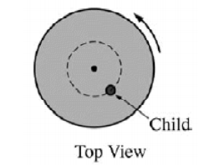

- The child moves toward the center of the platform, increasing the total angular momentum of the system.
- The child moves toward the center of the platform, decreasing the rotational inertia of the system.
- The child moves away from the center of the platform, increasing the total angular momentum of the system.
- The child moves away from the center of the platform, decreasing the rotational inertia of the system.

Free Response:

- A solid sphere (mass of m, radius of r, and I = 2/5 mr² ) is rolling without slipping on a rough surface with a speed of v. A ramp (mass of 2m and angle of θ) rests on a smooth surface that is located on Earth, as shown in the diagram. In Trial 1, the ramp is smooth and frictionless. In Trial 2, it is rough and has friction such that the ball rolls without slipping.
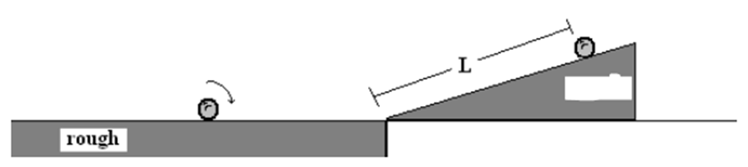
Trial 1

smooth

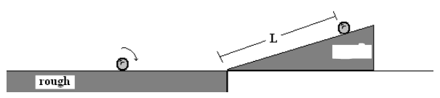

Trial 2

rough

- Find the height of the sphere relative to the ground when the sphere reaches the top of the ramp in trial 2.

- Indicate whether the height of the sphere relative to the ground when the sphere reaches the top of the ramp is greater in Trial 1 or Trial 2. Justify your answer in a clear, coherent paragraph length explanation.

- An ice skater starts his performance-ending spin with his arms outstretched (his moment of inertia is 100 kgm²), rotating at 2.5 rev/s. As he pulls his arms inward, his rotational inertia decreases to 70 kgm². Two students are discussing how to determine his final angular speed.

Anna: “I think we have to use conservation of angular momentum. The distance from the skater’s center of mass to the axis of rotation decreases as he pulls his arms inward. The total moment of inertia goes down, and so the angular velocity has to go up.”

Noah: “Well, I agree that the angular velocity goes up but I think you are going to get the wrong value. We need to use conservation of energy instead of conservation of momentum because there is no collision here. The rotational kinetic energy is what’s going to stay the same here, and as the moment of inertia decreases, the angular velocity goes up.”

- Which, if either, of these students do you agree with and think is correct? Explain why in a short paragraph.

- What is the skater’s final angular speed?

- What is the skater’s final kinetic energy?

- Is his final kinetic energy different than his initial kinetic energy? Explain why in a short paragraph.

