Rotation 1: Rotational Kinematics and Torque

All objects on a rotating object experience the same angular displacement (turn through the same angle in same amount of time), the same angular velocity, and the same angular acceleration. The linear or tangential quantities, however, depend on the radius and will be larger for objects that are a further distance away from the point of rotation.

If we are talking about points on a rotating object or the center of mass of an object that is rolling without friction, then
linear distance traveled = radius x angular displacement
linear velocity = radius x angular velocity
linear acceleration = radius x angular acceleration
Because the angular quantities are related to each other in the same way that the linear quantities are, the kinematic equations as well as the graphical relationships apply to the angular quantities.

An object fixed to spin about its center of mass will experience a resistance to a change in angular velocity--this is called rotational inertia.

A net torque acting on an object will cause that object to angularly accelerate--the rotational inertia resists this angular acceleration (Newton’s second law for a rotating system).

A torque is a force applied some distance from the point of rotation. That force must be perpendicular to the radius (a line drawn from the point of rotation to the point of application of the force). A force that is not perpendicular but parallel has no torque (it will not cause the system to spin).

For coupled motion problems, a Newton’s second law equation for the rotating part of the system must be written (remembering [angular acceleration = acceleration/radius).

Multiple Choice

- When a rigid object rotates about a fixed axis, what is true about all the points in the object? (There could be more than one correct choice.)
- They all have the same tangential acceleration.
- They all have the same angular speed.
- They all have the same angular acceleration.
- They all have the same tangential speed.
- They all have the same radial acceleration.

- Two children, Ahmed and Jacques, ride on a merry-go-round. Ahmed is at a greater distance from the axis of rotation than Jacques. Which of the following are true statements? (There could be more than one correct choice.)
- Jacques and Ahmed have the same angular speed.
- Ahmed has a greater tangential speed than Jacques.
- Jacques has a greater angular speed than Ahmed.
- Jacques has a smaller angular speed than Ahmed.
- Jacques and Ahmed have the same tangential speed.

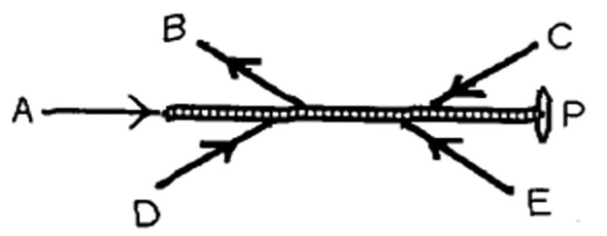
- Five forces act on a rod that is free to pivot at point P, as shown in the figure. Which of these forces is producing a counter-clockwise torque about point P?
- force A
- force B
- force C
- force D
- force E

- A cinder block of mass m = 4.0 kg is hung from a nylon string that is wrapped around a frictionless pulley having the shape of a cylindrical shell. If the cinder block accelerates downward at 4.90 m/s² when it is released, what is the mass M of the pulley?
- 6.0 kg
- 8.0 kg
- 4.0 kg
- 10 kg
- 2.0 kg

- A man in a gym is holding an 8.0-kg weight at arm's length, a distance of 0.55 m from his shoulder joint. What is the torque about his shoulder joint due to the weight if his arm is horizontal
- 0.24 N ∙ m
- 43 N ∙ m
- 15 N ∙ m
- 4.4 N ∙ m
- 0 N ∙ m

- Two blocks are joined by a light string that passes over the pulley shown in the diagram, which has radius R and moment of inertia I about its center. T1 and T2 are the tensions in the string on either side of the pulley and α is the angular acceleration of the pulley. Which of the following equations best describes the pulley's rotational motion during the time the blocks accelerate?
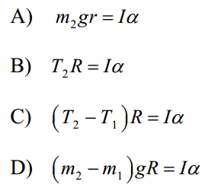

- A uniform solid cylinder (I = ½MR²) of mass 10 kg can rotate about a frictionless axle through its center O, as shown in the cross-sectional view in the figure. A rope wrapped around the outer radius R1 = 1.0 m exerts a force of magnitude F1 = 5.0 N to the right. A second rope wrapped around another section of radius R2 = 0.50 m exerts a force of magnitude F2 = 6.0 N downward. What is the angular acceleration of the cylinder?
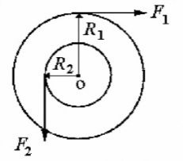

- 0.80 rad/s2
- 1.0 rad/s2
- 0.40 rad/s2
- 0.60 rad/s2

- A bowling ball is thrown down the bowling lane so that it is initially spinning with back-spin and sliding forward at the same time. As it moves, how does the force of friction affect the ball’s spin rate and the speed of the ball’s center of mass?
Spin rate Speed of center of mass
- spins faster decreases
- spins faster increases
- no change no change
- spins slower decreases

- Which of the following statements are true about an object’s rotational inertia? Select two answers.
- Rotational inertia is proportional to the object’s mass regardless of choice of axis.
- Rotational inertia is inversely proportional to the object’s speed.
- Rotational inertia has the units of kg m/s².
- Rotational inertia depends on the choice of the axis of rotation.

- A wheel rotates through 10.0 radians in 2.5 seconds as it is brought to rest with a constant angular acceleration. What was the initial angular velocity of the wheel before the braking began?
- 0.25 rad/s
- 0.625 rad/s
- 2.0 rad/s
- 8.0 rad/s

Free Response:

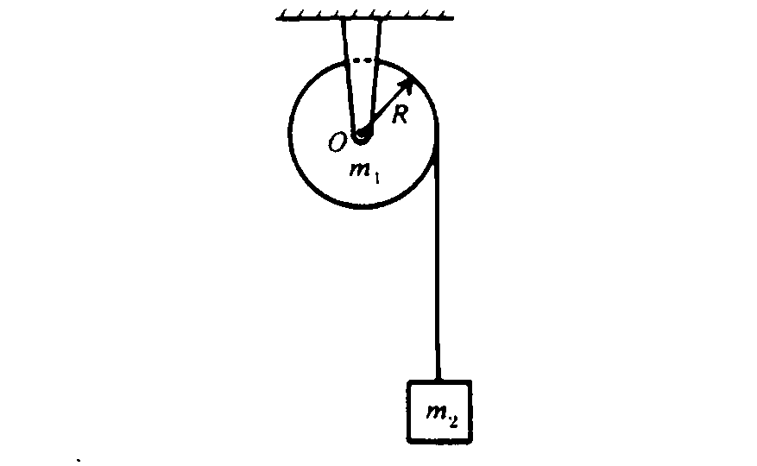
- A uniform solid cylinder of mass m₁ and radius R is mounted on frictionless bearings about a fixed axis through O. The moment of inertia of the cylinder about the axis is I = ½m₁R². A block of mass m₂, suspended by a cord wrapped around the cylinder as shown above, is released at time t = 0.

- On the diagram below draw and identify all of the forces acting on the cylinder and on the block.

- Write out an equation for each mass that relates the forces/torques acting on the mass to its acceleration/angular acceleration.

- In terms of m_{l}, m₂, R. and g, determine the acceleration of the block

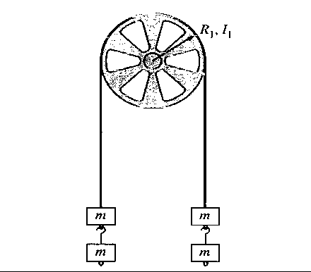

- A pulley of radius R₁ and rotational inertia I₁ is mounted on an axle with negligible friction. A light cord passing over the pulley has two blocks of mass m attached to either end, as shown above. Assume that the cord does not slip on the pulley. Determine the answers to parts (a) and (b) in terms of m, R₁, I₁, and fundamental constants.

a. Determine the tension T in the cord.

b. One block is now removed from the right and hung on the left. When the system is released from rest, the three blocks on the left accelerate downward with an acceleration g/3 . Determine the following.
i. The tension T₃ in the section of cord supporting the three blocks on the left

ii. The tension T_{l} in the section of cord supporting the single block on the right

iii. The rotational inertia I₁ of the pulley

