**Newton's Laws**

Laws 1 and 2 describe what the forces acting on an object do to its motion. If the forces acting on the object add to zero, the object will maintain constant motion. This means that the object will have constant or zero velocity that does not change. This is an important property that all objects have called inertia--a resistance to a change in motion (we also call this mass). If there is a net force acting on object, its motion will change or it will accelerate.

The second law describes how the net force, the acceleration, and the mass of an object are related. Writing it in terms of acceleration is most helpful [a=F/m]. This is the fallback equation for all Newton's second law problems--find the net outside force acting on a system, find the total inertia (mass) on the system.

Newton's third law is different and really acts to define what a force is. Necessarily, a force describes the interaction between 2 objects (if two objects cannot be identified, you are not talking about a force--this is why forces of inertia are refers to as fake forces). Anytime one object acts on another, the other object acts back with an equal and opposite reaction force. This force pair has certain conditions that must be true to qualify as a true third law force pair:

1) The forces must act on different objects [if object a acts on object b then object b acts on object a]

2) The forces must be equal in magnitude

3) The forces must be of the same type [if the action is a gravitational force the reaction must also be a gravitational force].

A common misconception is that the normal force and the weight of an object are action/reaction pairs. They cannot be for 2 reasons: they are different types of forces and they act on the same object.

The force pairs in that situation are: normal force (the object pushes on the surface and the surface pushes on the object) and weight (the earth pulls on theories and the object pulls on the earth). It is important to note that the third law does not help with defining the motion on an object because the force pairs act on different objects and an object's motion is determined by the forces acting on it.

**Multiple Choice**

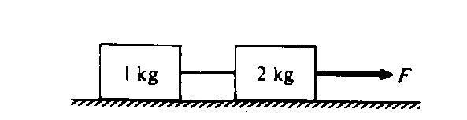

1. When the frictionless system shown above is accelerated by an applied force of magnitude F, the tension in the string between the blocks is

1. 2 F
2. F
3. 2/3 F
4. 0.5F
5. 1/3 F

2. A 20-ton truck collides with a 1500-lb car and causes a lot of damage to the car. During the collision

1. the car and the truck have the same magnitude acceleration.
2. the force on the truck due to the collision is slightly greater than the force on the car.
3. the force on the car due to the collision is much greater than the force on the truck.
4. the force of on the truck due to the collision is exactly equal to the force on the car.

3. Suppose you are playing hockey on a new-age ice surface for which there is no friction between the ice and the hockey puck. You wind up and hit the puck as hard as you can. After the puck loses contact with your stick, the puck will

1. speed up a little, and then move at a constant speed.
2. not slow down or speed up.
3. speed up a little, and then slow down.
4. start to slow down.

4. Which of the following statements is true?

1. The mass of a body is a quantitative measure of its inertia.
2. Mass is a vector quantity.
3. The mass of a body is directly proportional to the acceleration it is experiencing.
4. The unit of mass in the U.S. customary system is the Newton.
5. The mass of a body is inversely proportional to the resultant force acting on it.

5. A boy holds a bird in his hand. The reaction force to the weight of the bird is the force of the

1. earth on the bird.
2. bird on the earth.
3. hand on the bird.
4. bird on the hand.
5. earth on the hand.

6. A horse harnessed to a wagon refuses to pull, citing Newton's third law, which states that for every force there is an equal but opposite reaction force. The horse, incorrect in its reasoning, *can* pull the wagon because

1. after it gives a jerk and the wagon is moving, its pulling force will be greater than the reaction to this force.
2. the law applies only to static cases.
3. the wagon cannot possibly pull back with a force equal in magnitude to the pulling force.
4. the action and reaction forces are acting on different bodies.
5. after friction is overcome, the reaction force is less than the pulling force.

7. A block of wood is pulled by a horizontal string across a rough surface at a constant velocity by a force of 20 N. The coefficient of kinetic friction between the surfaces is 0.3. The force of friction is

1. impossible to determine without knowing the mass of the block.
2. impossible to determine without knowing the speed of the block.
3. 0.3 N
4. 6 N
5. 20 N

8. You are standing in a moving bus, facing forward, and you suddenly fall forward as the bus comes to an immediate stop. The force acting on you that causes you to fall forward is

1. the force due to kinetic friction between you and the floor of the bus.
2. the normal force due to your contact with the floor of the bus.
3. the force due to static friction between you and the floor of the bus.
4. the force of gravity.
5. No forces were acting on you to cause you to fall.



9. Two objects having masses *m*1 and *m*2 are connected to each other as shown in the figure and are released from rest. There is no friction on the table surface or in the pulley. The masses of the pulley and the string connecting the objects are completely negligible. What must be true about the tension *T* in the string just after the objects are released?

1. *T* = *m*2*g*
2. *T* > *m*2*g*
3. *T* = *m*1*g*
4. *T* > *m*1*g*
5. *T* < *m*2*g*

10. A stalled car is being pushed up a hill at constant velocity by three people. The net force on the car is

1. down the hill and greater than the weight of the car.
2. down the hill and equal to the weight of the car.
3. up the hill and greater than the weight of the car.
4. zero.
5. up the hill and equal to the weight of the car.

11. In order to lift a bucket of concrete, you must pull up harder on the bucket than it pulls down on you.

1. True
2. False

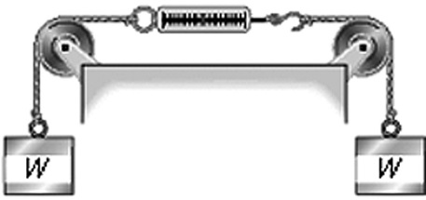

12. Two objects, each of weight *W*, hang vertically by spring scales as shown in the figure. The pulleys and the strings attached to the objects have negligible weight, and there is no appreciable friction in the pulleys. The reading in each scale is

1. more than *W*, but not quite twice as much.
2. 2*W*.
3. *W.*
4. more than 2*W*.
5. less than *W*.

13. Consider what happens when you jump up in the air. Which of the following is the most accurate statement?

1. It is the upward force exerted by the ground that pushes you up, but this force cannot exceed your weight.
2. When you jump up the earth exerts a force *F*1 on you and you exert a force *F*2 on the earth. You go up because *F*1 > *F*2.
3. When you push down on the earth with a force greater than your weight, the earth will push back with the same magnitude force and thus propel you into the air.
4. You are able to spring up because the earth exerts a force upward on you that is greater than the downward force you exert on the earth.
5. Since the ground is stationary, it cannot exert the upward force necessary to propel you into the air. Instead, it is the internal forces of your muscles acting on your body itself that propels your body into the air.

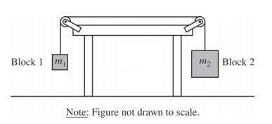

**Free Response**

1. Two blocks are connected by a string of negligible mass that passes over massless pulleys that turn with negligible friction, as shown in the figure above. The mass m2 of block 2 is greater than the mass m1 of block 1. The blocks are released from rest.

(a) The dots below represent the two blocks. Draw free-body diagrams showing and labeling the forces (not components) exerted on each block. Draw the relative lengths of all vectors to reflect the relative magnitudes of all the forces.

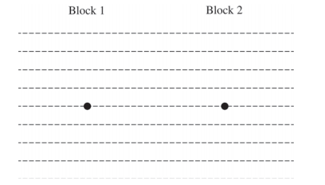

(b) Derive the magnitude of the acceleration of block 2. Express your answer in terms of m1, m2, and g.

Block 3 of mass m3 is added to the system, as shown below. There is no friction between block 3 and the table.

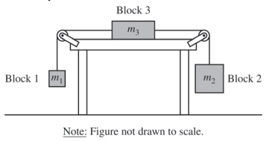

(c) Indicate whether the magnitude of the acceleration of block 2 is now larger, smaller, or the same as in the original two-block system. Explain how you arrived at your answer.

2. A student stands on a small boat that is floating in a lake. The mass of the student is 80 kg and the mass of the boat is 20 kg. The student jumps up and outward from the boat as shown in the picture.

Student and boat before jump

Student and boat after jump

a) On the two dots below, one representing the boat and one representing the student, draw a free body diagram for each object showing the forces (to scale) on each object *while the student is jumping* up and out from the boat.

|  |  |
| --- | --- |
|  |  |
| boat | student |

b) In a short but descriptive paragraph, completely describe and explain the motion of the boat *while the student is jumping* in terms of Newton’s three laws of motion.