Momentum

Momentum conservation is tied directly to Newton’s laws. In an interaction between two objects, they will pass momentum back and forth between each other. If one object loses momentum, the other object will gain the exact same amount of momentum. The objects will experience equal and opposite changes in momentum. This is a statement of Newton’s 3rd law and it works the exact same way for the interaction between two objects, no matter what the objects are. Momentum will always be conserved if the system is defined to be large enough. When an object is thrown against a wall, the object experiences a change in momentum but the wall does not appear to. If the earth is included in the system (the wall is attached to the earth), we can say that the earth experiences an equal and opposite change in momentum, but the mass of the earth dictates that its change in velocity will be very small. If we consider two objects that collide as a part of a system, we can say that all of the forces of the collision are internal forces and do not contribute to the net force. For the system, then, there is no external force and the system will not have an acceleration. If there is no change in velocity for the system, there will be no change in momentum. Newton’s second law can be manipulated from F = ma to F = Δp/t. If the net force acting on the system is zero, the change in momentum is zero.

An individual object can experience a change in momentum. It’s just that the momentum of the system is conserved. Using Newton’s second law, F = Δp/t, then Δp = F*t (change in momentum = force x time or impulse = force x time). Impulse and the change in momentum for an object are the same thing. This gives a convenient way of finding the average force that acts on an object.
Two things to keep in mind:
1) Change in velocity depends on the direction that an object moves. (a ball going into a wall with a speed of 10m/s and leaving with a speed of 10 m/s has a change in velocity of 20 m/s because it changed direction)
2) Regardless of how an object stops (from a given velocity) it will have the same change in momentum. Adjusting the time of collision will only affect the average force acting on it.

The area of a force vs. time graph is the change in momentum/impulse acting on the object. The slope of the same graph has no useful definition.

Multiple Choice

- A car accelerates from rest. In doing so the absolute value of the car's momentum changes by a certain amount and that of the Earth changes by:
- a larger amount.
- the same amount.
- a smaller amount.
- The answer depends on the interaction between the two.

- Consider two carts, of masses m and 2m, at rest on an air track. If you push first one cart for 3 s and then the other for the same length of time, exerting equal force on each, the momentum of the light cart compared to the momentum of the heavy cart is
- four times as much
- twice as much
- equal
- one-half as much
- one-quarter as much

- A person attempts to knock down a large wooden bowling pin by throwing a ball at it. The person has two balls of equal size and mass, one made of rubber and the other of putty. The rubber ball bounces back, while the ball of putty sticks to the pin. Which ball is most likely to topple the bowling pin?
- the rubber ball
- the ball of putty
- makes no difference
- need more information

- An object P has an initial velocity v. It strikes an initially stationary object Q which is attached to a spring, as shown. The compression of the spring is greatest at the instant when:
- the velocity of P is exactly zero
- P and Q move with the same velocity
- Q begins to move
- Q reaches the initial velocity of P
- All the kinetic energy of P has been transferred to the spring

- Complete the following statement: Momentum will be conserved in a two-body collision only if
- both bodies come to rest.
- the collision is perfectly elastic.
- the kinetic energy of the system is conserved.
- the net external force acting on the two-body system is zero.
- the internal forces of the two body system cancel in action-reaction pairs.

- While in horizontal flight at a speed of 20 m/s, a baseball of mass 0.11 kg is struck by a bat. After leaving the bat, the baseball has a speed of 29 m/s in a direction opposite to its original direction. The magnitude of the impulse given the ball is
- 0.99 kg · m/s
- 5.4 kg · m/s
- 2.2 kg · m/s
- 3.2 kg · m/s
- 0.55 kg · m/s

Questions 7-9:
A net force that varies as a function of time is applied to a mass of 7.0 kg according to the graph as shown below: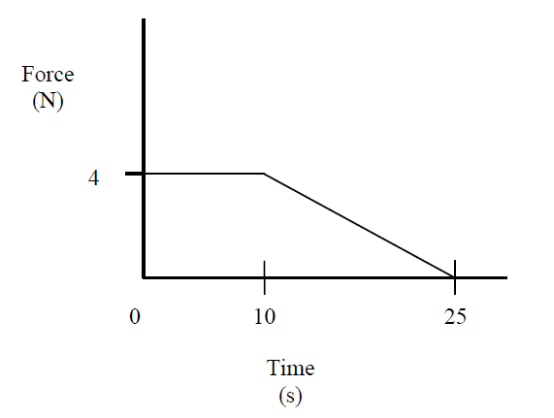
- Calculate the impulse applied to the mass during the first 25 seconds
- 70 Ns
- 40 Ns
- 30 Ns
- – 2/25 Ns

- If the object had an initial velocity of 3.0 m/s at time t = 0, it’s velocity after 25 s would be
- 7 m/s
- 10 m/s
- 13 m/s
- 15 m/s

- What is the acceleration of the object during the first 10 seconds?
- 0 m/s²
- 4/7 m/s²
- 7/4 m/s²
- 28 m/s²

- A rock is dropped from a high tower and falls freely under the influence of gravity. Which one of the following statements is true concerning the rock as it falls?
- It will gain an equal amount of momentum during each second.
- It will gain an equal amount of kinetic energy during each second.
- It will gain an equal amount of speed for each meter through which it falls.
- It will gain an equal amount of momentum for each meter through which it falls.
- The amount of momentum it gains will be proportional to the amount of potential energy that it loses.

- A 1.0-kg ball has a velocity of 12 m/s downward just before it strikes the ground and bounces up with a velocity of 12 m/s upward. What is the change in momentum of the ball?
- zero kg • m/s
- 12 kg • m/s, downward
- 12 kg • m/s, upward
- 24 kg • m/s, downward
- 24 kg • m/s, upward

- In which one of the following situations is linear momentum not conserved?
- A bomb suspended by a string explodes into one hundred fragments.
- A bowling ball collides with ten pins.
- A golf ball is struck by a club.
- An astronaut floating in space throws a hammer away and subsequently moves in the opposite direction.
- A tree limb is struck by lightning and falls to the ground.

- An object of mass 3m, initially at rest, explodes breaking into two fragments of mass m and 2m, respectively. Which one of the following statements concerning the fragments after the explosion is true?
- They may fly off at right angles.
- They may fly off in the same direction.
- The smaller fragment will have twice the speed of the larger fragment.
- The larger fragment will have twice the speed of the smaller fragment.
- The smaller fragment will have four times the speed of the larger fragment.

- An 80-kg astronaut carrying a 20-kg tool kit is initially drifting toward a stationary space shuttle at a speed of 2 m/s. If she throws the tool kit toward the shuttle with a speed of 6 m/s as seen from the shuttle, her final speed is
- 1 m/s toward the shuttle.
- 1 m/s away from the shuttle.
- 2 m/s toward the shuttle.
- 4 m/s toward the shuttle.
- 6 m/s away from the shuttle.

Free Response
- An arrow resting on a bow string experiences a variable force for 0.85 s as it is shot from the bow, as shown in the graph provided.
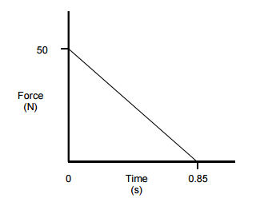
- Given the mass of the arrow as m_{arrow} = 0.20 kg, use the graph to calculate the speed of the arrow at the instant it leaves the bow string. Explicitly indicate the principles used in your calculations.

The arrow then travels in a parabolic path until it hits an apple on top of a man’s head. When the arrow hits the apple, it is at the same height as it was when it left the bow. The arrow and apple stick together and fly off his head, landing a certain distance behind the man. The mass of the apple is 0.4 kg.

- Determine the speed of the apple/arrow system as it leaves the man’s head. Explicitly indicate the principles used in your calculations.

- The archer states, “The momentum of the arrow and the apple could not be conserved during the collision because of the large frictional forces between the apple and the entering arrow.” Do you agree with this statement? Why or why not?

- Is this collision elastic? Justify your answer.

