**Kinematics**

1 D Kinematics

Most, if not all problems involving constant acceleration, can be solved by evaluating a velocity vs time graph. More than using the three equations, this is a hugely important skill. Identifying what the slope and the area of a graph represent is an extremely important test taking skill and should be the first thing that students do when they see a graph of any sort on the test--even before they read the problem. The slope of a velocity vs time graph is acceleration and the area of a velocity vs time graph is displacement.

When there is a constant acceleration In a problem, the v vs t graph is a straight line of some sort, making it very easy to use to solve a problem. Drawing the knowns on to the graph makes it very easy to solve for the unknown. If students need to use the kinematic equations, it is important to note that the first step will always be solving for the acceleration. The format of the new AP exam is such that they will have very few opportunities to use the kinematic equations and will be better served by using the v vs t graph.

Projectiles

In order for an object to be considered a projectile, it must be in free fall. All objects near the surface of the earth experience the same acceleration due to gravity (10 m/s), regardless of their mass. This could be explained by saying that the weight of the object (the force due to gravity) depends on the object's mass, and to find the acceleration, the net force is divided by the mass. A more elegant explanation is that all objects at the same (or roughly the same) distance from the earth are in the same gravitational field and experience the same force per unit mass (acceleration).

The only force acting on a projectile is the weight, nothing else, meaning that a projectile can only accelerate in the y-direction. One of the things that makes projectiles solvable is the independence of X and y motion: motion in the X direction for an object is independent of the option in the y direction. This means that the x component of the motion has constant velocity and does not affect the y component. The y component of the velocity behaves exactly like an object dropped or thrown straight up into the air. It stops at the highest point as it turns around without the acceleration of the object changing.

**Multiple Choice**

1. A toy dart is fired straight up into the air. Ignoring air resistance, when the dart reaches its maximum height, its velocity is
2. maximum
3. minimum
4. equal to its displacement multiplied by the time
5. equal to 0 m/s
6. equal to 9.8 m/s2
7. A toy dart is fired straight up into the air, and returns to its original position. In the absence of air friction, the total displacement of the toy dart is
8. zero
9. equal to twice the upward distance traveled
10. equal to the average speed of the dart divided by the time it was in the air
11. equal to the average speed of the dart divided by the acceleration due to gravity
12. equal to the final and initial speeds of the dart divided by the acceleration due to gravity
13. A Triumph sports car accelerates uniformly from rest to a speed of 30 m/s in 6 s. Calculate the distance the car travels in this time interval,
14. 5 m
15. 15 m
16. 90 m
17. 180 m
18. 360 m
19. A ball is dropped from the top of a building. In the absence of air resistance, the ball will hit the ground in 4.5s. The height of the building is
20. 25 m
21. 44 m
22. 240 m
23. 101 m
24. 10 m
25. A projectile was fired at 35 degrees above the horizontal. At the highest point in its trajectory its speed was 200 m/s. If air resistance is ignored, the initial velocity had a horizontal component of
26. zero
27. 200 cos (35º) m/s
28. 200 sin (35º) m/s
29. 200/cos (35º) m/s
30. 200 m/s
31. Which of the following is NOT true of a projectile launched from the ground at an angle?
32. The horizontal velocity is constant
33. The vertical acceleration is upward during the first half of the flight and downward during the second half of the flight
34. The horizontal acceleration is zero
35. The vertical acceleration is -10 m/s2
36. The time of flight can be found by horizontal distance divided by horizontal velocity

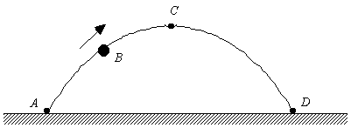

7. A tennis ball is thrown upward at an angle from point *A*. It follows a parabolic trajectory and hits the ground at point *D*. At the instant shown, the ball is at point *B*. Point *C* represents the highest position of the ball above the ground. How do the *x* and *y* components of the velocity vector of the ball compare at the points *B* and *C*?

1. The velocity components are non-zero at *B* and zero at *C*.
2. The *x* components are the same; the *y* component at *C* is 0 m/s.
3. The *x* components are the same; the *y* component has a larger magnitude at *C* than at *B*.
4. The *x* component is larger at *C* than at *B*; the *y* component at *B* points up while at *C*, it points downward.
5. The *x* component is larger at *B* than at *C*; the *y* component at *B* points down while at *C*, it points upward.

Questions 8 – 10: The graph below shows the velocity of an object (v) as a function of time (t).



8. What is the displacement of the object during the first four seconds shown?

1. 0 m
2. 8 m
3. 12 m
4. 16 m

9. At which of the following times is the object at rest?

1. 1 s
2. 4 s
3. 6 s
4. 0 s

10. During which of the following time intervals is the object speeding up?

1. 0 s – 2 s
2. 2 s – 4 s
3. 4 s – 6 s
4. 6 s – 9 s

Directions: For each of the questions below, two of the suggested answers are correct. For each of these questions, you must select both correct choices to earn credit.

11. A track athlete runs one complete lap around the track, starting and stopping at the same point. Which of the following quantities are zero for the athlete during this time?

1. distance
2. displacement
3. average velocity
4. average speed

12. Which of the following graphs of position vs. time or velocity vs. time show an object that is speeding up?



**Free Response**

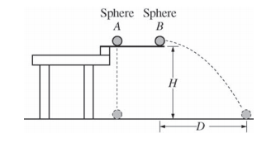

1. (7 points, suggested time 13 minutes)

Two identical spheres are released from a device at time t = 0 from the same height H, as shown above. Sphere A has no initial velocity and falls straight down. Sphere B is given an initial horizontal velocity of magnitude vo and travels a horizontal distance D before it reaches the ground. The spheres reach the ground at the same time ft, even though sphere B has more distance to cover before landing. Air resistance is negligible.

(a) The dots below represent spheres A and B. Draw a free-body diagram showing and labeling the forces (not components) exerted on each sphere at time 2 ft.

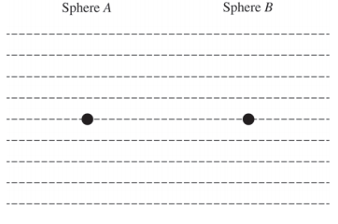

(b) On the axes below, sketch and label a graph of the horizontal component of the velocity of sphere A and of sphere B as a function of time.

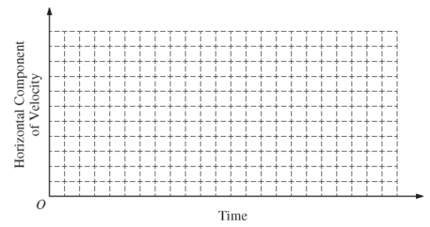

(c) In a clear, coherent, paragraph-length response, explain why the spheres reach the ground at the same time even though they travel different distances. Include references to your answers to parts (a) and (b).

2. Jim and Sara stand at the edge of a 50 m high cliff on the moon. Jim extends his arm over the cliff edge and throws a ball straight up with an initial speed of 20 m/s. Sara throws an identical ball with the same initial speed, but she throws the ball at a 30 degree angle above the horizontal.  
a. Consider each ball at the highest point in its flight. At this point:

i. Which ball has the greater vertical velocity? Circle your answer and explain briefly.

Sara’s Jim’s Both are the same

ii. Which ball has the greater horizontal velocity? Circle your answer and explain briefly.

Sara’s Jim’s Both are the same

iii. Which ball's velocity vector has greater magnitude? Circle your answer and explain briefly.

Sara’s Jim’s Both are the same

b. Now consider each ball just before it hits the ground, 50 m below where the balls were initially released. At this point:

i. Which ball has the greater vertical velocity? Circle your answer and explain briefly.

Sara’s Jim’s Both are the same

c. Which ball reaches the peak of its flight more quickly after being thrown? Circle your answer and explain briefly.

Sara’s Jim’s Both are the same

d. Below is a velocity-time graph representing the vertical velocity of Sara's ball. On the same axes, sketch a velocity-time graph representing the vertical velocity of Jim's ball.

|  |
| --- |
|  |

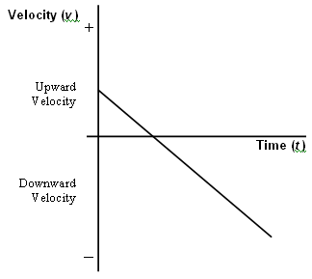

3. Imagine that identical stones, A and B, are dropped from the top of an amusement park ride. Stone B is dropped one second later than stone A. (Let the time when Stone A is dropped be t = 0.) Answer and explain each question below. You may use pictures and equations to aid in your justifications, but only as aids. Your answers must be mostly explanatory in nature.

A. While both stones are falling, how do the speeds of the stones A and B compare?

B. Does the difference in the speeds for Stone A and Stone B increase, decrease or stay the same as they both fall?

C. Will the separation of the two stones as they fall increase, decrease, or stay the same?

D. Will the time interval between when stone A hits the ground and when stone B hits the ground be equal to, greater than, or less than the one second between their release times?