Newton’s 3rd Law notes
For every force, there is an equal sized force acting in the opposite direction.
Ex: When you are standing still, gravity is pulling down just as hard as the floor is pushing up.
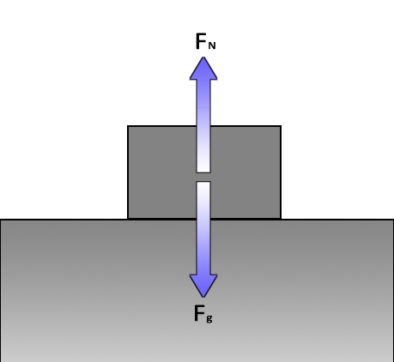
Balanced, at rest, F_{net} = 0 N
So then how does anything ever accelerate?
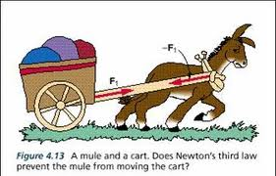
The equal and opposite forces aren’t acting on the same object. The horse pulls the cart so you draw that arrow. But the equal and opposite arrow is drawn on the cart, not the horse. So the cart can be unbalanced. The opposite force just has to exist somewhere in the universe.
Another example is a bug splattered on a truck’s windshield. Newton says they both experience the same force but because of the huge mass of the truck it barely decelerates verse the super small mass of the bug comes to such a abrupt stop that its body is flattened to death.
Ever played the ‘slug bug’ game with your siblings?
You: “Dad, John just punched me in the shoulder!”
Dad: “Technically honey, your shoulder hit him back just as hard.”

