Energy

Force vs. displacement graph: Determine the meaning of the slope and of the area of the graph. The slope of a force vs displacement graph has units of N/m and is not a quantity discussed much (unless the graph is a straight line with positive or negative slope, then there is a high likelihood of it representing the spring constant of spring). The area of a force vs. displacement graph has units of Nm or Joules and represents the work done by that force.

Work is the change in energy of an object. Anytime energy transforms from one type to another, work must be done. Work is calculated by multiplying the force in the direction of displacement by the displacement. Any force or component of the force that is perpendicular to the displacement does not do any work. This is why the centripetal force acting on an object does zero work--the force is perpendicular to the velocity. Anytime a force is perpendicular to the velocity or displacement of an object, the force does not do any work on an object and neither speeds the object up or slows it down.

Work done by a conservative force is independent of the path taken. Think gravity or the spring force- all that matters is the displacement of the object in the direction of the force. It does not matter in any way how the object moves along the way. Work done against a conservative force is stored as potential energy. This the definition of potential energy. Potential energy can be stored by doing work against gravity (think lifting an object) or a spring. A characteristic of a conservative force the ability to get the work done against it, back.
Work done by a non-conservative force depends heavily on the path taken by the object (think friction). Work done against a non-conservative force is lost as heat/sound/etc. to the environment. The net work done on an object (or the work done by the net force acting on an object) becomes kinetic energy.
Work and energy are all scalar quantities and direction is wholly unimportant when talking about work.
A force does positive work when it is in the direction of displacement of the object. Positive work generally tends to increase the energy of an object. A force does negative work on an object when it opposes the direction displacement. Negative work decreases the energy of an object. As long as no non conservative forces act on a system, the energy in that system will be 1) mechanical and 2) will not change.

The conservation of energy states that the total energy of a closed system will not change in value, just from one form to another. In general, when a non-conservative force does work on an object, it goes from a useful form (potential or kinetic) to a non-useful form (generally heat or sound).

A system cannot have conservation of energy if an outside force acts on the system. In that case, the outside force does work on the system and changes its energy. This does not violate the conservation of energy--it just means that the energy in the system does not remain constant. In order for a force to be considered an internal force, both objects involved in the force pair must be included in the system. If a system does not explicitly contain the earth, that system cannot have gravitational potential energy. GPE depends on the force of gravity--the force of gravity is the interaction between the earth and the object. If the earth is not a part of the system, the object's weight is an outside force and will do work on the system, either adding or removing energy.

Multiple Choice

- From the top of a high cliff, a ball is thrown horizontally with initial speed v₀. Which of the following graphs best represents the ball's kinetic energy K as a function of time t?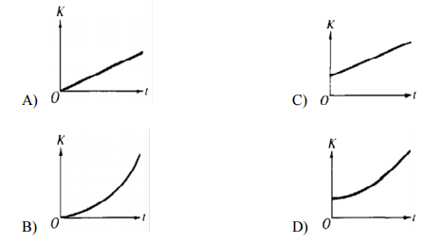

- A ball is dropped from rest and falls to the floor. The initial gravitational potential energy of the ball-Earth-floor system is 10 J. The ball then bounces back up to a height where the gravitational potential energy is 7 J. What was the mechanical energy of the ball-Earth-floor system the instant the ball left the floor?
- 0 J
- 3 J
- 7 J
- 10 J

Questions 3—4 refer to the following material.
A ball swings freely back and forth in an arc from points I to IV, as shown. Point II is the lowest point in the path, III is located 0.5 m above II, and IV is 1 m above II. Consider air resistance to be negligible.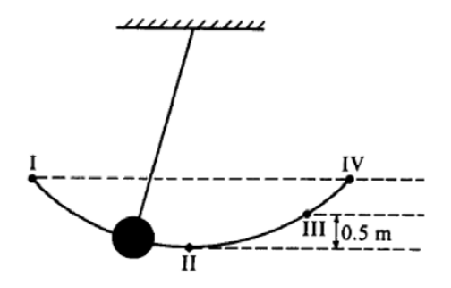
- If the potential energy is zero at II, where will the kinetic and potential energies of the ball be equal?
- At point II
- At some point between II and III
- At point III
- At some point between III and IV
- Which of the following correctly ranks the kinetic energy of the ball at the four locations pictured in the diagram?
- KE_{III} > KE_{II} > KEI > KE_{IV}
- KE_{II} > KE_{III} > KEI = KE_{IV}
- KE_{I} = KE_{IV} > KEIII > KE_{II}
- KE_{I} = KE_{IV} > KEII > KE_{III}

- A rock is lifted for a certain time by a force F that is greater in magnitude than the rock's weight W. The change in kinetic energy of the rock during this time is equal to the
- work done by the net force (F - W)
- work done by F alone
- work done by W alone
- difference in the momentum of the rock before and after this time
- difference in the potential energy of the rock before and after this time

- When a block slides a certain distance down an incline, the work done by gravity is 300 J. What is the work done by gravity if this block slides the same distance up the incline?
- 300 J
- Zero
- -300 J
- It cannot be determined without knowing the distance the block slides.
- It cannot be determined without knowing the coefficient of friction.

Questions 7—8
An object of mass 0.8 kg is initially at rest on a horizontal frictionless surface. The object is acted upon by a horizontal force F, the magnitude of which varies as function of the displacement of the object d as shown in the graph.
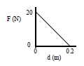

- Which of the following would be most likely to produce the force shown in the graph?
- a string tied to a falling mass
- a stretched spring
- a magnet placed in the direction of the displacement
- kinetic friction

- The amount of work done by the force F in displacing the object 0.2 m is most nearly
- 0 J
- 1 J
- 2 J
- 4 J

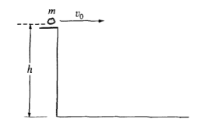
- A rock of mass m is thrown horizontally off a building from a height h, as shown. The speed of the rock as it leaves the thrower's hand at the edge of the building is v₀. What is the kinetic energy of the rock just before it hits the ground?
- mgh
- 1/2 mv₀²
- 1/2mv₀² − mgh
- 1/2 mv₀² + mgh

- An object is projected vertically upward from ground level and rises to a maximum height H. If air resistance is negligible, which of the following must be true for the object when it is at a height H/2?
- Its speed is half of its initial speed.
- Its potential energy is half of its initial potential energy.
- Its kinetic energy is half of its initial kinetic energy.
- Its total mechanical energy is half of its initial value.

Directions: For each of the questions or incomplete statements below, two of the suggested answers will be correct. For each of these questions, you must select both correct choices to earn credit. No partial credit will be earned if only one correct choice is selected. Select the two that are best in each case and then enter both of the appropriate letters in the corresponding space on the answer sheet.

- A block of mass m is sliding down a ramp which is set at an angle θ relative to the horizontal. The coefficient of kinetic friction between the block and the ramp is μ. Which of the following changes would reduce the work done against friction? Select two answers.
- Decreasing the angle
- Decreasing the mass
- Increasing the mass
- Decreasing the coefficient of friction

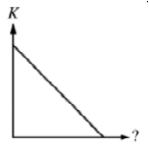
- A block is given a short push and then slides with constant fiction across a horizontal floor. The graph shows the kinetic energy of the block after the push ends as a function of unidentified quantity. The quantity could be which of the following? Select two answers.
- The speed of the block
- The distance traveled by the block
- The time elapsed since push
- The magnitude of the net work done on the block

- Pierre lifts a 60-kg crate onto a truck bed 1 m high in 3 s. Marie lifts twenty-four 2.5-kg boxes onto the same truck bed in a time of 2 min. Which of the following statements concerning work and power are true? Select two answers.
- Marie operates at a greater power level than Pierre.
- Pierre operates at a greater power level than Marie.
- Marie does more work than Pierre.
- Marie and Pierre do the same amount of work.

Free Response

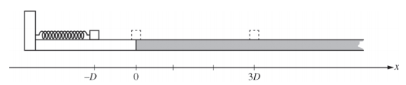

- A block is initially at position x = 0 and in contact with an uncompressed spring of negligible mass. The block is pushed back along a frictionless surface from position x = 0 to x = -D , as shown above, compressing the spring by an amount Δx = D . The block is then released. At x = 0 the block enters a rough part of the track and eventually comes to rest at position x = 3D . The coefficient of kinetic friction between the block and the rough track is µ.

(a) On the axes below, sketch and label graphs of the following two quantities as a function of the position of the block between x = -D and x = 3D. You do not need to calculate values for the vertical axis, but the same vertical scale should be used for both quantities.

i. The kinetic energy K of the block

ii. The potential energy U of the block-spring system

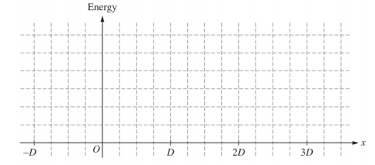

The spring is now compressed twice as much, to Δx = -2D. A student is asked to predict whether the final position of the block will be twice as far at x = 6D. The student reasons that since the spring will be compressed twice as much as before, the block will have more energy when it leaves the spring, so it will slide farther along the track before stopping at position x = 6D.

(b) i. Which aspects of the student’s reasoning, if any, are correct? Explain how you arrived at your answer.

ii. Which aspects of the student’s reasoning, if any, are incorrect? Explain how you arrived at your answer.

(c) Use quantitative reasoning, including equations as needed, to develop an expression for the new final position of the block. Express your answer in terms of D.

(d) Explain how any correct aspects of the student’s reasoning identified in part (b) are expressed by your mathematical relationships in part (c). Explain how your relationships in part (c) correct any incorrect aspects of the student’s reasoning identified in part (b). Refer to the relationships you wrote in part (c), not just the final answer you obtained by manipulating those relationships.

