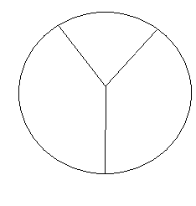
Newton’s 2nd Law
Can you figure out where to put things in the circle? Give it a shot then check with me.
Equation: F = ma
Units: N = kg*(m/s²)

ma = F = am
kicking bowling ball kicking basketball
EX 1: As a result of a serve, a tennis ball with a mass of 58g accelerates at 43 m/s². What force is responsible? (Hint: There is a little extra step.)

EX 2: You pull a 12 kg wagon east with a force of 6 N. How much will the wagon accelerate? Draw a force diagram.

