CIrcular Motion and Gravitation

Circular Motion: Anytime an object moves in a circle, it is accelerating. Acceleration is any change in velocity, and an object moving in a circle with a constant speed is constantly changing direction. This acceleration is always in toward the middle of a circle. The easiest way to explain this is by using the force acting on the object--in order to turn it in a circle, the force must point to the center for the circle and the acceleration will be in the same direction as the force.

There is no force named “The Centripetal Force”--that is simply a label that we give to the net force causing an object to move in a circle. The centripetal force will always be caused by one or more different types of forces. For a horizontal circle, it is typically just one force. A vertical circle will be a combination of gravity and another force. The centripetal force acting on an object will not change the object’s speed, only its direction. This is for two reasons: 1) the force is perpendicular to velocity and perpendicular quantities do not affect each other and 2) the centripetal force does no work on the object.

Gravitation: Gravity is the force between any two masses. It is an extremely weak force, meaning a lot of mass is required to get an appreciable force. When talking about a large mass and the objects around it, it is convenient to talk about the gravitation field. A mass creates a gravitational field. All objects the same distance from the planet experience the same gravitational field. Another word for the gravitational field is the acceleration due to gravity. An object's acceleration because of gravity is independent of that object’s mass.

Orbiting objects are in perpetual free fall—free fall because the only force acting on the object is gravity and perpetual because the object has a high sideways velocity that causes it to miss the planet (so it is falling around the object). In order to find qualities relevant to circular orbit, net force (the centripetal force, because it is moving in a circle and has centripetal acceleration) is set equal to the gravitational force.

Multiple Choice

- Four satellites are in a circular orbit about the Earth, well outside the atmosphere. The mass (m) and orbital radius (r) of each satellite are given below. Which satellite has the greatest speed?
Mass Radius
- m/2 r
- m r/2
- m r
- m 2r

- The acceleration due to gravity at the surface of the earth is g. The radius of the earth is RE. The distance from the center of the earth to a point where the acceleration due to gravity is g/9 is
- RE
- 9RE
- RE/3
- 3RE

- An object has a mass of 4,000 kg and experiences a gravitational force of 20,000 N. The strength of the gravitational field at this location is
- 0.2 N/kg
- 5 N/kg
- 50 N/kg
- 200 N/kg
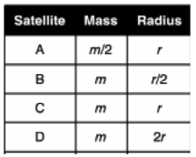
- Four satellites are in a circular orbit around Earth, well outside the atmosphere. The mass (m) and orbital radius (r) of each satellite are given in the provided data table. Which satellite has the greatest speed?
- A
- B
- C
- D

- An object weighing 4 N swings back and forth on the end of a string. At the bottom of the swing, the tension in the string is 6 N. What is the magnitude of the centripetal acceleration of the object at the bottom of the swing?
- 0
- 1/2 g
- g
- 3/2 g

- A 30 kg child sits on the edge of a merry go round at a radius of 6 m. The tangential speed of the child is 12 m/s. The work done by the centripetal force during one complete revolution is
- 0 J
- 1440 J
- 5760 J
- 18086 J

Questions 7-10
A ball on the end of a string is being swung in a vertical circle, rotating clockwise as shown above.
- Which of the following vectors represents the centripetal force acting on the ball at position I?
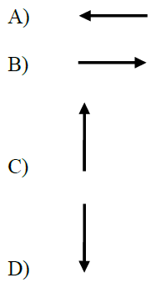
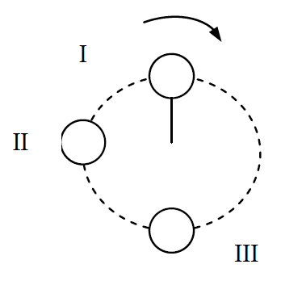

- If the string were suddenly cut when the ball is at position II shown in the figure above, the subsequent motion of the ball would be
- to move to the right.
- to move to the left.
- to move to the top of the page.
- to move down and to the right

- The tension in the string is
- greater at position I than at position III
- greatest at position II
- greater at position III than at position I
- greater at position I than at position II

- The ball has a mass m and a speed v as it moves around the vertical circle of radius r. Which of the following expressions can be used to find the minimum speed of the ball at position I such that the circular path is maintained?
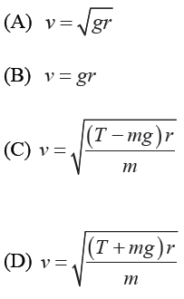

- A motorcycle passes over the top of a hill that has a radius of curvature of 100 m. The mass of the motorcycle plus rider is 300 kg. The motorcycle is moving at a speed of 30 m/s. The surface exerts a normal force of magnitude FN on the motorcycle. The motorcycle passes over the top of the hill again but now is moving at a speed of 33 m/s. How does the new normal force exerted on the motorcycle compare to FN?
- The new normal force is greater than FN.
- The new normal force is less than FN.
- The new normal force is equal to FN.
- The new normal force is greater or less than FN, depending on the gravitational force.

- A motorcycle passes over the top of a hill that has a radius of curvature of 100 m. The mass of the motorcycle plus rider is 300 kg. The motorcycle is moving at a speed of 30 m/s. The surface exerts a normal force of magnitude FN on the motorcycle. The motorcycle passes over the top of the hill again but now is moving at a speed of 33 m/s. How does the new normal force exerted on the motorcycle compare to FN?
- The new normal force is greater than FN.
- The new normal force is less than FN.
- The new normal force is equal to FN.
- The new normal force is greater or less than FN, depending on the gravitational force.

Directions: For each of the questions or incomplete statements below, two of the suggested answers will be correct. For each of these questions, you must select both correct choices to earn credit. No partial credit will be earned if only one correct choice is selected. Select the two that are best in each case and then enter both of the appropriate letters in the corresponding space on the answer sheet.

- Two spacecraft are 45,500 km apart and heading toward a large planet. The spacecraft plan to rendezvous and orbit the planet to determine its mass and size. Spacecraft Alpha, with a mass of 3400 kg, and spacecraft Beta, with a mass of 1700 kg, plan a circular orbit around the planet at a radius of 9.4 × 10¹¹ m from the planet’s center. When both spacecraft are in the same circular orbit around the planet (select two answers.),
- Alpha experiences twice the centripetal acceleration as Beta.
- Alpha experiences the same centripetal acceleration as Beta
- Alpha experiences twice the gravitational force as Beta.
- Alpha experiences the same gravitational force as Beta.

- A carnival merry-go-round rotates around a vertical axis at a constant rate. Two horses are attached to the rotating merry-go-round with the red horse placed at a shorter distance from the center of the merry-go-round than the blue horse. Which of the following statements are true concerning both horses? Select two answers.
- The blue horse has a greater period than the red horse.
- The blue horse and the red horse have equal periods.
- The blue horse has a greater speed than the red horse.
- The blue horse and the red horse have equal speeds.

Free Response:

- A satellite of mass m is moving in a circular orbit with linear speed v around a planet of mass M, orbiting at a particular distance r from the center of the planet.

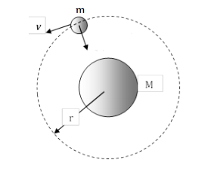

- Qualitatively discuss why the satellite is continually in free-fall as it orbits the planet. Justify your answer in a clear, coherent, paragraph-length explanation.

- Quantitatively determine the radius of revolution, r, of the satellite in terms of the given quantities and any fundamental constants.

- What is the relationship between the radius of revolution and the mass of the satellite that is in free-fall around the planet? Justify your response.

- Describe in a clear, coherent, paragraph-length explanation how and why the speed of the planet would be greater if were to enter an orbit with radius less than r.

