Kinematics Review

Use the following to answer question 1:

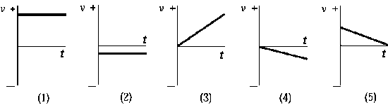

1. Which graph of *v* versus *t* best describes the motion of a particle whose velocity is constant and negative?

A) 1 B) 2 C) 3 D) 4 E) 5

2.

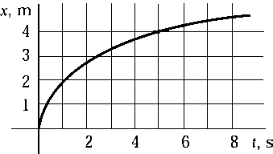

The graph shows how the position of a particle depends on time. Which choice is closest to the average speed of the particle in the time interval between 0 and 6 s?

A) 0.40 m/s B) 0.67 m/s C) 0.75 m/s D) 1.50 m/s E) 2.22 m/s

3. If an object is moving at uniform speed in a straight line, its instantaneous velocity halfway through any time interval is

A) greater than its average velocity. D) half of its average velocity.

B) less than its average velocity. E) twice its average velocity.

C) the same as its average velocity.

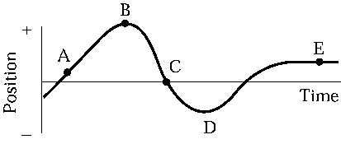

4. An object moves along the *x* axis as shown in the diagram. At which point or points is the object instantaneously at rest?

A) A and E B) B, D, and E C) C only D) E only E) None of these is correct.

Use the following to answer question 5:

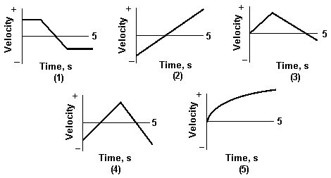

5. In which graph does the particle have a constant acceleration for the entire 5 s?

A) 1 B) 2 C) 3 D) 4 E) 5

6 . Which one of the following is *not* a vector quantity?

A) acceleration D) average velocity

B) average speed E) instantaneous velocity

C) displacement

7. The graph below shows the position of an object as a function of time.



a) What is the velocity of the object at t = 3 s?

b) In a clear, coherent, paragraph-length response, describe the motion of the object for the time t = 0 s until the time t = 8 s. Include important quantities and directions.

8. On the graphs below, plot the motion of an object which:

Has an initial position of 1 m

Moves at a constant velocity of 2 m/s for two seconds

Stays at rest for two seconds

Moves backwards and speeds up for two seconds

Moves backwards and slows down for two seconds





9. The graph below shows the velocity of an object as a function of time.



a) Find the acceleration of the object at t = 4 s.

b) Find the displacement of the object between t = 0 s and t = 7 s.

c) Write a description of the motion of the object. Be specific and quantitative (include numbers).

10. An object moves forwards 40 m in 2 seconds and then backwards 10 m in 1 second.

a) What is the distance traveled by the object?

b) What is the displacement of the object?

c) What is the average velocity of the object?

d) What is the average speed of the object?

11. A student rolls a marble down a steel ramp and times how long it takes it to reach the end. Her data are shown in the table.

|  |  |  |  |  |  |
| --- | --- | --- | --- | --- | --- |
| Velocity (cm/s) | 3.6 | 7.2 | 10.8 | 14.4 | 18.0 |
| Time (s) | 0.5 | 1.0 | 1.5 | 2.0 | 2.5 |
|  |  |  |  |  |  |

On the graph below, plot the data such that it generates a straight line. Label the axes accordingly and choose a reasonable scale. Plot a best fit line and use it to find the acceleration of the object.

