Tension and Normal Force

This session is mostly a review of specific applications of Newton’s second law. With the new AP 1 course, there is not as much emphasis on the use of trigonometry to solve complex problems. What's more important is understanding how components change with respect to each other. 2nd law problems can be solved by straightening out free body diagrams and combining masses as opposed to writing out 2nd law equations and solving a system of equations. Writing out 2nd law equations is helpful and necessary, but the systems of equations can sometimes be a struggle.

Normal force: the perpendicular force. This is a surface force that arises when any object is in contact with any surface. The only time an object will not experience a normal force is when it is suspended (not touching a wall or the ground), or in free fall. When an object is on an inclined plane, weight acts straight down and the normal force acts at a 90 degree angle to the surface. Because all of the weight is not in the opposite direction of the normal force and only part of the weight is, the normal force is equal to that part of weight. As the incline increases, that part of weight (and therefore the normal force) decreases. As the incline increases, the other part of the weight (the part pulling down the incline) increases.

Tension: a force from stings. Tension is pulling force and can only pull. The most difficult part of tension is the idea that tension is the same through all parts of a string (as long as there are no massive pulleys). If two people pull on opposite ends of a rope with a 100 N force, the tension in that rope is 100 N (and not 200 N). Tension is (usually) an interior force and does not contribute to the net force acting on a system. This can be very convenient when finding the acceleration of a system. All one must do is find the net outside force and divide it by the total inertia (mass) of a system.

Multiple Choice
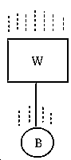
- The system in the figure consists of a steel ball attached by a cord to a large block of wood. If the system is allowed to free fall, the tension in the cord is (hint, draw a free body diagram for the ball and assume it is accelerating down at 10m/s²)
- zero.
- equal to the difference of the masses of B and W.
- equal to the difference of the weights of B and W.
- equal to the weight of B.
- equal to the sum of the weights of B and W.

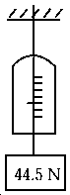
- A 44.5-N weight is hung on a spring scale (which will indicate tension), and the scale is hung on a string. The assembly is allowed to accelerate down at 4.90 m/s². The scale reads
- 0 N
- 22.2 N
- 44.5 N
- 66.7 N
- 71.2 N

- A man riding in an elevator experiences a normal force greater than his actual weight. Which one of the following statements could be true?
- The elevator moves upward with constant speed.
- The elevator moves downward with constant speed.
- The elevator moves upward with decreasing speed.
- The elevator moves downward with decreasing speed.
- The elevator moves downward with increasing speed.

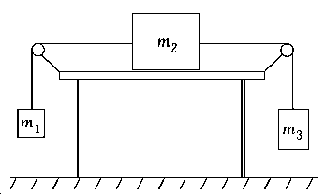

- For this problem, assume no friction. A mass m2 = 3.5 kg rests on a horizontal table and is attached by strings to masses m1 = 1.5 kg and m3 = 2.5 kg as shown. The masses m1 and m3 hang freely. The system is initially held at rest. After it is released, the acceleration of mass m2 will be
- zero
- 1.3 m/s²
- 5.2 m/s²
- 8.7 m/s²
- 9.8 m/s²

- Two tug-of-war teams are pulling on the ends of a rope, each team with a force of 1000 N. If the rope does not move, the tension in the rope is (draw a free body diagram for each team)
- 2000 N
- 500 N
- 1000 N
- 0 N
- 2000 kg

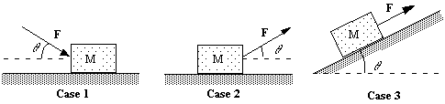
- Note the three situations:

In which case will the magnitude of the normal force on the block be equal to Mg + F sin θ ?
- case 1 only
- case 2 only
- both cases 1 and 2
- both cases 2 and 3
- cases 1, 2, and 3

- A particle of mass 1.3 kg is sliding down a frictionless slope inclined at 30º to the horizontal. The acceleration of the particle down the slope is
- 1.3 m/s2
- 9.8 m/s2
- 0.5 m/s2
- 8.5 m/s2
- 4.9 m/s2

- If two metal blocks of different masses slide freely down the same frictionless incline, which one of the following is true?
- They have equal accelerations.
- They have unequal accelerations, but the forces acting on them are equal.
- The more massive block reaches the bottom first.
- The less massive block reaches the bottom first.
- None of these is correct.

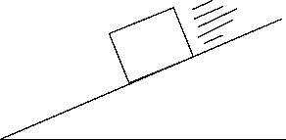

- Which of the following free-body diagrams represents the block sliding down a frictionless inclined plane?
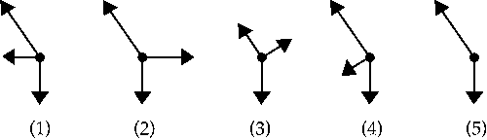
- 1
- 2
- 3
- 4
- 5

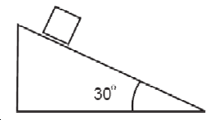
- A 2 kg wooden block rests on an inclined plane as shown above. The frictional force between the block and the plane is most nearly
- 20 N
- 16.66 N
- 11.76 N
- 10 N

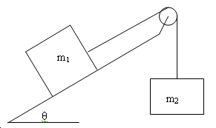
Free Response:

- Two blocks are connected by a light string that passes over a frictionless pulley and are initially at rest. There is friction between the incline and mass 1. Two students, Levi and Ruby, make the following observations:
Ruby: “If we reduce the angle of incline, the normal force on the block will increase, causing the friction on mass 1 to also increase, but mass 2 will pull harder on mass 1 and the system will accelerate in the direction of mass 2.”
Levi: “Increasing the angle of incline will cause the part of gravity that pulls the block down the plane to increase and the normal force to decrease, reducing friction and causing the system to accelerate in the direction of mass 2.”
a. What parts of Ruby’s statement are incorrect? Explain your reasoning.

b. What parts of Levi’s statement are incorrect? Explain your reasoning.

c. What parts of Ruby’s statement are correct? Explain your reasoning.

d. What parts of Levi’s statement are correct? Explain your reasoning.

e. Should the angle of incline be increased or decreased in order to make the system accelerate in the direction of mass 2? Justify your answer.

